MONKTON TOWN PLAN
2013-2018

MONKTON, VERMONT

ADOPTED BY PLANNING COMMISSION _____________________________

Acknowledgements

The Monkton Planning Commission would like to acknowledge the support and efforts of those people and entities that have made this plan update possible. This project was supported with town funds and a 2012-2013 Municipal Planning Grant from the Vermont Department of Housing and Community Affairs. Addison County Regional Planning Commission provided technical assistance throughout the planning process.

A special thanks to John (Buzz) Kuhns, whose wonderful photos illustrate the plan.

In celebration of our Town and Community,

The Monkton Planning Commission:
Michael Bayer
Sam Burr
Peter Close
Jay Frater
Thea Gaudette
Wendy Sue Harper
Jordon Jiskra
Lee Mahony

Cover image: The Monkton Flag, designed by Monkton resident, Linda Reynolds.

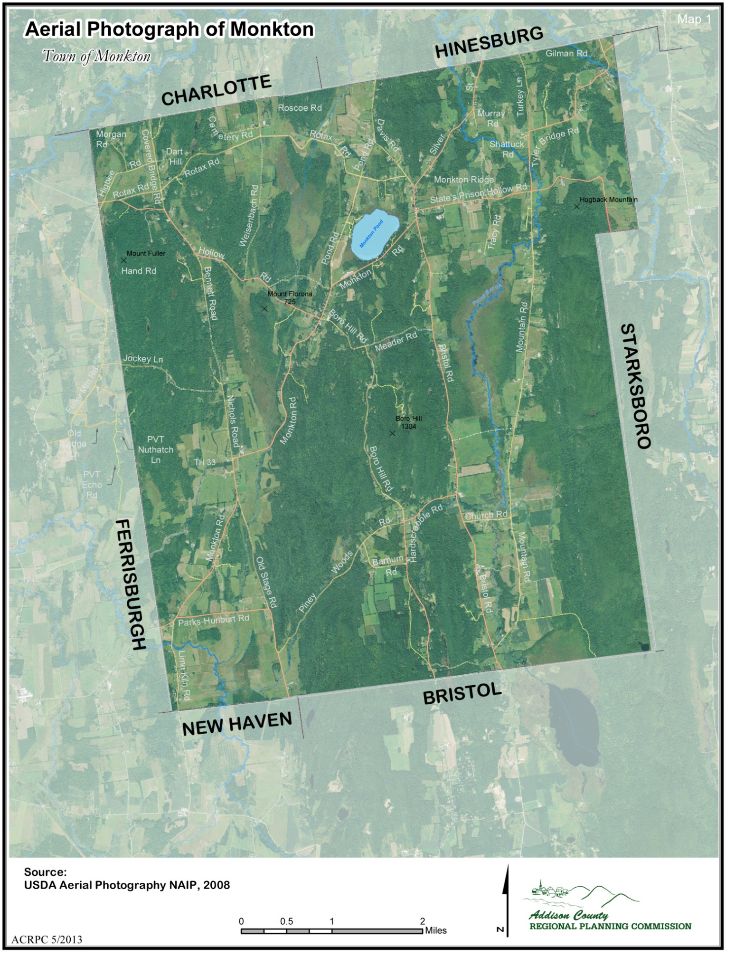
Cover image of Monkton’s Flag designed by Monkton Resident, Linda Reynolds

TABLE OF CONTENTS

TABLE OF CONTENTS 4
PURPOSE 6
INTRODUCTION 7
GUIDING PRINCIPLES 9
TOWN HISTORY 10
POPULATION 11
CURRENT AND HISTORIC POPULATION 11
AGE OF POPULATION 13
RACE AND ETHNICITY 14
EDUCATION AND INCOME 14
HOUSING 15
AFFORDABLE HOUSING and HOUSING STOCK 16
HEATING and WEATHERIZATION 17
HOUSING and THE WORKING LANDSCAPE 17
EDUCATION and CHILDCARE 19
HISTORY of MONKTON SCHOOLS 19
MONKTON CENTRAL SCHOOL 19
TOWN GROWTH and SCHOOL ENROLLMENT 21
CHILDCARE & EARLY EDUCATION SERVICES 22
UTILITIES and FACILITIES 23
ELECTRICITY 27
RUSSELL LIBRARY 30
RECREATION 33
ENERGY 37
CURRENT ENERGY USE 38
ALTERNATIVE ENERGY AND ENERGY CONSERVATION 38
ALTERNATIVE AND RENEWABLE RESOURCES 39
LAND USE, TRANSPORTATION and ENERGY 41
MONKTON ENERGY COMMITTEE 42
TRANSPORTATION 43
EXISTING CONDITIONS 44
TOWN CENTER and SLOWING TRAFFIC 47
PUBLIC TRANSPORTATION 48
ECONOMY and ECONOMIC DEVELOPMENT 49
WORK FORCE AND INCOME 50
AGRICULTURE 54
COST OF HOUSING 54
TOWN OPERATING BUDGET 54
TOURISM AND OTHER TOWN ATTRACTIONS 54
NATURAL RESOURCES 56
AQUATIC HABITAT 57
FOREST HABITAT AND TRAVEL CORRIDORS 57
RIPARIAN HABITAT BUFFERS 58
LAND PROTECTION AND MAINTENANCE 60
RARE, THREATENED, AND ENDANGERED SPECIES AND FRAGILE NATURAL AREAS 60
WATER RESOURCES 63
WETLANDS 64
GROUND WATER 65
AQUIFER/ WELLHEAD PROTECTION 66
DRINKING WATER QUALITY 66
SOIL AND MINERAL RESOURCES 68
AGRICULTURAL RESOURCES 71
FOREST RESOURCES 75
SCENIC RESOURCES 79
AIR QUALITY 80
LAND USE 83
FARMS, FORESTS AND OPEN SPACE 84
ENVIRONMENTALLY SENSITIVE AREAS 85
HILLS AND RIDGELINES 85
IMPORTANT SCENIC VIEWS 86
MANAGING GROWTH 86
LAND USE PLANNING REGIONS 86
ZONING DISTRICTS 88
OVERLAY DISTRICTS 88
PLAN IMPLEMENTATION 95
COMPATABILITY 98

MAPS
Elevation 90
Slope 91
Land Use Planning Regions 92
Overlay Districts 93
Zoning District: Cons. Prohib 94

Labor Shed 53
Import. Resources/Habitat 59
Public, Conserved/Institu. 62
Septic Suitability 70
Earth Resources 74
Land Cover 76

Aerial Ortho 3
Population Density 18
Utilities/Facilities 25
Road Names 45
Transportation Safety 46
Commute Shed 52

PURPOSE

PURPOSE

The purpose of this Plan is to set forth the community's land use and planning goals for the next five years and to establish a framework for accomplishing those goals. While the Plan sets forth community goals and objectives, the policies and other means for achieving those ends are set forth in the town zoning and subdivision regulations, other town regulations and ordinances and in the day-to-day operation of the town Planning Commission and the Development Review Board. The elements addressed in the plan adhere to those required in the State Planning and Development Act (Title 24 V.S.A., Chapter 117).

A Town Plan is not a static document to be revised every five years and set aside; it is instead the reference for all planning and zoning decisions. As the town works to interpret existing regulations and develop new ones they will refer to the Plan to see how their actions further these goals. A Town Plan also exists to inform the regional and state government, neighboring towns and regions, and private companies and groups what Monkton requires of them. All private or governmental activity affecting Monkton should take note of the Town Plan and, where appropriate, be reviewed in light of the plan's goals. Likewise, it is the responsibility of the town as it writes its Plan to take note of the obligations placed upon us by our neighboring towns. For this reason, the Town of Monkton has attempted wherever possible to look to its abutting towns for guidance and information regarding their goals. We have also attempted, wherever possible, to acknowledge these goals, such as where conservation zones abut adjoining communities, and to address these goals and draft policy accordingly.

The town plan serves a role in State regulatory proceedings. Act 250 requires development projects to conform to the town plan. Other State proceedings for utility and road projects, under section 248, consider goals of the town plan and impacts to issues addressed in the town plan.
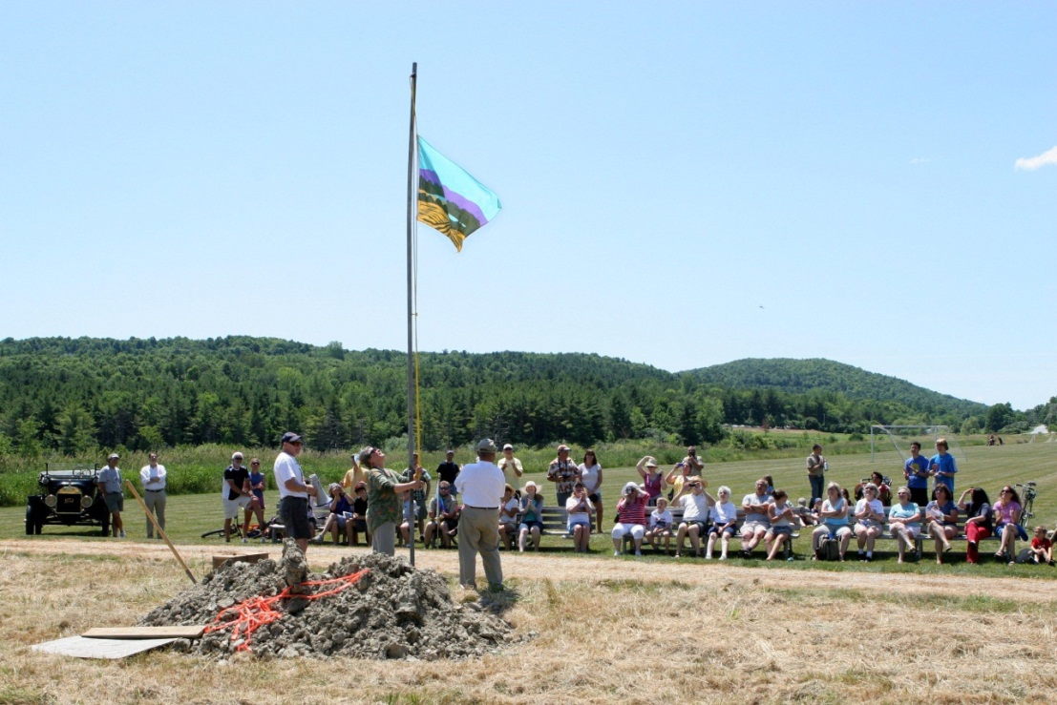
Raising of the Monkton Flag

INTRODUCTION

Monkton is a traditional farming community whose citizens value its rural character and quality of life: protecting and revitalizing the working landscape that defines Monkton while focusing on growth and activities into a town center. This Plan establishes guiding principles in accordance with the community's goals as set forth in the document.

Until early in the 1970's, Monkton was a rural community largely unchanged from the early days of the century. Farming, primarily dairy farming was the major economic and social force in the town and was responsible for the land-use pattern we see today -- two village centers with some commercial development surrounded by a mixture of open farmland, working woodlands, and dispersed commercial activities.

Beginning in the 1970's, Monkton began to feel the influence of Chittenden County’s growth as a regional employment center. More families with jobs in Burlington began to move into Monkton, seeking a rural living environment even though their job, shopping and leisure activities were oriented toward more urban areas to the north. Throughout the decade of the 1970's, land-use impacts of this change were slight. Farming continued as a strong industry and continued to dominate the land-use patterns. Homes for these new ex-urbanites were built on land split off from farms, generally on large-acreage tracts dispersed throughout the town.

In the early 1980’s, changes in the Vermont and national economy began to be felt in Monkton. First, the national farm economy declined to the point where most producers -- including dairy farmers -- were operating below the break-even point. Many farmers in Monkton, as well as across Vermont left farming. In 1973 Monkton had 37 active dairy farms; in 1990 that number stood at 15, by 1997 the number was 6 and by 2013 the number had decreased to three. As the decade of the 1990's progressed, despite government efforts at price control, milk prices remained generally below the cost of production.

Despite continued contraction of the dairy industry, farms continue to be a major economic activity in the town of Monkton. The town now hosts a more diverse agricultural base including fruit and vegetable farms, nursery operations, livestock and artisan cheese makers. Consolidation in the dairy industry has taken place as well as contraction, which has led to large fields farmed by landowners who live in adjacent towns.

At the same time the agricultural industry that shaped Monkton was on the decline, the demand for residential use increased. Throughout the 1980s Burlington enjoyed a period of unprecedented economic growth. Immigrants from across the United States came to the area not only for jobs, but also to enjoy a rural lifestyle. The suburban and ex-urban growth confined to Chittenden County began to move further away from Burlington and into Addison County as both the demand for land and land prices in Chittenden County rose.

Today in Monkton most residents work outside of town. Many farmers faced with declining incomes from their agricultural operations and increasing land values -- and property taxes -- find selling some or all of their land for residential development an attractive and often necessary alternative.
The dominant land-use pattern is changing as a result of this change in economic trends. Farmland along roads is being subdivided into building lots. Woodland, especially on hillsides with picturesque views, is being sold for residential use. Monkton Pond, once a rural vacation area, is now being developed for year round housing. Roads, the town hall and library, school and other public facilities are feeling the pressure of increased demand by residents and by ever increasing non-resident through traffic.

As the Town faces new development pressures many new questions remain unanswered. Key among them is how will we maintain the critical balance between ecological functions and water resource quality and development while maintaining the working landscape?

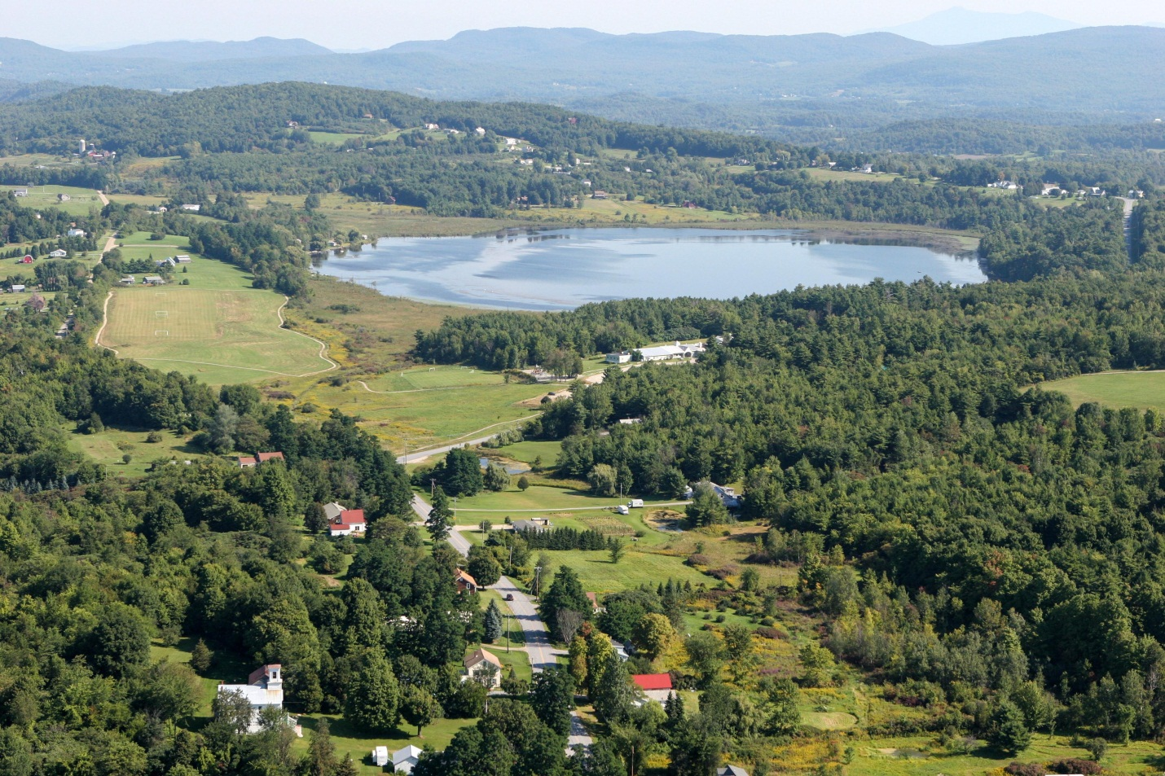
Monkton Pond

GUIDING PRINCIPLES

The following are the guiding principles of the Monkton Town Plan, which lay the ground work for the goals and recommendations found in each section. All town policies and regulations should resonate with these guiding principles, and further the goals of this plan.

- Support a diverse social and economic population and the ability for families to move into, grow, and stay in Monkton.

- Retain and steward Monkton’s unique historic, natural and scenic characteristics.

- Ensure the preservation of the working landscape for future generations.

- Maintain the proper function of our ecological resources in order to protect air and water quality, soil health and wildlife habitat.

- Direct growth to reflect historic settlement patterns of denser village centers and hamlets, surrounded by agricultural fields, forests and other natural features.

- Promote a viable, diverse and creative local economy fitting with Monkton’s rural character.

- Foster places and programs where residents can feel a part of a cohesive community.

- Support opportunities for high quality education and educational opportunities for all ages of Monkton residents.

- Ensure a safe, well-maintained transportation network that considers the needs of a diversity of users, including pedestrians and cyclists.

- Strengthen the opportunities for the Town and residents to conserve energy and use alternative energy sources.

- Promote recycling, efficient trash disposal and composting.

TOWN HISTORY

Monkton was chartered by Governor Wentworth of New Hampshire in 1762 and was organized as a town in 1786. The history of the town closely follows that of neighboring towns in Addison County. Settlement of the town was sporadic before the Revolutionary War, and many of the early settlers left their homes during the course of the war, seeking safety elsewhere. The overall settlement of the town began after the war.

While many of the early settlers were farmers, there was also early exploitation of mineral deposits found in the town. Monkton's iron provided metal to the American fleet built at Vergennes during the War of 1812. Yellow ochre was also found, but the most abundant mineral was high-grade kaolin, used primarily in ceramics.

With the gradual rise and predominance of agriculture, greater settlement and development of farms took place. During the 19th century the sheep industry led, and in 1840, there were approximately 6200 head of sheep in town, as compared to only 1200 cattle.

By the middle of the 19th century, Monkton was established as a self-sufficient, agrarian community. In 1880, for example Monkton had (6) manufacturers, (8) blacksmiths and wheelwrights, (3) physicians, (12) carpenters (architects), (3) dressmakers, (10) teachers, (3) butchers as well as farmers, ministers, cattle dealers, and farm machinery dealers.

In the latter part of the 19th century, however, Monkton's population began to decline. The lure of free land and the promise of better fortunes in the west attracted many, especially as the sheep industry in Vermont began to decline. Whole families from Monkton moved westward across the northern tip of New York State and into the Ohio Valley and beyond. Many of the old-name families in Monkton trace ancestors to many western population centers.

The population decline continued steadily throughout the first half of the 20th century, reaching its lowest point in over 150 years during the 1950s. As indicated by census data, however, there has been a dramatic increase in Monkton's population from the late 1960's. This increase has followed the increases in Chittenden and Addison Counties and has been facilitated by the modernization of the road system during this period.

Monkton has changed substantially as a result of the population increases. It is no longer a self-sufficient community, as it was during the 19th century. Although the town has retained its agrarian character, the majority of residents are now commuters who are dependent upon other communities for employment as well as most goods and services. Since 1985, development in Monkton has been almost exclusively residential, with some recent marked increase in cottage industry and small businesses. The residential development that has occurred has been predominately single-family homes scattered randomly throughout the town.

POPULATION
GOALS AND RECOMMENDED ACTIONS
Monkton’s population will:
- be multi-generational with an active youth and senior population
- be diverse

We will achieve this by:

- Including housing policies in our plan and zoning regulations that encourage a diversity of housing types, including affordable options for young families and seniors.
- Surveying the needs of the senior population in Monkton to identify their needs and whether or not they are being met.
- Seeking opportunities for local economic development (see Economic Development section).
- Building a cohesive village center and recreation areas which provide opportunities for resident to interact and enjoy their community (see Land Use section).
- Preserving and cultivating our agricultural land and economy (see Agriculture in Natural Resources and Economic section).
- Supporting a high-quality school system and infrastructure (see Education section).

DISCUSSION

CURRENT AND HISTORIC POPULATION
In 2000 the Census reported that Monkton had a population of 1,759. In 2010 the population had grown to 1,980. This is a 12 percent growth rate in the past ten years, a slight decrease in the growth rate between 1990 and 2000 of 16 percent, but still significant compared to growth rates between 1-3 percent in many Addison County towns As Monkton borders Chittenden County, much of Monkton’s growth can be attributed to the growth of the greater Burlington area. Chittenden County saw accelerated development starting in the late 1960s. During the 1970s growth in Monkton occurred at a dramatic rate. In 1970 the Town’s population was 765; by 1980 the population had increased by 57 percent to 1201. During that same time the Monkton region increased by 35.1 percent. Between 1970 and 1990 Monkton grew more than twice as quickly as the Addison County region (93.7 percent versus 38.9 percent) and more than three times as fast as the entire state (93.7 percent versus 26.5 percent). As Middlebury grows as an economic hub, growth pressures and commuter traffic through Monkton come from both the north and the south. By 1990, Monkton had exceeded the record population of 1830 and during the last half century nearly quadrupled, as more families are choosing to live central to both Middlebury and Burlington.

Population decline in the years following the decline of the sheep industry through the end of the Great Depression occurred as a result of out-migration. Population growth during the 1950s and 1960s occurred as a result of natural increase (birth of new Town residents) and in-migration. Much of Monkton’s growth in population over the last two decades has been a result of in-migration. Between the 1990 and 2000 Census there was an increase of 277 new residents, and between 2000 and 2010 there was an increase of 221 more residents.

AGE OF POPULATION
In 2010, the median age of Monkton residents was 41, up from 37 in 2000. As can be seen in the above graph, the population of 55 and older has dramatically increased from 2000 to 2010, as baby boomers of the 1940 and 1950’s enter retirement age. Because of this, there will be more of a demand for facilities and services for the elderly in the next 10-20 years. Particularly important needs will include those for specialized housing, health care and transportation.

Other age groups have maintained similar numbers over the past 10 years, except the population of residents aged 20-24, which has increased. This could reflect the population of adults returning to live with their parents upon graduation from college due to a tight job market nation-wide.

Population of persons age 25-34 is decreasing only slightly in absolute terms and decreasing as a percentage of total population. In order to attract young families to Monkton, it is important that properties in Monkton be affordable to first time home buyers, most likely in this age bracket.

Population of people also ages 5-19 is decreasing only slightly in absolute terms and decreasing as a percentage of total population. The rapid growth in the number of school age children seen in the 80’s and 90’s has slowed as "baby boomers" have exited childbearing years and the trend towards fewer children per family has continued. Monkton, like much of Vermont, became less affordable for young families.

HOUSEHOLD SIZE and TYPE
Household sizes continue to decline in most towns in Vermont, another factor that impacts Vermont schools, and causes declining enrollment numbers in small towns. In 1970 the average household size in Monkton was 3.9 persons. By 1990 it had decreased to 2.95 persons, and in 2010 the average household size was 2.67. As can be seen in the above pie chart, the majority of Monkton’s population lives in households with no children. Thirty four percent of households have children 18 and younger, and only seven percent have children under the age of six. Fifteen percent of Monkton residents live alone.

RACE AND ETHNICITY
As can be seen in the table below, Monkton mirrors diversity trends of most of Vermont, which is 96 percent white. Monkton’s population is 97.6 percent white, reflecting the rural areas of the state, the majority of which are of English, Irish, French, German or Italian descent. Other ethnicities represented in Monkton include American Indian, Asian Indian, African American, Chinese, Filipino, Korean, Mexican, Puerto Rican, and Vietnamese.

Race | Population in Monkton # | %
American Indian or Native Alaskan | 2 | 0.1
Asian Indian | 1 | 0.1
Black or African American | 9 | 0.5
Chinese | 1 | 0.1
Filipino | 2 | 0.1
Korean | 1 | 0.1
Mexican | 10 | 0.5
Puerto Rican | 4 | 0.2
Other Hispanic or Latino | 11 | 0.5
Vietnamese | 1 | 0.1
White | 1,957 | 97.4
Two or more races | 23 | 1.2

Source: 2010 U.S. Census

EDUCATION AND INCOME
Monkton’s population has attained a level of education similar to many towns in Addison County. Ninety three percent of Monkton’s population, 25 and older, has a high-school diploma compared to ninety percent, regionally. Thirty seven percent have a bachelor’s degree, compared to thirty four percent regionally. Twelve percent have attained a graduate or professional degree compared to 13.9 percent for the County. Median individual income does correlate with education level. For Monkton, median income for those with a high-school diploma in 2010 was $33,797. It was $44,688 for those with a bachelor’s degree and $47,500 for those with a graduate or professional degree.

HOUSING
GOALS AND RECOMMENDED ACTIONS

Housing in Monkton will:
- Offer a diversity of housing options.
- Be safe.
- Be affordable.
- Be developed in a way to preserve the natural, cultural and scenic features of Monkton.
- Support the preservation and adaptive re-use of our historic buildings.
- Not create undue infrastructure cost and maintenance for the municipality.

We will achieve this by:
- Incentivizing the development of affordable homes.
- Encouraging the use of Planned Unit Developments (PUD’s).
- Having a land use plan which mimics historic settlement patterns of village and hamlets surrounded by agriculture and open space.
- Offering educational seminars/workshops for home owner regarding grants and programs supporting energy efficiency/weatherizing, and land-use best practices related to residential development and the protection of natural resources.
- Encouraging better building practices and maintenance to prevent loss or degradation of existing housing.
- Identifying substandard sewage disposal systems.
- Supporting fire department efforts for chimney and wood-burning safety.
- Discouraging development in remote or environmentally significant areas.
- Investigating public transportation options with ACTR.
- Encouraging shared utilities and driveways for any new developments.
- Encouraging on-site storm water management following green infrastructure models of management.

DISCUSSION
In 2010, Monkton had a total of 798 housing units in which to house 741 households. The 798 housing units include owner-occupied, rental and seasonal homes, and also mobile homes. The number of units has increased by more than 100 over the past ten years, an indication that growth in Monkton is real and without careful planning and zoning, fragmentation of Monkton’s landscape will continue. Additional housing units in the future should include rental options that are not necessarily a product of single family home structures. Like many rural Vermont towns Monkton’s housing challenges include how to encourage more dense development where development is already dense – i.e. in our village center and hamlets, and how to provide a diversity of affordable housing options.

CHANGE IN TOTAL HOUSING UNITS
1940 | 167
1950 | 166
1960 | 184
1970 | 247
1980 | 434
1990 | 565
2000 | 642
2010 | 798

MONKTON HOUSING TYPES
Year: | 2000 | 2010
Total Housing Units | 642 | 798
Single family homes | 508 (79 %) | 726 (91 %)
Attached | 10 (2 %) | 8 (1 %)
*Multi-unit | # unknown | #unknown
Mobile Homes | 61 (10%) | 60 (7.5 %)

Source: 2010 U.S. Census
*The Exact number of multi-unit homes has not been calculated, but is believed to have increased from 2000-2010 according to local knowledge of our Town.

AFFORDABLE HOUSING and HOUSING STOCK
Most of Monkton’s homes are currently single family/owner occupied units. Prior to the 2012 zoning update, Monkton’s zoning regulations did not allow housing units larger than two family structures. This severely limited the type of housing available and potential affordable living situations for those not owning their own home.

The State determines housing affordability based on what a household earning 80 percent of the county median family income (MFI) could afford if spending no more than 30 percent of their gross income on housing. In 2010, the Addison County median family income (MFI) was $67,178. Based on this information, a household earning 80 percent of the Addison County MFI would have an annual income of approximately $53,780. Thirty percent of this figure equals $1,300 a month. Statistics show that the median monthly homeowner costs for Monkton residents was $1,446, between 2005-2009, slightly over what is considered ‘affordable’ for Addison County.

Between 2005-2009, twenty two percent of Monkton home owners spent 30 percent or more of their monthly income on housing costs, and approximately nine percent spent over 50 percent of their monthly income on housing costs. These figures are comparable to other Addison County towns.

Historically, Monkton has attracted households comprised of a wide spectrum of income groups. However, since the mid-nineties, housing prices in Monkton have steadily increased to above both Addison County and Vermont median prices. In 2010 the median selling price for a single family home in Monkton was $247,000, compared to a median price of $219,000 in Addison County. Currently, the number of existing homes in Monkton that would qualify for Vermont Housing Authority (VHFA) reduced interest rate financing, by virtue of meeting the affordable home test, is severely limited. In light of this, creating avenues for the development of affordable housing in Monkton should be first and foremost. Monkton’s affordable housing options should address the needs of people who are elderly and disabled, and should attract and maintain young families in the area.

The Unified Planning Regulations adopted in 2012 now have a number of regulations in place that support ways in which to diversify Monkton’s housing stock, including allowing multi-family structures (up to four units) in all residential areas. Conditional use permitting could allow for five or more units. Incentives associated with PUD developments include a 25 percent increase in number of units allowed, if affordable housing is incorporated into the development. Monkton regulations also allow for accessory units within single family homes, another way to diversify the housing stock and provide more affordable options.

HEATING and WEATHERIZATION
For many, affordable living is determined by maintenance and heating costs of the home, this is especially true in Vermont’s northern climate (please see the Energy section for how Monkton residents heat their homes). In the interest of encouraging energy efficiency, and also increasing affordability of Monkton homes, educational material on minimizing the costs of weatherization and on alternative energy choices should be made available at the Monkton town office. The idea of a town wood bank has been discussed by the Monkton Energy Committee as a way to offer free, local wood to those most in need. Both Ripton and Lincoln have successful wood banks with wood donated by local firewood companies.

For more information on ways to implement affordable housing options, go to the following websites:
Orton Foundation, implementation guides: http://www.orton.org/resources/heart_soul_implementation_guides
Vermont Affordable Housing Coalition: http://www.vtaffordablehousing.org/

HOUSING and THE WORKING LANDSCAPE
As Monkton grows and develops we must ensure that housing that adjoins agricultural areas (whether they be working farms or managed forests) be sited in an unobtrusive manner and be limited in number. The town encourages the incorporation of right-to-farm covenants in deeds. Another way in which to preserve our open space, agricultural lands, and forests is to create flexible land use codes that allow for placement of new homes in a manner that does not unnecessarily infringe on the continuity of natural features and prime agricultural soils.

While conservation subdivisions work to protect the rural landscape, it is advantageous to promote growth in existing residential areas before developing the more rural areas of a town. Encouraging development in/near historically dense areas, where public amenities and services, such as public transportation, are available, better protects our land base while serving the needs of residents.
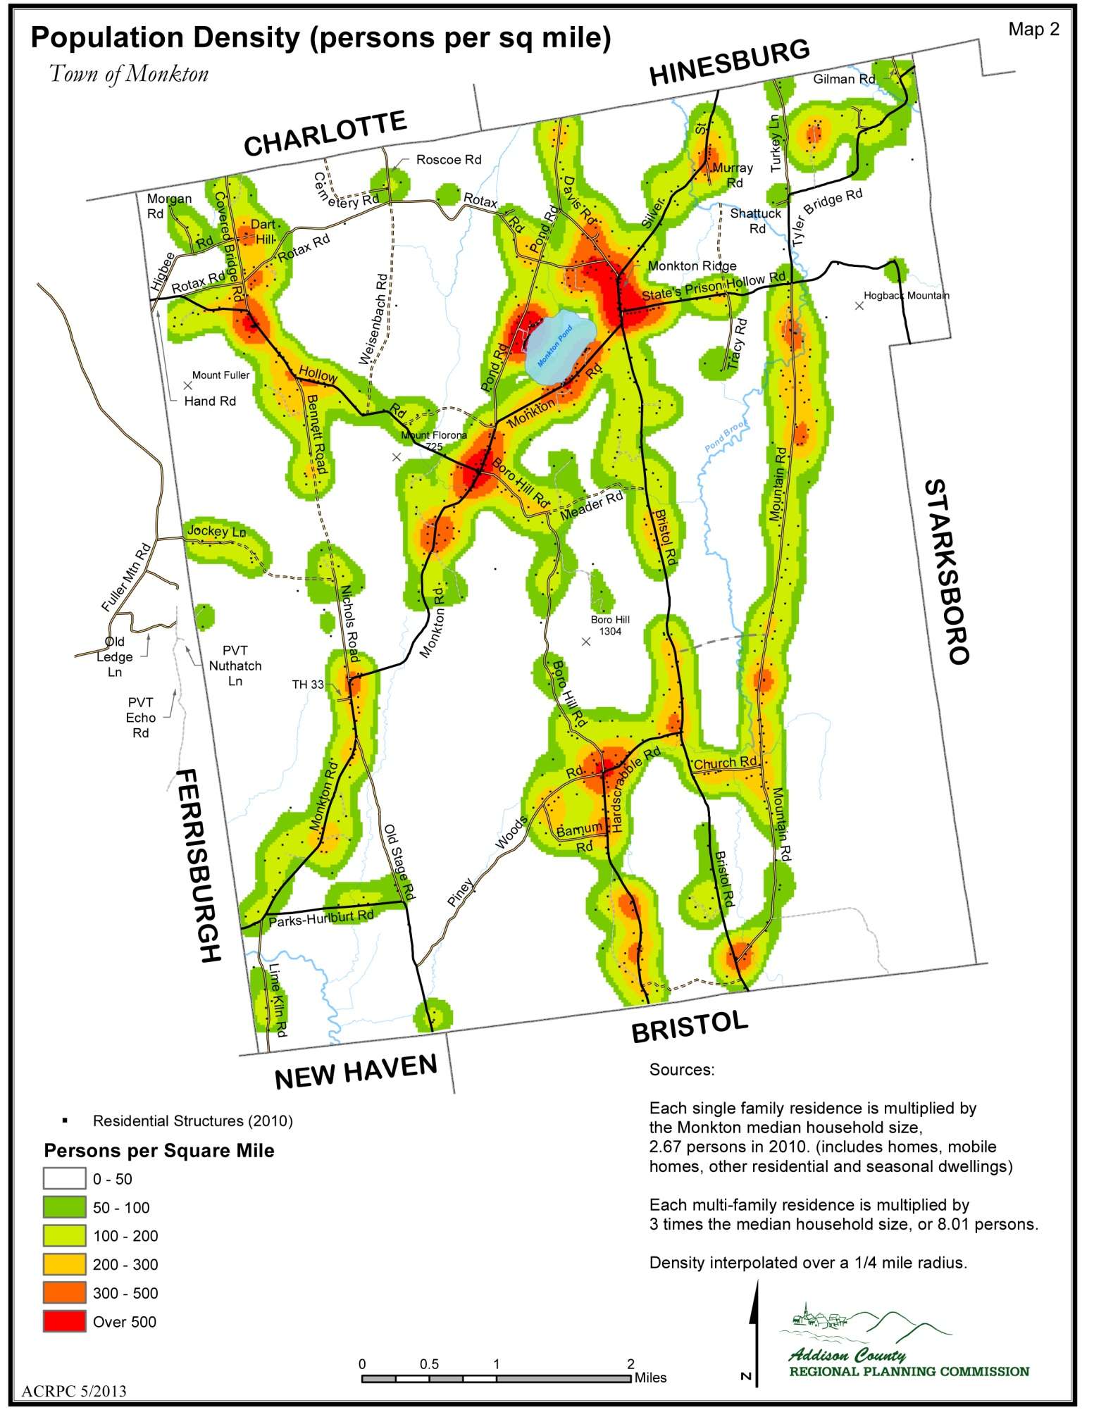

EDUCATION and CHILDCARE
GOALS AND RECOMMENDED ACTIONS

Our education plan will:
- Support high quality education within the town of Monkton for all elementary aged
children residing here.
- Support Monkton Central School as a vital community service and community center.
- Provide access to educational services and opportunities for all Monkton residents.
- Support safe, affordable, high quality childcare in Monkton for Monkton residents.

We will do this by:
- Participate in long-term planning for the Monkton Central School.
- Encourage summer use of existing educational facilities
- Provide information on on-going regional educational opportunities at the Town Office and Library.
- Support long-range plans to improve our village center that provides services such as a new library facility and public transportation routes to surrounding towns.
- Permit childcare facilities as a home occupation in residential zones.
- Inventory existing home-daycare operations in Monkton.

DISCUSSION

HISTORY of MONKTON SCHOOLS
Public primary schools have been an integral part of Monkton from the earliest settlement days. Originally, two school districts were formed, each with a one-room school encompassing all grades. Later the number of districts and schools were expanded to ten. As the population decreased from a high point in the mid 1830's, the number of schools shrunk to four. These four schools were located on the Ridge, in the Boro, in Barnumtown and in East Monkton through the 1950’s.

Education evolved in a manner similar to the rest of the state. As the population increased, the need for larger facilities, and more teachers brought about an increase in expenses. The state began to assume a larger role in the education process, establishing numerous standards in a variety of areas such as the number of days of attendance, teacher certification, curriculum and facilities specifications. At the same time, the state began sharing with the towns the cost of education. An education structure gradually evolved, which now includes a State Department of Education, State Education Commissioner, and regional school districts that encompass the local schools found in each town.

MONKTON CENTRAL SCHOOL
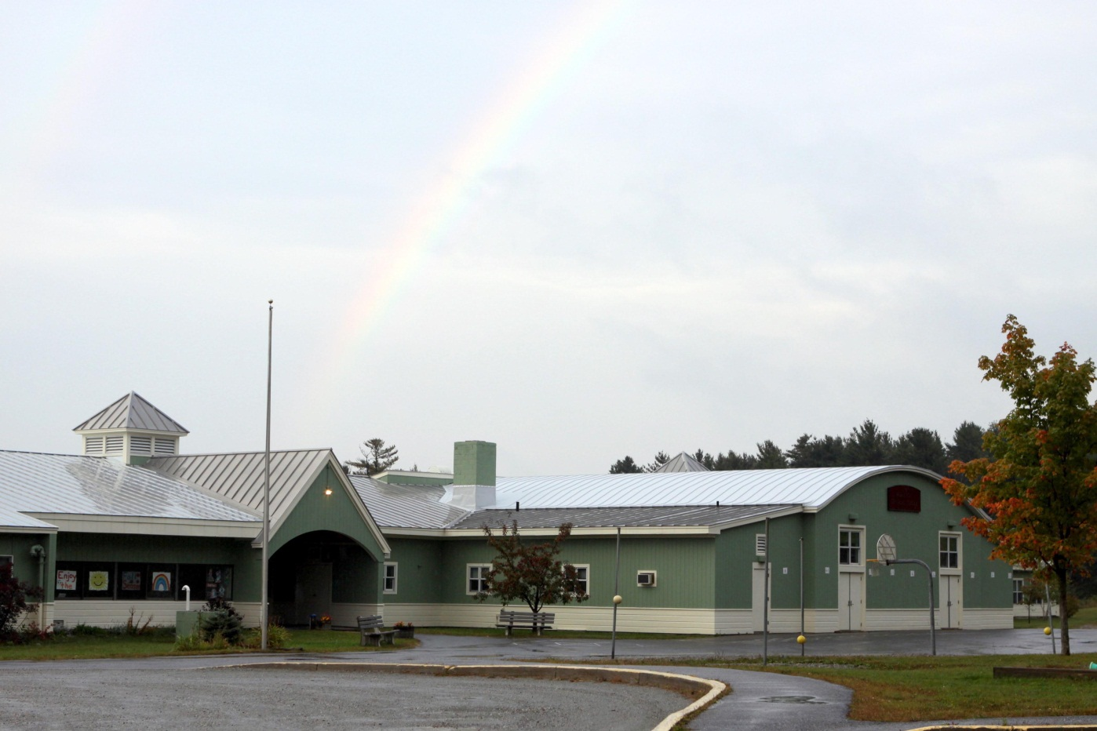
Monkton Central School was built in 1960 and currently serves approximately 175 students. Monkton Central School provides a public education for grades kindergarten through the sixth grade. In the fall of 2012, the staff and faculty consisted of a principal, a secretary, 34 teachers, and support staff including regular program assistants, special education assistants, custodians and food service personnel. The capacity of the school is 225 students. The school board for the elementary school consists of a chairperson and four directors. Members are elected by Australian ballot on Town Meeting Day, whose terms of service vary from one to three years.
Monkton Central School

The school, located between Monkton Ridge and Monkton Boro, was expanded in 1986. In 1997 there were major renovations to expand the number of classrooms from 10 to 12. It is a one-story concrete block construction encompassing approximate 15,000 square feet. There is currently a trailer used as storage, which in the past, was used as a temporary classroom. The gymnasium continues to double as a cafeteria and classroom. It includes a kitchen and administrative office; and serves as a public meeting space for public meetings and other town events. In the most recent renovations, the heating system was upgraded to two oil-fired furnaces, which provide forced hot air heating. Water for the school is pumped from a drilled well. A mound septic system adjacent to the school building handles sewage.

In 1993, the State of Vermont granted the school a variance to permit the installation of a new septic system. In granting this variance, the state set a cap of 200 students and staff in the school. This upper limit has been exceeded, with a student population of 216 at the end of the 1994/95 school year. The town and the state have implemented a plan that will allow for continued use of the present school as well as the proposed school expansion by allowing an off-site septic system. In 1997 the off-site septic system was completed on the Morse Park property. With this new septic addition, the school has adequate sewage disposal.

Monkton Central School provides local bus transportation. Four buses are used to transport all students to the elementary school, two of them are used to transport the middle and high school students to Mount Abraham Union High School in Bristol. Though this practice economically utilizes four buses to transport students to two locations 13 miles apart, it results in long school days.

ADDISON NORTHEAST SUPERVISORY UNION
Monkton Central School is part of the Addison Northeast Supervisory Union (ANeSU). The supervisory union headquarters located in Bristol represents five towns; Bristol, Lincoln, Monkton, New Haven and Starksboro, each with its own elementary school (kindergarten to 6th grade). Mount Abraham Union High School (MAUHS) in Bristol provides middle school (grades 7 -8) and high school (grades 9-12) for the five district towns.

Within the supervisory union, each individual town elects a school board for its elementary school and adopts a budget funded by local property taxes and state aid. For the union high school district, each town has representation on the middle and high school board of directors. Towns are assessed operating and capital expenditure costs based on the number of students from each town.

OTHER EDUCATIONAL SERVICES
Technical and vocational educational opportunities are available to Monkton students at the Patricia Hannaford Career Center in Middlebury. Adult educational classes are available at Community College of Vermont (CCV), also in Middlebury. Adults may also choose to take online courses if access to a computer and the internet is an option. The Willowell Foundation, based in Monkton, is an educational nonprofit center offering environmental, agricultural and art-related programs for both children and adults.

TOWN GROWTH and SCHOOL ENROLLMENT
This plan expects development and population growth at rates and in locations that fall within the capacity limits of Town services, with particular interest in education. A considerable amount of town taxes are committed to education and as such, attention needs to be given to how land use decisions, regulations and population trends impact school enrollment, and in turn effect costs and benefits to Monkton residents. Compared to many schools in Addison County, Monkton Central schools enrollments remains steady and the school likely attracts young families to the area.

This plan recognizes the importance of the Central School and the adjacent Morse Park, as a vibrant civic center for our Town. Not only does it provide a hub of activity for many families in Monkton, it is physically situated in the center of Monkton. Any new pedestrian and cycling infrastructure should incorporate the needs of those travelling to and from the school on a daily basis, including safe walking routes for school children.

CHILDCARE & EARLY EDUCATION SERVICES
The Town of Monkton recognizes the need for more affordable and locally available childcare services. These services may range from informal unregistered or unlicensed day care facilities serving 6 or less children to state registered/licensed daycare facilities serving 6 or more children, as well as early education preschools with a more formalized curriculum. The Town encourages all childcare providers to receive State certification.

Currently Monkton residents are served by home day care operations and licensed daycare centers in surrounding towns. Larger licensed daycare and preschool centers exist in Middlebury and Hinesburg. The ANeSU offers an Early Essential Education (EEE) program through the union school district and based at the district offices in Bristol. Monkton Central School offers an afterschool program for K-6th grade.

The Mary Johnson Children’s Center in Middlebury administers a child care referral program for Addison County; Addison County Childcare Services: 388-4304 or e-mail referral@mjccvt.org.

UTILITIES and FACILITIES
Goals and Recommended Actions
Changes, upgrades or repurposing of any existing utility infrastructure should be considered with the informed consent of the town. Entities proposing such projects should hold at their expense, hold at least one warned public meeting culminating in a Town vote.

Monkton will:
- Provide the needed services to create a safe, healthy community in which to live, work and play.
- Provide updated efficient technologies, telecommunications services, and infrastructure without undue environmental and/or economic impact to our residents.
- Protect our environmental and cultural assets when planning for the future.

We will achieve this by:

- Holding hearings on proposed utility projects in order to catalog the concerns and sentiments of the neighboring landowners and other residents towards the construction of such projects.

- Participating to the fullest extent possible in hearings before the Vermont Public Service Board on projects located in Monkton or neighboring towns.

- Consulting with experts to understand the environmental, safety, aesthetic, and economic effects of such projects.

- Encouraging conservation and renewable energy sources with localized distribution as an alternative to wide scale transmission and distribution projects.

- Working with town and regional agencies and boards to ensure public access to public lands.

- Supporting the work of the Monkton Recreation Committee.

- Surveying the needs of telecommuters and other business owners in Monkton.

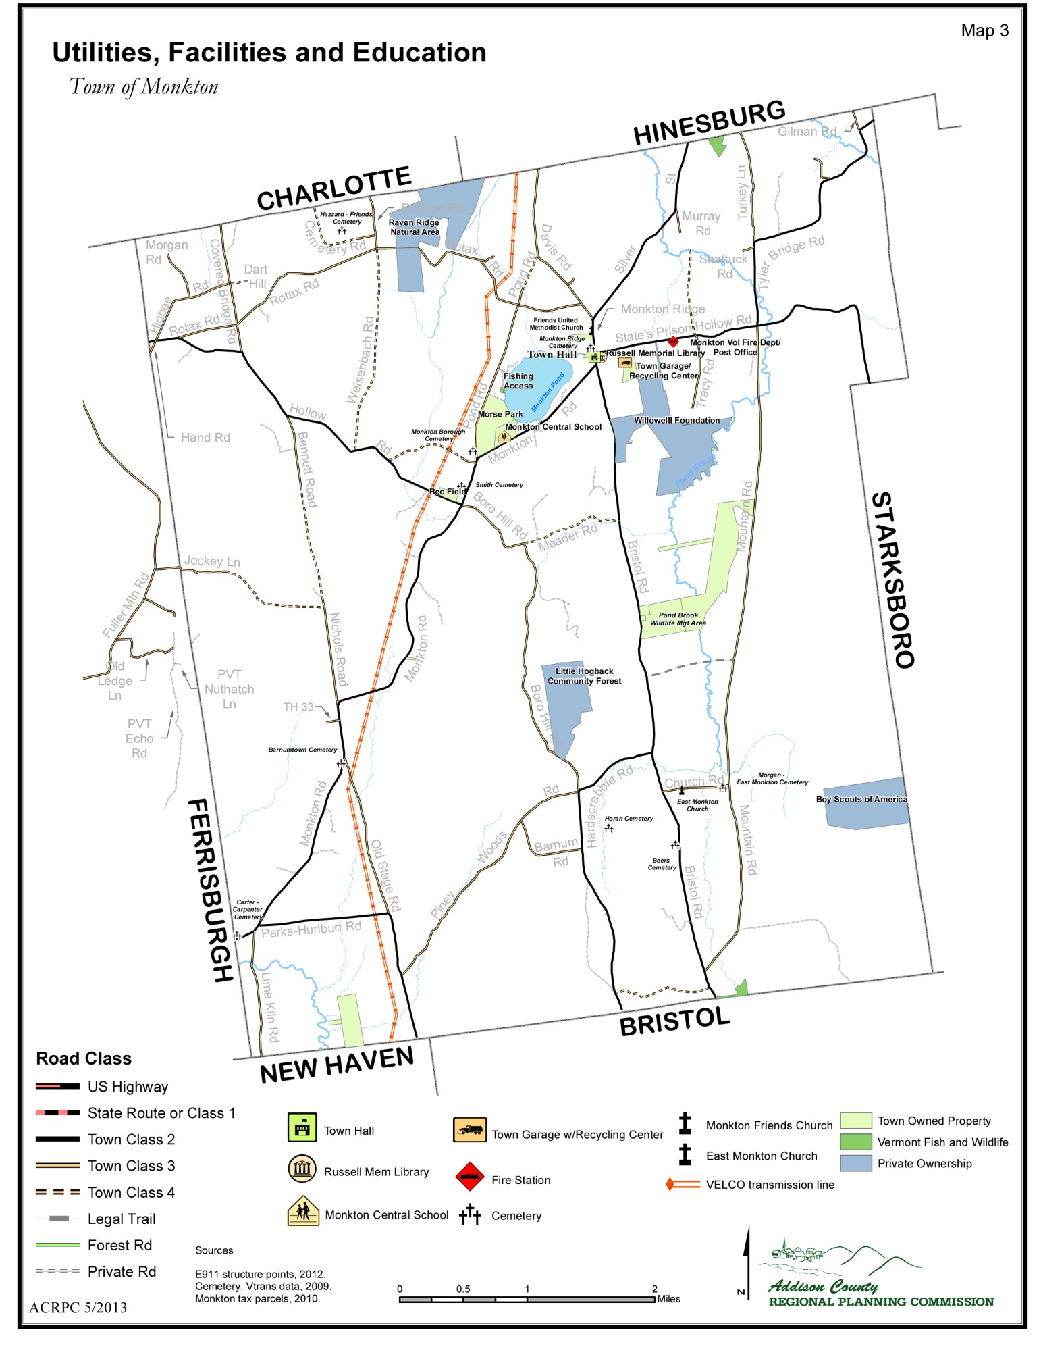
DISCUSSION

The following utilities presently serve the Town of Monkton:

Electric Green Mountain Power
Telephone Champlain Valley Telecom, Verizon
Cable TV Comcast
Satellite Direct TV/Dish
Cellular Telephone Local service available through regional providers.
Internet Access Local access available through regional providers, including DSL and cable.
The Town recognizes that the Vermont Public Service Board is the regulatory body for utility projects in the state. Therefore to protect our environment and economic interest the Town requests that the Public Service Board require the developer of any proposed utility project to provide the following analysis conducted by licensed or certified professionals:

- A wildlife habitat assessment, including assessment of impact to bears and to migratory, resident and breeding avian and bat populations;
- A rare species assessment; and mitigation plans (if necessary);
- A visual impact assessment, including pre- and post-construction photo simulations of the project as seen during the day and at night.
- Alternative sites analysis.
- Identify and protect any potentially impacted ground water recharge areas.
- Adequate financial surety, either in cash or letter of credit, to repair damage to local roads
  - or to stabilize the entire construction site during construction of the Project. The financial surety should be available to the municipality in the event that the municipality is forced to conduct work to secure the stability of the soil and vegetation on the site, including the access road, after construction is completed.
- Sufficient decommissioning funds, kept in an escrow account associated with the property that is separate from the developer’s general accounts, so that the site will be restored to natural conditions if the project is not repowered at the end of its useful life.
- A contingency plan that outlines mitigation action, in the event of unforeseen and unacceptable negative impacts from the completed project.
- Financial assistance to the town to pay for the hiring of qualified engineering,
environmental, and legal consultants to assist the Town in reviewing the application and establishing local revenue agreements.

ELECTRICITY
At the present time the distribution of electric power in Monkton is provided by Green Mountain Power Corporation. In addition to local distribution lines, a transmission line owned and maintained by VELCO currently runs from along the western edge of the town. A natural gas pipeline has been proposed to run primarily in the VELCO right of way.

The Town of Monkton believes that the existing distribution and transmission facilities serving Monkton are adequate to meet the current utility requirements. As the Region’s electrical needs grow we believe that small localized power sources which encourage alternative fuel sources and are located to meet the need are preferable to wide scale transmission and distribution projects.

This plan encourages local and renewable projects such as solar farms, group net metering, the use of geothermal heating, and viable small scale hydro. See the energy section for more information.

TELECOMMUNICATIONS
At the time of this writing, The Town of Monkton has one permitted telecommunication tower location site on Boro Hill. The permit for the existing facility currently restricts the erection of additional towers. This may be amended in the future. Additional sites should be considered as a Conditional Use only after professional consultants, approved by the DRB and hired by the applicant (at the applicant’s expense), confirm the need and benefits of the proposed location. Alternative technologies should be considered. Up to date telecommunication infrastructure is essential in supporting the economy of the town.

IMPACTS of UTILITY INFRASTRUCTURE
In order to protect the rural –residential atmosphere of the town, any new distribution or transmission facilities or upgrades to the facilities currently in place within the town shall be done in such a way as to not adversely affect the rural nature of the community. Any such project shall be necessary for the delivery of an adequate and consistent supply of electrical power and of direct benefit to Vermonters.

The use of the VELCO right of way, the potential location of a natural gas pipeline, and the permitting of renewable energy projects in Monkton are governed by the Vermont Public Service Board through the application process for a Certificate of Public Good pursuant to Section 248 of Title 30 of the Vermont Statutes.

The impact of large scale utility projects on the core values expressed in this plan are tremendous.
The impact on our wetlands and conserved areas must be acknowledged . The ability of our fire department and emergency management infrastructure to be able to deal with potential problems must be supported. Any off-site mitigation, must have a component to reimburse those directly impacted by the area compromised.

Rural towns have a disproportionate financial burden to present the expert testimony and legal briefs required in the process. Our critical resources of our agriculture, forestry and rural homes are heavily affected by the ever increasing use of the VELCO right of way.
Hopefully, the Legislature will adjust the Section 248 process to enable towns to participate in a more effective and economically feasible manner. Vermont needs to give Monkton a better way to present the concerns of Monkton residents and the problems created by these utilitiy projects in the permitting process and provide solutions.

Regarding the recent proposal of Vermont Gas’ Addison County pipeline and any other type of utility scale transmission or generation proposed to impact Monkton, this plan supports energy infrastructure and services which do not cause undue adverse impact to the health and safety of our residents or on the environmental and scenic qualities of our natural resources, and supports the associated goals within this plan Monkton adopts the following implementation measures for entities proposing transmission or generation infrastructure, each of which should be considered during a public service board review process:

a. Proposed infrastructure shall be designed to provide substantive economic benefits to the town and its citizens. As requested by the Town, designs shall provide service in the Village Planning Area while implementing and reinforcing the Town’s planning goals for this planning area.

b. Proposed infrastructure shall fully utilize existing infrastructure and utility right-of-ways to meet the Region’s energy needs before additional infrastructure is built or new rights of ways are required. This shall include collocating energy transmission and distribution lines, including pipelines, telephone and cable lines, in the same corridors on the same infrastructure, and to coordinate the delivery of their services to reduce the health, safety, environmental and economic impacts of the services they provide. Providers shall exhaust all feasible areas where landowners will voluntarily negotiate rights of way prior to pursuing eminent domain against any individual landowner. All transmission corridors shall be located outside of populated areas and away from residences, businesses and public buildings and spaces to provide margins for safety, noise and other impacts.

c. To require providers to conduct thorough and proper siting analyses that address sensitive wildlife habitat, soil conditions and impacts on agricultural, forest and water resources, in accordance with the goals of the associated sections of this plan.

d. To provide an analysis of viable alternatives to the proposed project to the town which calculates costs whether capital, environmental or health when evaluating both locally generated and imported energy sources.

e. To provide necessary training, support and equipment for our emergency personnel to respond successfully to any emergency situation involving the infrastructure proposed.

f. To communicate transparently and clearly with affected landowners, Town officials and ACRPC to develop appropriate health, safety and environmental mitigation plans prior to filing their Section 248 applications and to continue communicating throughout the permitting and, if applicable, construction process.

g. To work toward the phasing out of fossil fuels and encouraging renewable energy resources such as solar, wind and locally generated methane.

h. To bury transmission and distribution lines and other service lines and/ or site the line to reduce aesthetic, historic and natural resource impacts of the lines. New corridors shall be designed to minimize the aesthetic impact on all properties adjacent to the line and preserve the property values of the citizens of Monkton.

In addition to these implementation measures, the Town of Monkton holds entities proposing transmission and/or generation infrastructure responsible for supporting and helping to implement, where applicable, the goals of our natural and scenic resources plan, our land‐use plan, and our energy plan.

Understanding the importance of tourism and the unique character of the town, the surrounding Addison County Region and the State of Vermont, all necessary efforts shall be taken to limit the visual impact of both distribution and transmission facilities. Efforts shall be made to promote and preserve panoramic views within the Town. For this reason any changes to the existing distribution configuration must include mitigation when deemed necessary by the Town. Such mitigation may include, but is not limited to, modification of design and additional landscaping.

Also of concern to the Town are the possible health concerns of electromagnetic fields as well as the use of herbicides or other environmental hazards. It shall be incumbent upon the utility provider to demonstrate the absence of any health issues. Any effects must be minimized or eliminated entirely, keeping in mind the effects upon property values of abutting property owners. When necessary, affected landowners should receive compensation for these affects or any related loss of property values. New zoning regulations should call for the underground installation of new or upgraded or enhanced facilities.

SOLID WASTE MANAGEMENT
Monkton is a member of Addison County Solid Waste Management District. The Town provides a recycling facility at the Town Garage twice a month for mandatory household recycling. The District collects hazardous wastes generated by households at the Middlebury Transfer Station. These wastes include items such as paints, cleansers, poisons, contaminated fuel, and antifreeze. Residents can also take advantage of commercial curbside pickup. All businesses in town generating hazardous wastes make individual arrangements for their disposal.

TOWN OWNED PROPERTIES and EQUIPMENT

The Town owns the following facilities:

- Town Hall
- Town Garage
- Monkton Fire Station
- Monkton Elementary School
- Monkton Recreation Field
- Morse Park

The Town Highway Department owns the following municipal equipment:

1994 John Deere 410D Backhoe
1990 John Deere544E Bucket Loader
1995 Case 5240A Tractor
2003 Int’l Tandem Dump Truck
2005 John Deere 772D Road Grader
2005 Diamond Roadside Mower
2007 Ford F550 Dump Truck
2009 MackGU713 Dump Truck
2013 MackGU713 Dump Truck

TOWN ADMINISTRATION
The Town Clerk, Assistant Town Clerk, Treasurer and Assistant Treasurer provide Town administrative services. A five member Select Board elected by Australian ballot governs the Town. The Planning Commission is also elected by Australian ballot as is the school treasurer, the delinquent tax collector, town and school moderators, the constable, listers, auditors, justices of the peace, and school board members. The Town is also served by numerous volunteer committees.

TOWN HALL
In 1859, the residents of Monkton Ridge donated funds and labor to build a New Greek Revival style Town Hall, after the original town hall in Monkton Boro had fallen into disrepair. Over the years a cupola and an interior stage were removed. In 1977 $15,000 was voted to refurbish the building. Construction of a new town hall was considered, but at a cost of around $48,000 it was deemed too expensive. In 1978 the Monkton Town Hall was listed in the National Register of Historic Places. In the 1980’s a vault to properly house the town records was constructed.

As Monkton enters the second decade of the 21st century a building constructed over 150 years ago is only marginally adequate to house town services for a population which has almost doubled in the past thirty years. Space for town officials is extremely cramped and lacks any sort of privacy; room for town boards to meet is also limited. Although the current Town Hall is a wonderful example of classic New England architecture and has served the town well for a century and a half, the citizens of Monkton should well consider the need for a more modern and efficient facility in the years to come.

The town has plans to build a new Town Hall facility on a Town-owned property just north of its current location, with plans to house a new library space.

RUSSELL LIBRARY
The Russell Library, named in honor of Albert P. Russell, (one of the first and most significant benefactors of the library) is located on Monkton Ridge directly across from the Town Hall. The library is open on Tuesday from 3:00 P.M. to 8:00 P.M., Thursday from 3pm-7pm, and on Fridays from 9:00 A.M to 1:00 P.M. and Saturday from 9:00 A.M. to 2:00 P.M.

The Library’s staff is comprised of two librarians and the assistance of volunteers. The primary function of the library is to serve children and adult popular reading. The facility, which contains approximately 3,000 volumes and periodicals also offers a collection of books on tape and CD. The Library also offers a number of children’s programs including story hours And internet access.

There are a small number of reference documents including town reports from over a hundred years ago and the Russell collection of old Vermont history books. The Russell Library participates in the Vermont Interlibrary Loan Program and is open to all county residents without charge.

The building and land for the library were provided by a trust established by Dr. George Russell, in honor of his father, Albert Russell. A board of trustees, elected by the town, oversees the operations of the library.

POST OFFICE
Monkton’s post office is currently housed in the volunteer firehouse. It does not provide rural route services. These are provided by Bristol, New Haven, Charlotte, Hinesburg and North Ferrisburgh USPS operations. Due to this, there is a diversity of postal codes used by Monkton residents, depending on which rural route their physical address has been designated within. Only those residents who have a post office box at the Monkton post office have a mailing address that includes ‘Monkton’ in the address. USPS is currently discussing the possible closure or limiting the hours of the Monkton Post Office due to USPS cost cutting measures
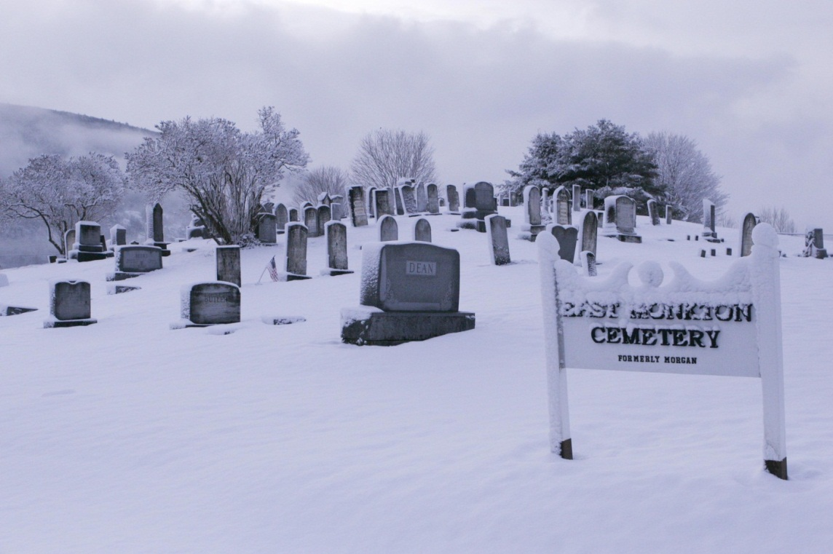
CEMETARIES
There are currently three in-use cemeteries in Monkton. Monkton Ridge Cemetery sits next to the Town Hall and dates back to 1804. The Monkton Borough Cemetery, on Pond Road dates back to 1816 and the Morgan Cemetery, on Church Street in East Monkton dates back to 1812. There is also the Hurlbert cemetery and the Carter cemetery.
East Monkton Cemetery
The cemeteries are maintained by the Town. According to historic records there are six other cemeteries in Monkton, the earliest of which dates to 1793.

HEALTH AND SAFETY

Monkton has a privately run volunteer fire department and is part of a mutual aid network providing and receiving auxiliary support as required by surrounding towns. The fire department is situated in a
town-owned building, but is a private operation. The building is also used for town meetings.

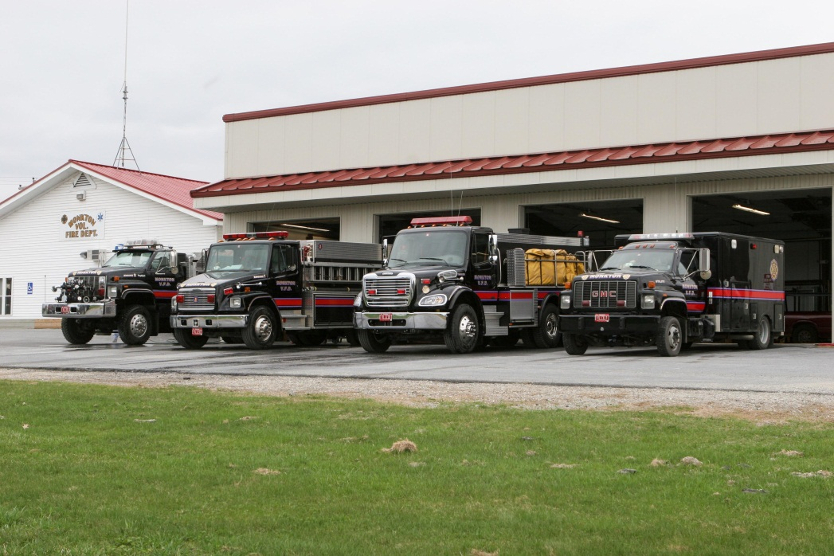
The Fire Department has one boat and six trucks, including a brush truck, equipment truck, two tankers, a mini-pumper and a mainline pumper. The Fire Department is supported by private donations and an allocation voted by the town at town meeting. Monkton First Response, Bristol Rescue and Vergennes Area Rescue Association provide emergency medical services.
Monkton Volunteer Fire Department Trucks

Regional health care service providers serve the Town of Monkton. Porter Medical Center in Middlebury and Fletcher Allen Health Care (FAHC) in Burlington serve as major medical providers.

The Town of Monkton has no police department. Law enforcement is provided by the Vermont State Police and contracted as needed through the Addison County Sheriff’s Department. In addition, a constable is elected. Increased population growth may necessitate the creation of a local law enforcement agency, leading to additional town capital expenditures

Presently no extended care facilities are located within the Town of Monkton. Various county and regional organizations provide in-house and community services. The Town recognizes the importance of these services and provides support through its annual budget. Future growth within the town, and particularly among older members of the community, will lead to the need for the promotion of such facilities within the town.

Among the many organizations providing additional community services identified in the town’s annual report are:
Addison County Community Action Group
Addison County Hospice
Addison County Home Health Care Agency
Community Health Services
Elderly Services
Have A Heart Food Shelf
Champlain Office of Economic Opportunity (CVOEO)
Women Safe

Additional regional services, such as Addison County Community Action Group, Social Services, and Courthouses etc. are located in Middlebury.

PUBLIC TRANSPORTATION
Addison County Transit Resources (ACTR) provides public transportation services in Addison County . ACTR is a 501(c)(3) organization eligible to receive federal public transit funds via the Rail, Air and Public Transit (RAPT) section of the Vermont Agency of Transportation. Funds must be matched by a 20% local contribution. There are currently no direct, daily routes to Monkton, however ACTR provides many Monkton residents transportation under their special service programs such as: Ride Match, Reach-Up, Champlain Valley Agency on Aging, Medicaid and Ride Share programs as well as providing transportation for special needs at area schools. ACTR has a lift-equipped van to serve specialized transportation needs. ACTR and Chittenden County Transportation Authority (CCTA) provide connections from Bristol to Middlebury and Vergennes and Hinesburg to Burlington. More information on public transportation can be found in the transportation section of the plan.

RECREATION
The town of Monkton has two public park areas, and a number of popular walking, cycling and hiking loops. Privately owned open land, suitable for Nordic skiing, equestrian and camping facilities are also abundant. The ‘Recreation Field’, on Hollow Road is 6.2 acres and contains multi-use facilities including parking, a playground, athletic fields, open areas and a covered pavilion.
Morse Park is located between Monkton Ridge and Monkton Boro and borders both Monkton and Pond Roads. It is adjacent to the Monkton Central School and the State of Vermont Fish and Game Access Area on Monkton Pond. This parcel was acquired by the Town in 1996, and consists of 37.1 acres of open fields, wetlands and woods. The park contains several playing fields, a parking area and a walking trail that is over a mile long. The recreation committee has more plans in the future for this site and is committed to making sure the area is available for the people of Monkton to enjoy. The State of Vermont maintains an access area on Monkton Pond. The area is comprised of 1.8 acres and is located on Access Road and has facilities for boat and canoe access to the pond. Raven Ridge, a privately owned conservation property is also a popular place for hiking.

Special consideration should be given to wildlife habitat areas and areas of significant bio-diversity. Fishing and hunting in these areas should be managed for the continual protection of these lands and for the recreational value that these open spaces provide to the community. The identification of such places is critical to their protection. Please see the Natural Resource section for more information

The Monkton Central School has outdoor and indoor recreation facilities used by the community. Playgrounds, playing fields, as well as a multipurpose room are available. There is also an archery range at the school.

Monkton has an active recreation committee which plans recreational activities and maintains current recreational facilities. The committee and this plan support the up-keep and creation of new outdoor recreational facilities, such as multi-use trails, hiking and biking paths when opportunities arise, including the use of class 4 roads no longer used for motor vehicles. The neighboring towns of Bristol and Hinesburg have active recreation committees and programs open to Monkton residents.

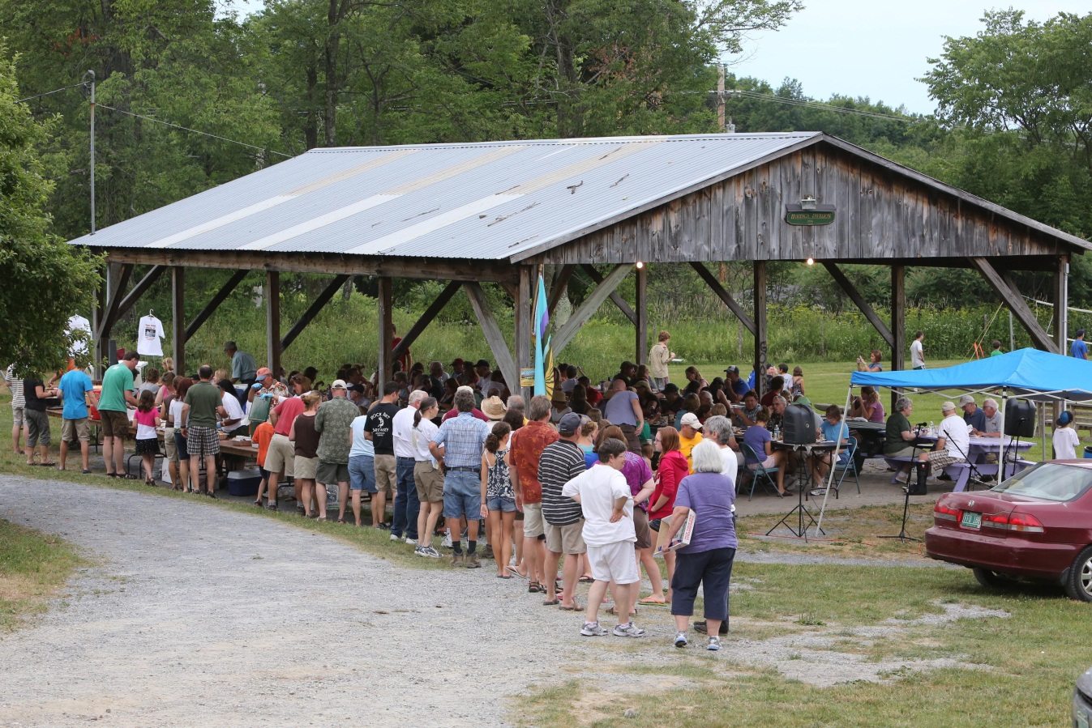
Monkton Recreational Facilities
CULTURAL RESOURCES
Early cultural activities revolved around the various church groups in Monkton. Earliest were the Baptists and Congregationalists, followed shortly by the Methodists and later by the Friends Society, all organized in the late 1790's or shortly after 1800. Over the years, these groups built and sold to one another various church buildings in Monkton Boro and Monkton Ridge. The church built in 1879 by The Society of Friends on Monkton Ridge is still currently in use by the Methodists. It replaces a meetinghouse built by the Quakers in 1798. In 1866, the Methodists built the church still standing in East Monkton. At that time it was part of a thriving settlement of many homes and shops that are now gone.

In addition to these Church organizations, Monkton was host to Modern Woodsman of America whose chapter was founded around 1900 but was inactive by 1960. The Florona Grange, founded in the late 1800’s, was an active part of Monkton’s community fabric and was located in the Baptist Church in Monkton Boro. The grange building has been sold into private ownership. This federal style church was built in 1811 and modified with changes to its steeple in 1854. It shares with the 1806 Congregational Church in Middlebury the distinction of being the two oldest churches in Addison County to retain their nearly original appearances.

The following information on the Monkton Town Hall is from the 1961 History of Monkton by Leon V. Bushey, Jessie Thomas, and Howard M. French:

“The first Town Hall was built at the ‘Boro’ … at a date undetermined. … From what we can learn the old town hall became too small, and repairs were being considered, some of the Monkton Ridge folks, stood up in meeting and said that if the people of Monkton would stand for the new town hall to be built at Monkton Ridge, they would see that it did not cost the town itself ‘A red penny’, and with that understanding it was voted to let them go ahead with the erection of a new building. This was done, and records show that the Selectmen namely, John French, Andrew Holmes and George Lamos, purchased of James Spencer and Guy Fuller the land for this building in August 17, 1859. The work was mostly donated and the material also, except what was paid for by the people living on or about the Ridge. Building was erected the same year as far as can be learned.”

In 1977, Monkton voters approved spending $15,000 to refurbish the Town Hall. Construction of a new Town Hall was considered but, at a building cost of $23,000 to $48,000, it was deemed to be too expensive. The 1977 renovations included removal of the stage. Earlier, the cupola had been removed and later a concrete vault was added to the building.

On January 3, 1978, the Monkton Town Hall was listed in the National Register of Historic Places by the National Park Service of the U.S. Department of the Interior (Record Number 373933, Item Number 78000225).

MONKTON MUSEUM and HISTORIC SOCIETY
The Monkton Museum and Historical Society (MM&HS) was first incorporated in 1976, the year of the nation’s bicentennial. In 1994, the Society became inactive. MM&HS was reorganized in 2004. The Society is a non-profit, tax-exempt organization incorporated under the laws of the State of Vermont. The purpose of the Society is to collect and preserve historical Monkton artifacts, to serve as a resource of reliable information for those interested in Monkton’s history, and to organize educational opportunities for the community at large and area students of all ages. The Society is working to create an inventory and database of historical artifacts in its possession as well as a directory and database on Monkton cemeteries and individual gravestone information to facilitate genealogical research. Monthly meetings provide an opportunity to discuss topics related to Monkton history and to host guest presentations on various historical topics. A long-term goal of the Society is the preservation and restoration of the Monkton Boro schoolhouse.

The efforts of these early residents have left a heritage that today accounts for several beautiful and architecturally significant structures. A publication of the Vermont Division for Historic Preservation, The Historic Architecture of Addison County devotes a section to Monkton’s early architecture. A pamphlet containing Monkton’s section is available for purchase at the Town Hall.

Cultural resources refer to the dedication and involvement of the community members within that community. Public buildings and lands provide avenues of community development. The town should encourage the evolution of our cultural resources in the process of creating a more involved and effective community. Knowledge regarding historic and educational resources is imperative to this objective. The Region has defined several regional and supra-regional cultural resources, such as the Addison County Field Days, dairy co-ops, local newspapers and radio stations, and offices of public works. Through the increased and continued support of these institutions, the town can aid in the creation of a stronger community.

ENERGY
GOALS AND RECOMMENDED ACTIONS
Our energy plan will:

- Support alternative energy projects which do not impact our identified scenic and natural resources, such as our ridgelines and our water resources.
- Increase Municipal energy efficiency and conservation.
- Reduce energy use by town residents.
- Support the development of alternative energy sources
- Increase energy conservation in new development projects

We will do this by:
- Encouraging walking and cycling within town by directing growth toward compact development within village areas with appropriate sidewalks and paths linking amenities and services.
- Seeking funds to create park and ride areas to promote car and van pooling.
- Promoting the use of energy efficient lighting appliances and practices, replacing incandescent lights with compact fluorescent bulbs or LED lighting.
- Promoting building practices that use energy efficient materials and heating systems, solar orientation, and other alternative or renewable energy systems.
- Encouraging programs such as Efficiency Vermont to analyze residential, commercial and municipal buildings.
- Encouraging the use of the Property Accessed Clean Energy [PACE] program which provides twenty year loans, tied to the property, for residential energy upgrades
- Reviewing zoning bylaws to insure the inclusion of which supports the installations of renewable energy technologies in existing and new homes
- Creating incentives that promote energy efficiency in new and existing buildings.
- Encouraging the use of solar, wind, biomass, hydro and ground-source power while carefully weighing the benefits of such installations against their impacts on water, wildlife, scenic, forest, and historic resources.
- Encouraging net metering; the sale of electricity back into the grid.
- Eliminating property tax increases on renewable energy installations. [Under Vermont law a town can vote to exclude certain renewable energy systems from local property tax].
- Researching funding sources and supportive programs that would enable the town to retrofit/install renewable energy systems for town buildings and the school.
- Developing a municipal energy plan and encouraging energy conservation town wide.
- Working with the town energy coordinator and energy committee to determine a work plan and a priority task list.
- Supporting the development of local and sustainable food systems within town.
- Promoting composting as a way to divert organic waste from the waste stream.
- Exploring the creation of a wood-bank as a source of heating fuel for those in need.

DISCUSSION
This plan supports energy conservation and the development, installation, and utilization of natural and low polluting resources such as small-scale wind turbine systems, solar, bio-mass, and ground - source heat for residential homes, small businesses, and municipal buildings. These alternative energy resources should be promoted in the town’s future by all possible means, while aligning with the goals of protecting and cultivating our natural and scenic resources, such as the protection of our scenic ridgelines.

As a community and society we should look to curb our dependency on fossil fuels. Where and how we build our homes, services and civic buildings and how we interact with the surrounding region, has a dramatic impact on this dependency. As a car-dependent town, Monkton must look for ways to decrease our fossil fuel consumption and alternatives to single occupancy commuting.

CURRENT ENERGY USE
The majority of Monkton residents heat their homes with oil. As seen in the table below, propane and wood are also used by many residents. While only one or two residences depend solely on solar technologies, 14 residents have incorporated some solar technology into their home heating system. A map from the Vermont Energy Atlas, seen on the following page, shows homes in Monkton which either have photovoltaic or thermal roof systems.

ALTERNATIVE ENERGY AND ENERGY CONSERVATION
Renewable energy technology that utilizes natural resources, such as solar, wind, ground-heat and hydro, has advanced in recent years. The efficiency and cost effectiveness of using these technologies has made it possible for more residents and communities to use them. Town facilities and our school should be models of energy conservation and utilize the latest technology to take advantage of our local, natural assets.

Types of Fuels Used in Monkton Residences by 2010
Propane | 198
Electricity | 3
Oil/kerosene | 402
Wood | 131
Solar energy | 14
Other fuel | 5

Source: 2010 U.S. Census
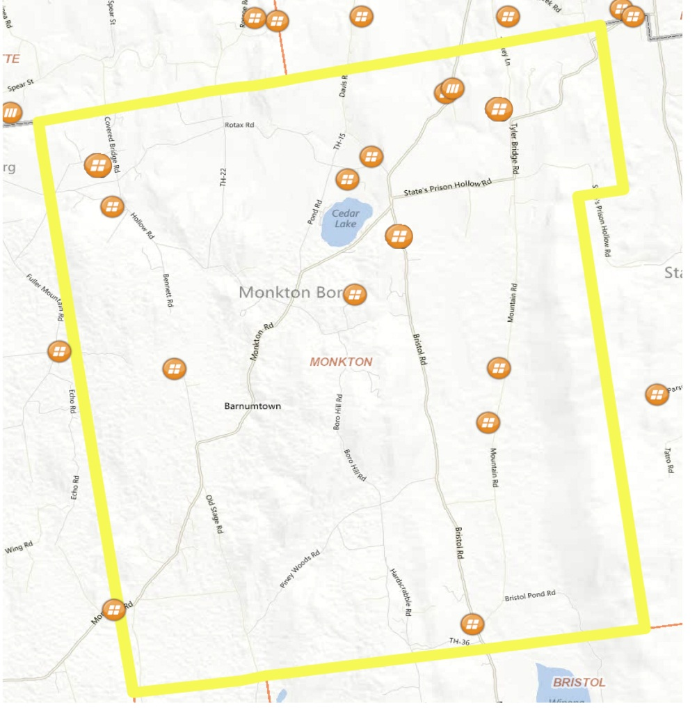

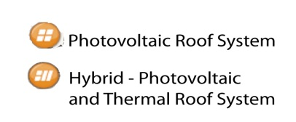
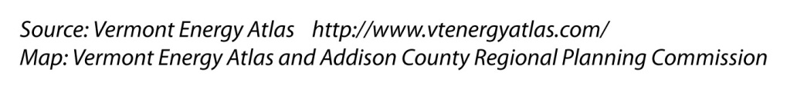

ALTERNATIVE AND RENEWABLE RESOURCES
Conserving energy by using alternative methods can play an important role in the local economy while protecting the environment. Energy used in the home represents a significant percentage of total statewide energy consumption. In addition’ improved energy efficiency would make homes more affordable and marketable. State energy officials estimate that simple conservation measures incorporated in new housing construction can result in a 20 to 30 percent reduction in energy used for
space and water heating.

This plan encourages building practices that use energy efficient materials, heating systems, lighting and appliances. Where possible, buildings should be sited so as to take advantage of southeast, south, or southwest orientations for passive solar gain. This plan also encourages the siting of newly constructed buildings in a way that does not impede solar energy collection by adjacent buildings, except where topographically unreasonable.

The people of Monkton should be asked to vote to exempt from property taxes installations whose sole purpose is the utilization of renewable energy resources. Several private projects harnessing solar, ground source energy, hydro, and/or wind energy have been established in recent years, as can be seen on the map on the previous page.
COMMERCIAL WIND ENERGY SYSTEMS
Commercial wind energy systems (wind farms) are defined as those that are regulated under Section 248 of Title 30 of the Vermont Statutes but not including net metering applications (as per 30 V.S.A. §219a) or temporary meteorological towers. These are generally large-scale projects with multiple turbines designed to generate electricity. It is the policy of the Town of Monkton that commercial wind energy systems are prohibited throughout all of town.
Commercial wind should be neither a permitted or conditional use in the Zoning Bylaw, therefore it is prohibited. In addition, Monkton’s high elevation lands - those most desirable for commercial wind energy development - contain many important natural resources and water recharge areas and are among the most sensitive sites from a development perspective. For the most part these high elevation lands are located in the areas designated as Ridgelines and the Conservation Prohibited District where development is limited to agriculture; commercial forestry; forestry for research and education.
While Monkton rejects commercial wind energy systems, the Town recognizes the fact that they may still be allowed by the Vermont Public Service Board. Should this occur, the Town requests that the Public Service Board require the developer to provide the following analysis conducted by licensed or certified professionals :

1. A wildlife habitat assessment, including assessment of impact to bears and to migratory, resident and breeding avian and bat populations;

2. A rare species assessment; and mitigation plans (if necessary);

3. A visual impact assessment, including pre- and post-construction photo simulations of the project as seen during the day and at night.

4. Alternative sites analysis.

5. Identify and protect any potentially impacted ground water recharge areas.

6. Adequate financial surety, either in cash or letter of credit, to repair damage to local roads

a. or to stabilize the entire construction site during construction of the Project. The financial surety should be available to the municipality in the event that the municipality is forced to conduct work to secure the stability of the soil and vegetation on the site, including the access road, after construction is completed.

7. Sufficient decommissioning funds, kept in an escrow account associated with the property that is separate from the developer’s general accounts, so that the site will be restored to natural conditions if the project is not repowered at the end of its useful life.

8. A contingency plan that outlines mitigation action, in the event of unforeseen and unacceptable negative impacts from the completed project.

9. Financial assistance to the town to pay for the hiring of qualified engineering,
environmental, and legal consultants to assist the Town in reviewing the application and establishing local revenue agreements.
Any upgrade must have a direct benefit to the residents and landowners who would be asked to host utility infrastructure on their property.
INDIVIDUAL WIND ENERGY SYSTEMS
Wind energy systems are beginning to be used as an energy source on a residential scale. Towns may only regulate wind facilities that do not connect in any way to the public power supply. The Vermont Public Service Board regulates wind systems that are connected to the power grid. Individual wind systems with blades less than 20 feet in diameter are not regulated unless a town specifically addresses them in their zoning bylaws.
Rural areas with low density residential development or working agricultural landscapes are the most appropriate places to locate individual wind systems. Their height and visual prominence make them incompatible with densely settled areas. Individual wind energy systems must be designed so that they are not located as a focal point in one of the designated scenic areas of Monkton. The permitting of these facilities should be reviewed under the conditional use review process with additional safeguards specified in the Zoning Regulations. At a minimum, the additional safeguards should regulate setbacks which accommodate a fall zone, operational noise levels, and lighting.
Net metering is one way in which a homeowner can realize savings from operating an individual wind system. Under net metering, a homeowner is permitted to connect suitable generating equipment to the public power grid. During periods when more energy is generated than the property is using, the metered amount of electrical energy provided to the grid reduces residential electric bills. In order to net meter, the homeowner must receive a Certificate of Public Good. Wind energy systems of up to 15kw or less are eligible for net metered electric rates. Monkton supports net metering, and does not view it as a commercial use.

LAND USE, TRANSPORTATION and ENERGY
Concentrating development in the village district, encouraging job development in town, and supporting local businesses, including farms and our local food system, are some ways this plan supports reductions in energy use. Supporting alternatives to the car, such as partnering with ACTR to establish routes from and to Monkton, and providing walking and cycling provisions, are directly associated with decreasing energy consumption. This plan supports such efforts.

Some farms in Vermont are producing bio-mass crops, such as corn for corn pellet stoves, and seed-oil crops for the production of bio-diesel for both on-site production operations and off-site sales. Local forests are being harvested to provide wood pellets to heat schools and other buildings. This plan supports these kinds of initiatives as another way to both support our farms and forestry businesses to produce cleaner, local energy sources. More information on biomass can be found at the Biomass Energy Resource e Center (BERC): www.biomasscenter.org

MONKTON ENERGY COMMITTEE
The Monkton energy committee was formed in 2012 to help the town energy coordinator and the town conserve energy; use energy in a more sustainable and affordable way; encourage efficiency to lower demands on increasingly expensive energy ; and learn about environmental and economic consequences of energy use. The energy committee has worked on the PACE program, Button Up Vermont, municipal audits, and provided information on solar projects on municipal land to the select board and school board. It offers educational programs on energy technologies and conservation strategies such as the Monkton Energy Fair, which took place for the first time in October 2012. It is examining the possibility of having a wood bank to provide a supply of cut, split, and seasoned wood to resident in temporary need. The Energy Committee plans to develop an energy plan for Monkton.

TRANSPORTATION
GOALS AND RECOMMENDATIONS:
Our transportation system will:

  - Provide a safe transportation network that protects water quality and meets the needs of automobiles, agriculture, forestry, small businesses, pedestrians and bicyclists, as well as other users within the town’s financial means.
  - Preserve the scenic character of Monkton’s roads and the adjoining landscape features.
  - Reduce reliance on personal automobile use by promoting energy-efficient modes of transportation, public transportation, carpooling and other alternatives that reduce reliance on the automobile and petroleum products.
  - Decrease and slow traffic travelling on Monkton and Bristol Road, and create a stronger pedestrian-friendly village center at the intersection of State Prison Hollow Road and Monkton Ridge.

We will achieve this by:

- Discouraging strip development along all arterial highways and major collector roads in Monkton.
- Requiring all development proposals to determine impacts to Monkton’s transportation network.
- Directing amenities and services to our town center.
- Restraining inappropriate growth that would negatively affect Monkton’s transportation network.
- Consider paving or re-paving projects be opportunities to incorporate infrastructure for pedestrians and cyclists.
- Following access management guidelines to minimize curb cuts and driveways along transportation routes.
- Whenever possible, engaging the public in discussions regarding paving and road design decisions.
- Identifying and taking inventory of scenic roads and features within Monkton.

- Working with Addison County Transportation Resources (ACTR) to begin the process of creating a Monkton Bus Route or Loop that would run through Monkton Ridge on a regular schedule.
- Seeking funding for park and ride infrastructure through VTRANS park and ride grant program.
- Seeking funding to create a Monkton cycling and pedestrian plan specifically focused on creating connections between Monkton Ridge and Monkton Borough for bikes, feet and horse-riding.
- Partnering with the Addison County Transportation Committee (the TAC) and neighboring towns to develop ways to redirect traffic back to Vermont Rte. 116 and US Route 7.

- Surveying public transportation needs of Monkton residents.

DISCUSSION

EXISTING CONDITIONS
The Town of Monkton has 52.85 miles of road of which 25.52 are paved. In the State of Vermont, bridges of 20 feet or more are monitored by the Vermont Agency of Transportation and evaluated for safety. The town has two bridges over twenty feet. One bridge crosses Little Otter Creek (Bridge 21) on Lime Kiln Road, the second crosses Lewis Creek (Bridge 22) on Tyler Bridge Road. Both bridges are currently rated OK with no deficiencies noted. In addition, the Town of Monkton has 15 short town bridges, ranging from 6-foot culverts to 18-foot long bridges. Detailed information on the condition of these bridges is available through AOT.

The transportation system in the town of Monkton is limited by the topography of the town and few options exist for the creation of new roads to efficiently move traffic that originates outside of the town boundaries. We are therefore challenged to design and implement measures to manage increasing car and truck traffic within the existing road network.

From the Regional Transportation Plan Map, it is evident that the State Aid Highway #3 (Bristol Road) has become a direct route and throughway from Middlebury and Bristol to points north through Silver Street. State Aid Highway #1 (Monkton Road) has become a direct route from Middlebury and points south as well as New York and Vergennes through Monkton (over Monkton Ridge) and on to Silver Street towards Hinesburg, Burlington and points north. According to the Vermont Department of Motor Vehicles, the Average Annual Daily Traffic (AADT) on Silver Street in 2010 was 4,020. The ADDT for Bristol Road was 2,940 and 1,570 for Monkton Road.

State Aid Highways #2 (Hollow Road) and #4 (State Prison Hollow Road) have seen an increase in traffic as well, related to development of the Mountain Road and Tyler Bridge Road areas, though not to the extent of State Aid Highways 1 and 3. With the population growth in Monkton and the surrounding area, these highways will continue to bear a greater burden over time. State Aid Highway #2 has been greatly improved over the past five years. The town can expect increased capital expenses for road improvements and maintenance in coming years.

As Monkton has grown, Class 3 roads have seen a greater flow of traffic traveling at higher speeds. There are no current plans for these roads to change significantly and most have been widened and graded to drain surface run-off. However, as the town continues to grow, there is increasing pressure to pave dirt roads.

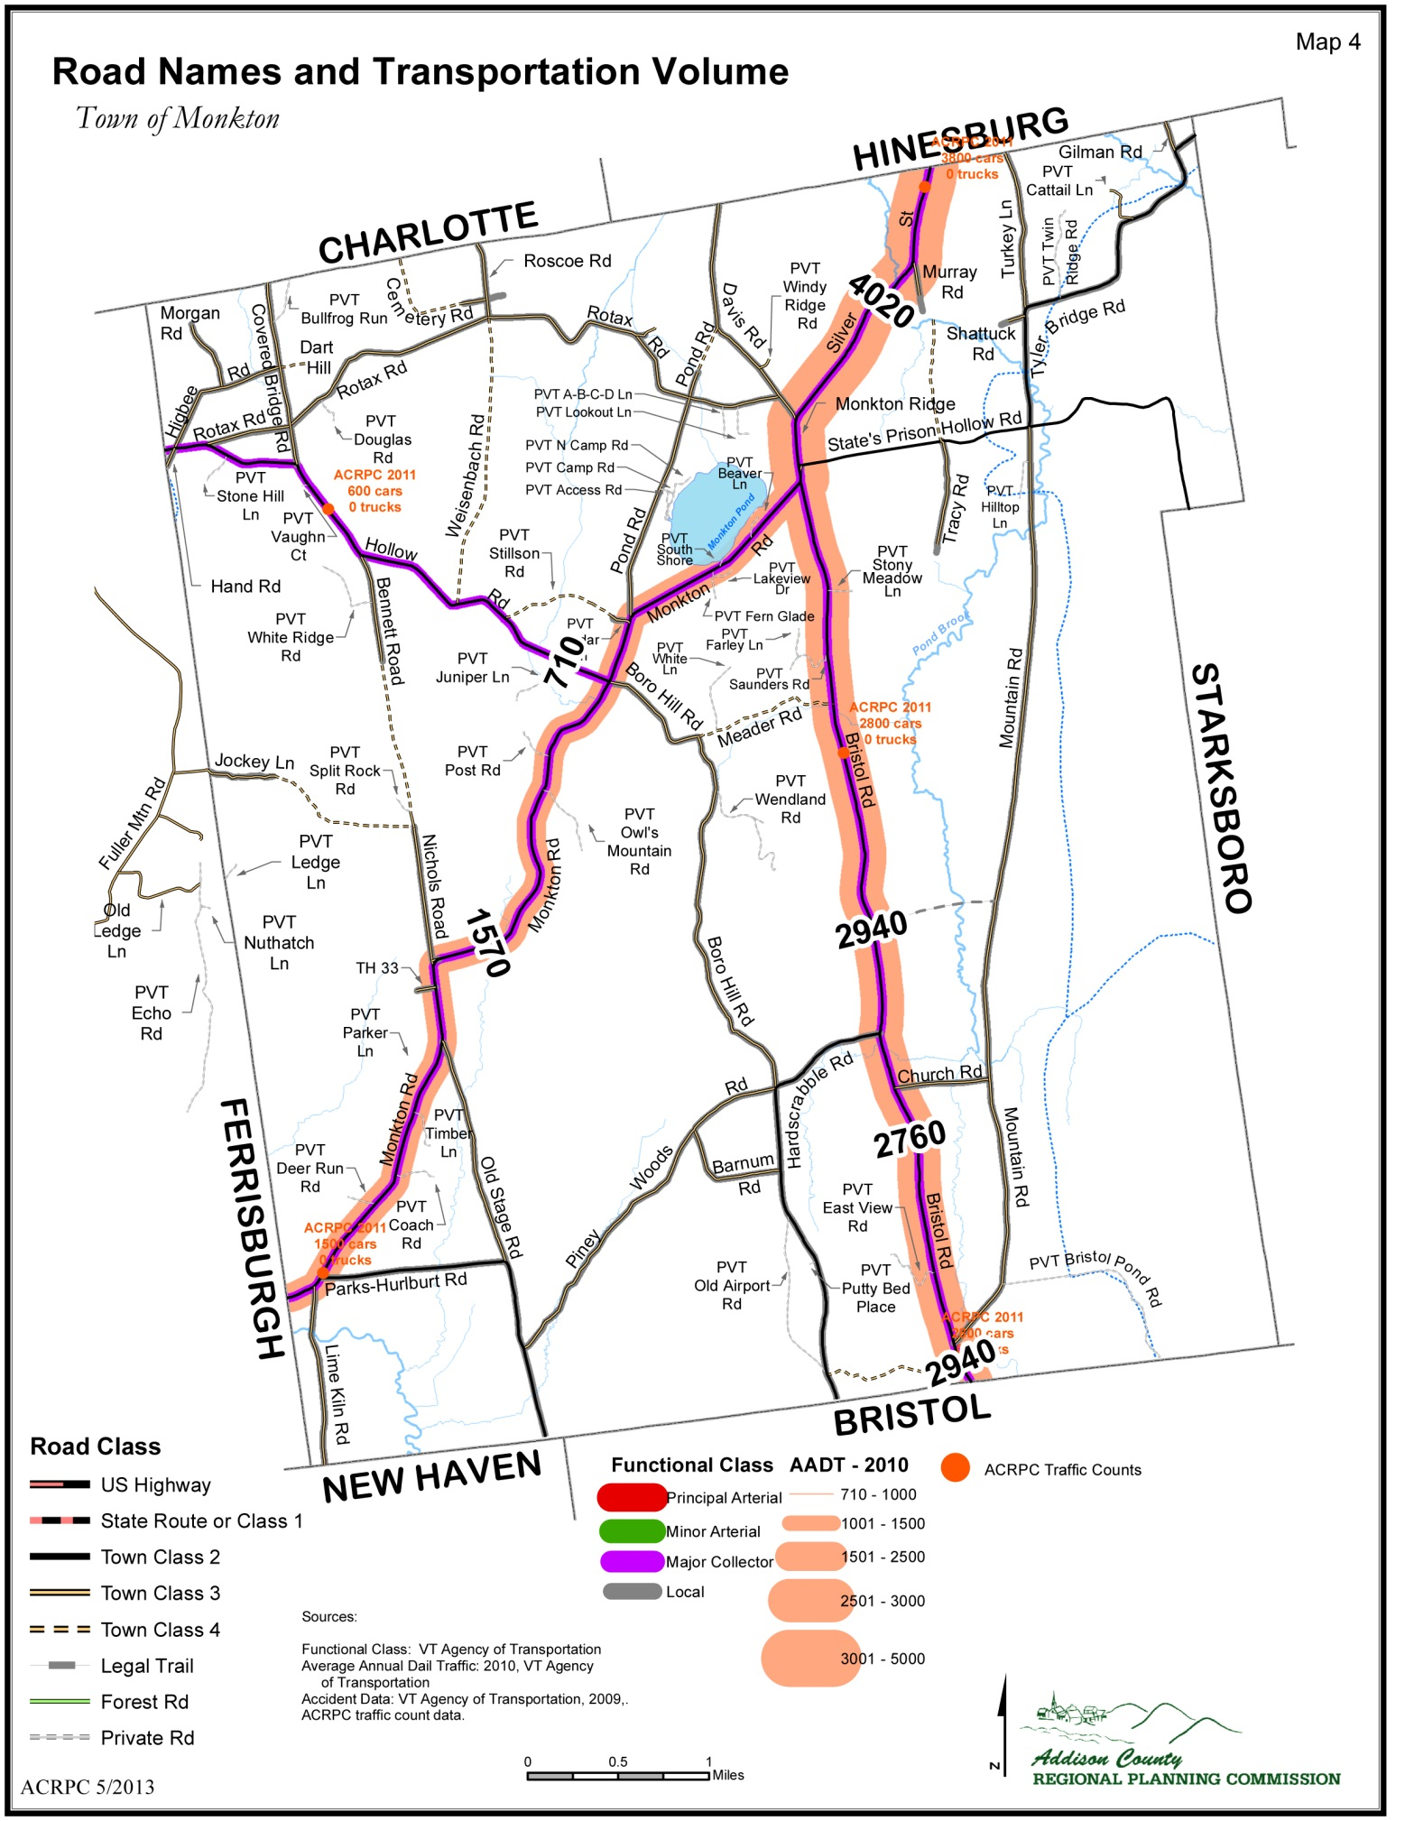
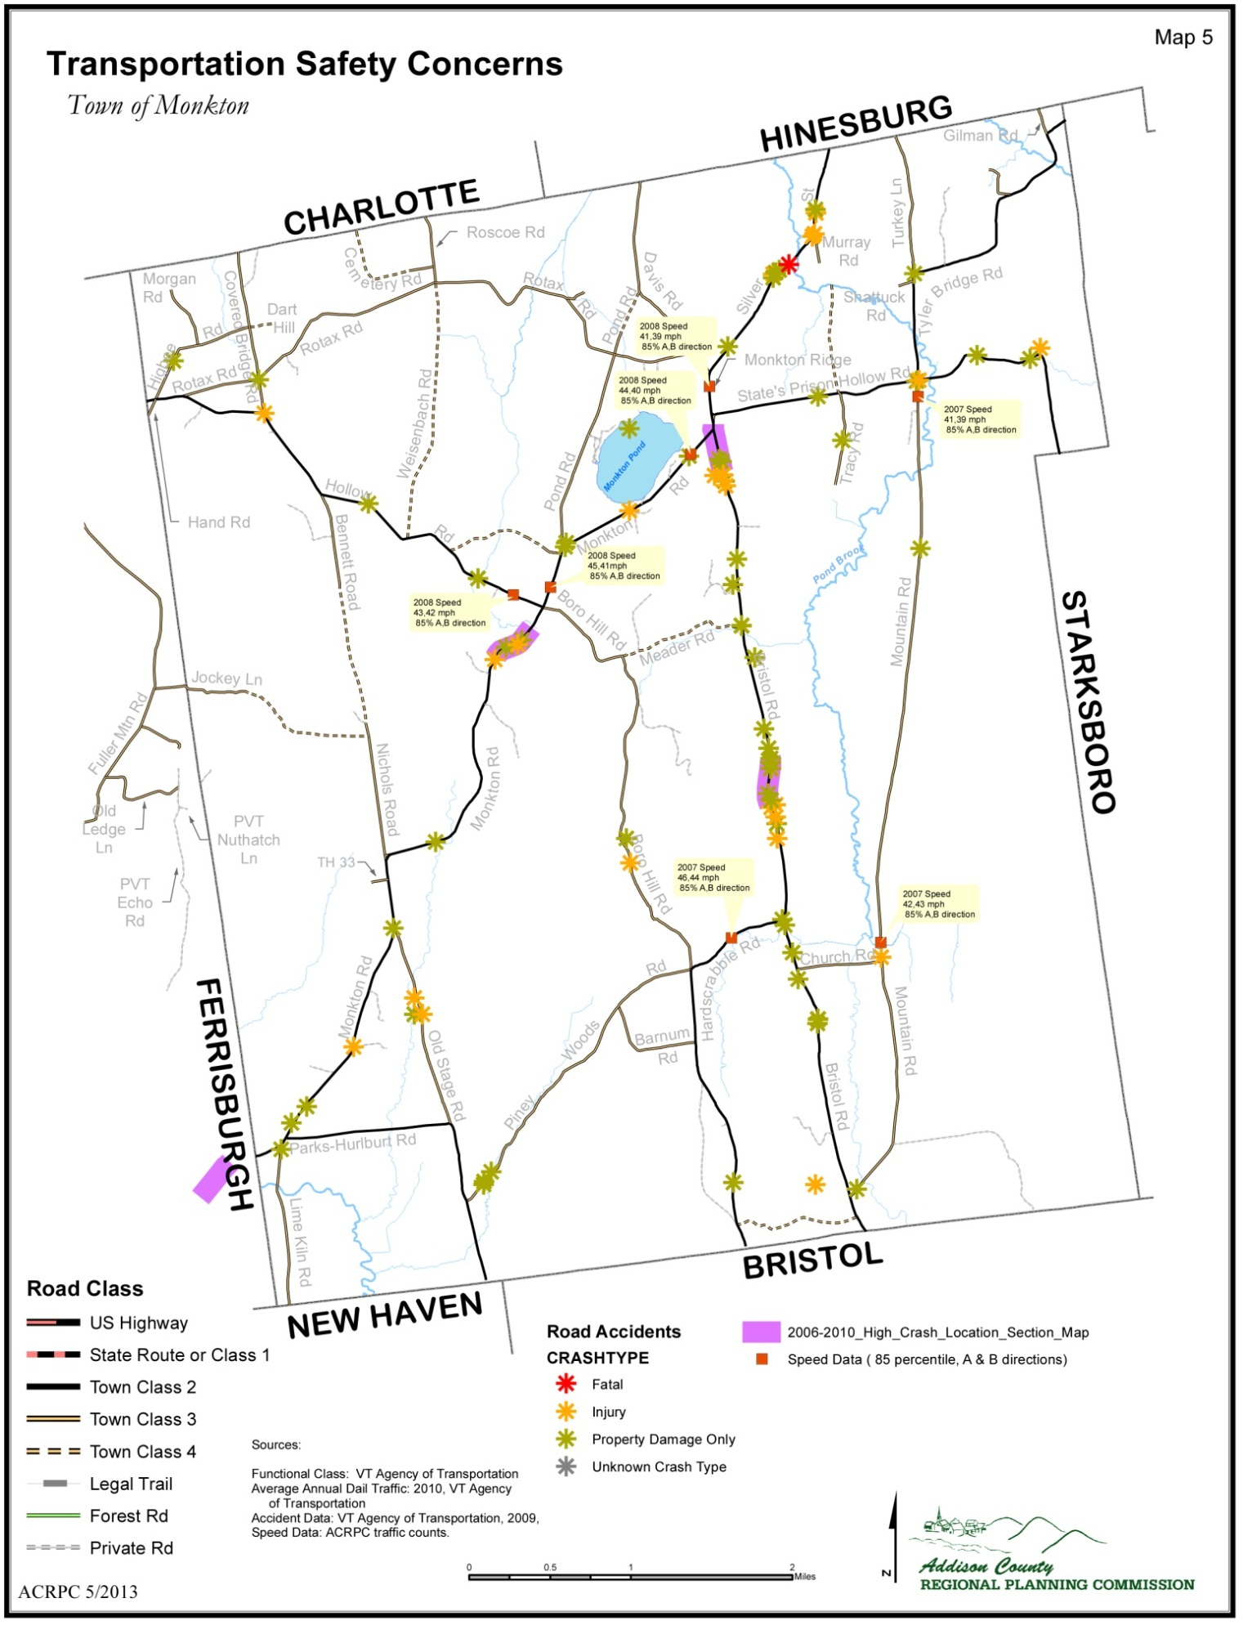
If traffic reduction and control measures fail, Monkton will need as a last resort, to begin the difficult discussion to consider reopening some previously closed class 4 roads. We recognize that this topic appears at first glance to directly contradict the goal of maintaining the rural character of the town. The town needs to take a realistic look at where new development is likely to take place and begin to design the road system that will accommodate this development as well as ever increasing traffic

SCENIC CHARACTER and ROADS
The Town of Monkton's unique rural character is in part due to its scenic landscape and unpaved gravel roads. The 33 miles of unpaved gravel roads reflect the town's agricultural heritage. Today these unpaved rural roads, often tree lined with historical stone walls and old foundations, are recognized by many residents as a fundamental asset that should be preserved. Unpaved rural roads have a natural traffic calming effect that permits shared use for horseback riding, bicycling, and walking that contribute to the quality of life sought by rural residents. Favorite walking areas include Pond Road Loop with the area around Monkton Pond, and the Five Mile Loop, which includes Turkey Lane and Gilman Road. The beauty of the landscape with its gravel roads is recognized as a natural resource that visitors seek, which stimulates the economy. Some unpaved gravel roads are still used for moving agricultural equipment. The Town of Monkton encourages the preservation of existing scenic unpaved gravel roads in their present state with the exception of enhancements for essential safety upgrades; these roads are a part of the rural character, cultural and historical heritage of the town. Transportation systems are encouraged that respect and protect local environmental, cultural, and historical resources.

TOWN CENTER and SLOWING TRAFFIC
As the town grows and begins the process of developing a town center (around the lot purchased several years ago to house new town administrative offices) and a walkable community, we need to make sure that drivers understand that they are passing through a residential area and slow down.

Strategies to slow traffic on the Ridge might include a redesign of the intersections of State’s Prison Hollow Road and Monkton Ridge, and the addition of a sidewalk and bike lane. It is especially important to clearly define State’s Prison Hollow Road’s actual alignment and to stop the gradual expansion of the road into the General Store’s parking lot thereby making ingress and egress from the general store safer.

In the fall of 2012, Monkton was the recipient of a regional planning grant (Transportation Advisory Council/ACRPC) to initiate a planning study for the intersection of State Hollow Prison Road and Route 116. This study will look at the intersection for safer realignment, the incorporation of a park and ride area, as well as safer pedestrian connections between the public buildings in this area.

Understanding that we are not the only town in the region to suffer with the problem of high speed through-traffic, which does not originate within our town borders, we must begin to view this issue as a regional rather than a town problem. During this planning period, Monkton should partner with the Addison Country Transportation Committee (the TAC) and neighboring towns to develop ways to redirect traffic back to Vermont Rte. 116 and US Route 7, without simply moving our traffic problem to another town. Appropriate region wide strategies might include a uniform posted speed for town roads that make town roads less appealing to these drivers.

PUBLIC TRANSPORTATION
Data from ACTR tells us that between 2007 and 2011 ACTR provided 2,230 trips for Monkton residents (a number which may be under reported because of the multiple mailing addresses within the town), clearly demonstrates that there is significant interest is this type of service. Currently there are several informal park and ride lots in town including the parking area across from the Russell Memorial Library on Monkton Ridge. In order to create a safe environment that will encourage town residents to carpool or ride share, the town should locate and create a park and ride with sufficient spaces to meet both current and anticipated needs. The availability of funding through grants or other state programs to underwrite the construction of a park and ride should be pursued.

ECONOMY and ECONOMIC DEVELOPMENT

GOALS AND RECOMMENDED ACTIONS
Our local economy will:
  - Sustain locally based jobs while maintaining the rural character of Monkton
  - Support a robust regional economy

We will do this by:
- Encouraging agricultural businesses, including investigating the feasibility of a Monkton Farmers Market to showcase our local farms.
- Encouraging and supporting forestry businesses
- Working with ACTR to improve transportation options and ride-sharing opportunities to employment centers such as Burlington and Middlebury.
- Providing residents with programs for cutting housing costs associated with heating and maintenance.
- Ensure telecommunications infrastructure and regulations are in place for telecommuting and home-based businesses.
- Engage business owners within the town to learn about the problems imposed by local regulations and what could be done to create a climate that welcomes the development of new business.
- Talk with town officials regarding the possibility of creating a capital budget for future town facility improvements.

DISCUSSION
Monkton sits in the upper northeast section of Addison County, within a half hour drive, on scenic roads, to Burlington, Middlebury, Hinesburg and Vergennes. This makes it an attractive place for families where one or more of the working occupants are travelling to more than one of these locations. For many households, one member may drive 30 miles north to work, and the other may drive 30 or less miles in an opposite direction. While being located in the middle of these economic hubs may be convenient for Monkton residents, it puts a strain on Monkton’s infrastructure and character and has increased the speed at which Monkton has transitioned from an agricultural economy to primarily a bedroom community. Without a strong base of farmers or others working within town, volunteer operations such as local fire and rescue groups decline and our agricultural land base is bought for home construction. Commuters going both north and south travel directly through town, making our roads busy and less safe for walking and cycling.

Monkton’s continuing dairy farms and the developing diverse agricultural ventures should be encouraged and supported in order to ensure they are maintained as a viable employment option for young farmers and future business men and women. Monkton is now part of the land base that supplies food directly to Chittenden County, and as such provides a green edge to the most urban part of the State. We should nurture this role, ensuring the lines between suburban and rural are distinct, and our agricultural heritage and working landscape continue to flourish.

Diversified farms in Monkton provide food to Middlebury and the five-town area. Local groups such as ACORN are working hard to create connections between local farms and institutional purchasers and local people. However, 80% of every food dollar pays for food from outside the region. So more work needs to be done to increase market share.

Monkton has a diversity of small businesses. Small businesses strengthen Monkton as a place to live and work. Such businesses need to be supported and new businesses encouraged. Telecommunication access, such as high speed internet and cell phone reception, should be available to all residents in order to offer increased opportunity to work and study from the home/and or from town/public buildings.

WORK FORCE AND INCOME
Monkton is largely a bedroom community to Chittenden and Southern Addison County, having a citizen population of 1,980. There are 1,196 workers over sixteen, of which 871 are employed outside of town. According to the 2010 U.S. Census, out of 739 households in Monkton, 244 households have one person working, 364 households have two people working, and 54 households have more than two people working. Seventy-seven have no one currently in the labor force. The majority of two-parent families in Monkton are such that both parents are working outside of the home. Out of 192 families with children under the age of 6, 130 have both parents in the work force (approximately 70 %). Out of 315 families with children between the ages of 6 and 17, 273 families include both parents in the work force (approximately 86%).

Monkton’s median household income in 2010 was $75,846 up from $53,807 in 1999. When inflation is considered, this is a $4,700 increase in median household income in ten years. Comparatively, Monkton’s median household income is higher than that of the County and neighboring towns. The median household income for Addison County in 2010 was $55,427. In New Haven the median household income was $61,103 and in Bristol it was $51,578. Approximately three precent, or approximately 60 residents in Monkton live below the poverty level. In Bristol, 7.8 percent of residents and 4.8 percent of New Haven residents live below the poverty level. According to the federally defined poverty level; an individual making no more than $931 net income a month is considered to be living below the poverty level, or a family of four, making no more than $1,921 net monthly income.

According to the 2010 U.S. Census, 205 (17%) of the working population of Monkton work in the Education Services industry and 191 (15%) work in the construction industry. Other leading industries of employment for Monkton residents include manufacturing, health care services, and retail. According to the 2010 U.S. Census, 43 (4%) residents work in the agricultural industry, including forestry.

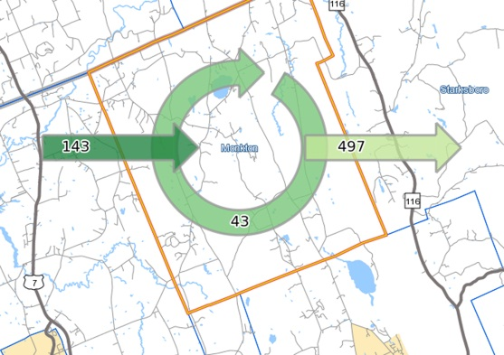
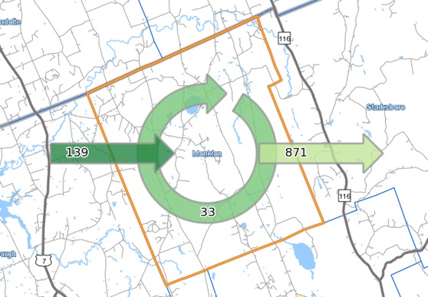
2002 ‘U.S.Census ‘On The Map’
2010 U.S.Census ‘On The Map’
The above diagrams from 2002 and 2010 show almost twice the amount of working residents are living in Monkton, but are commuting out of town for work.

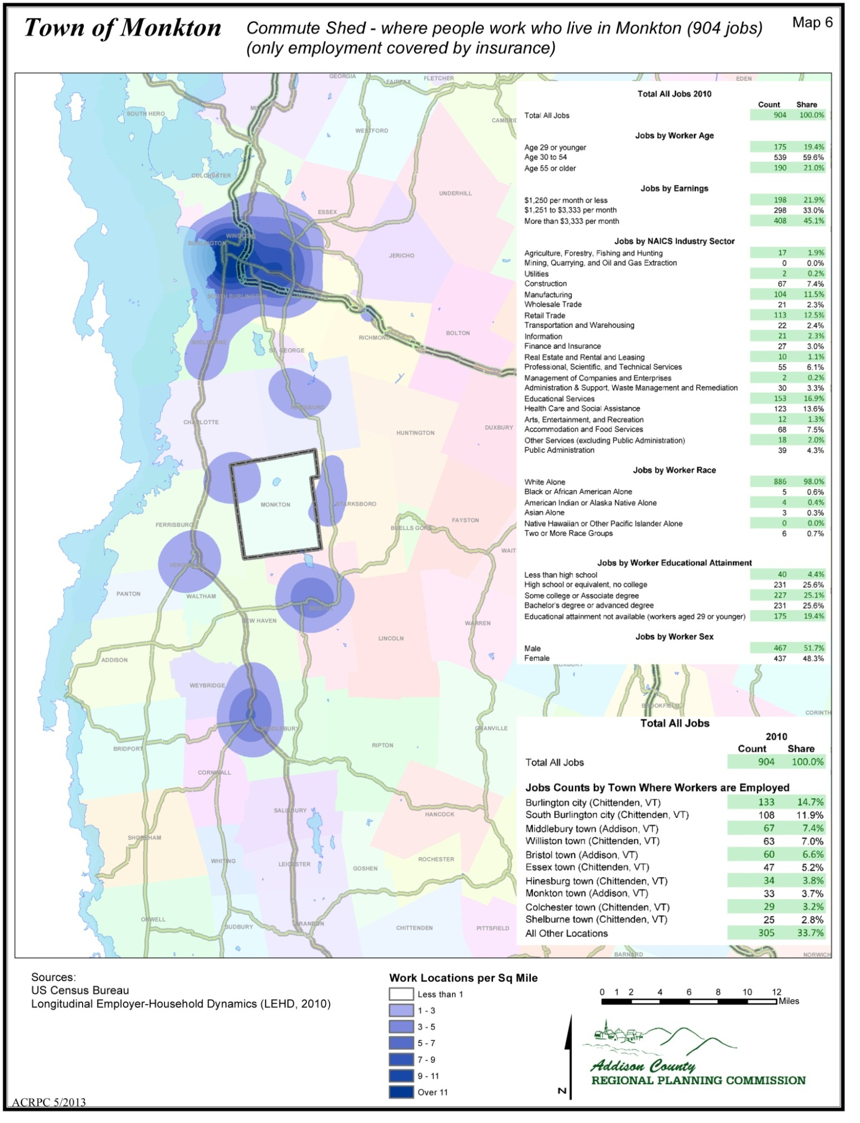
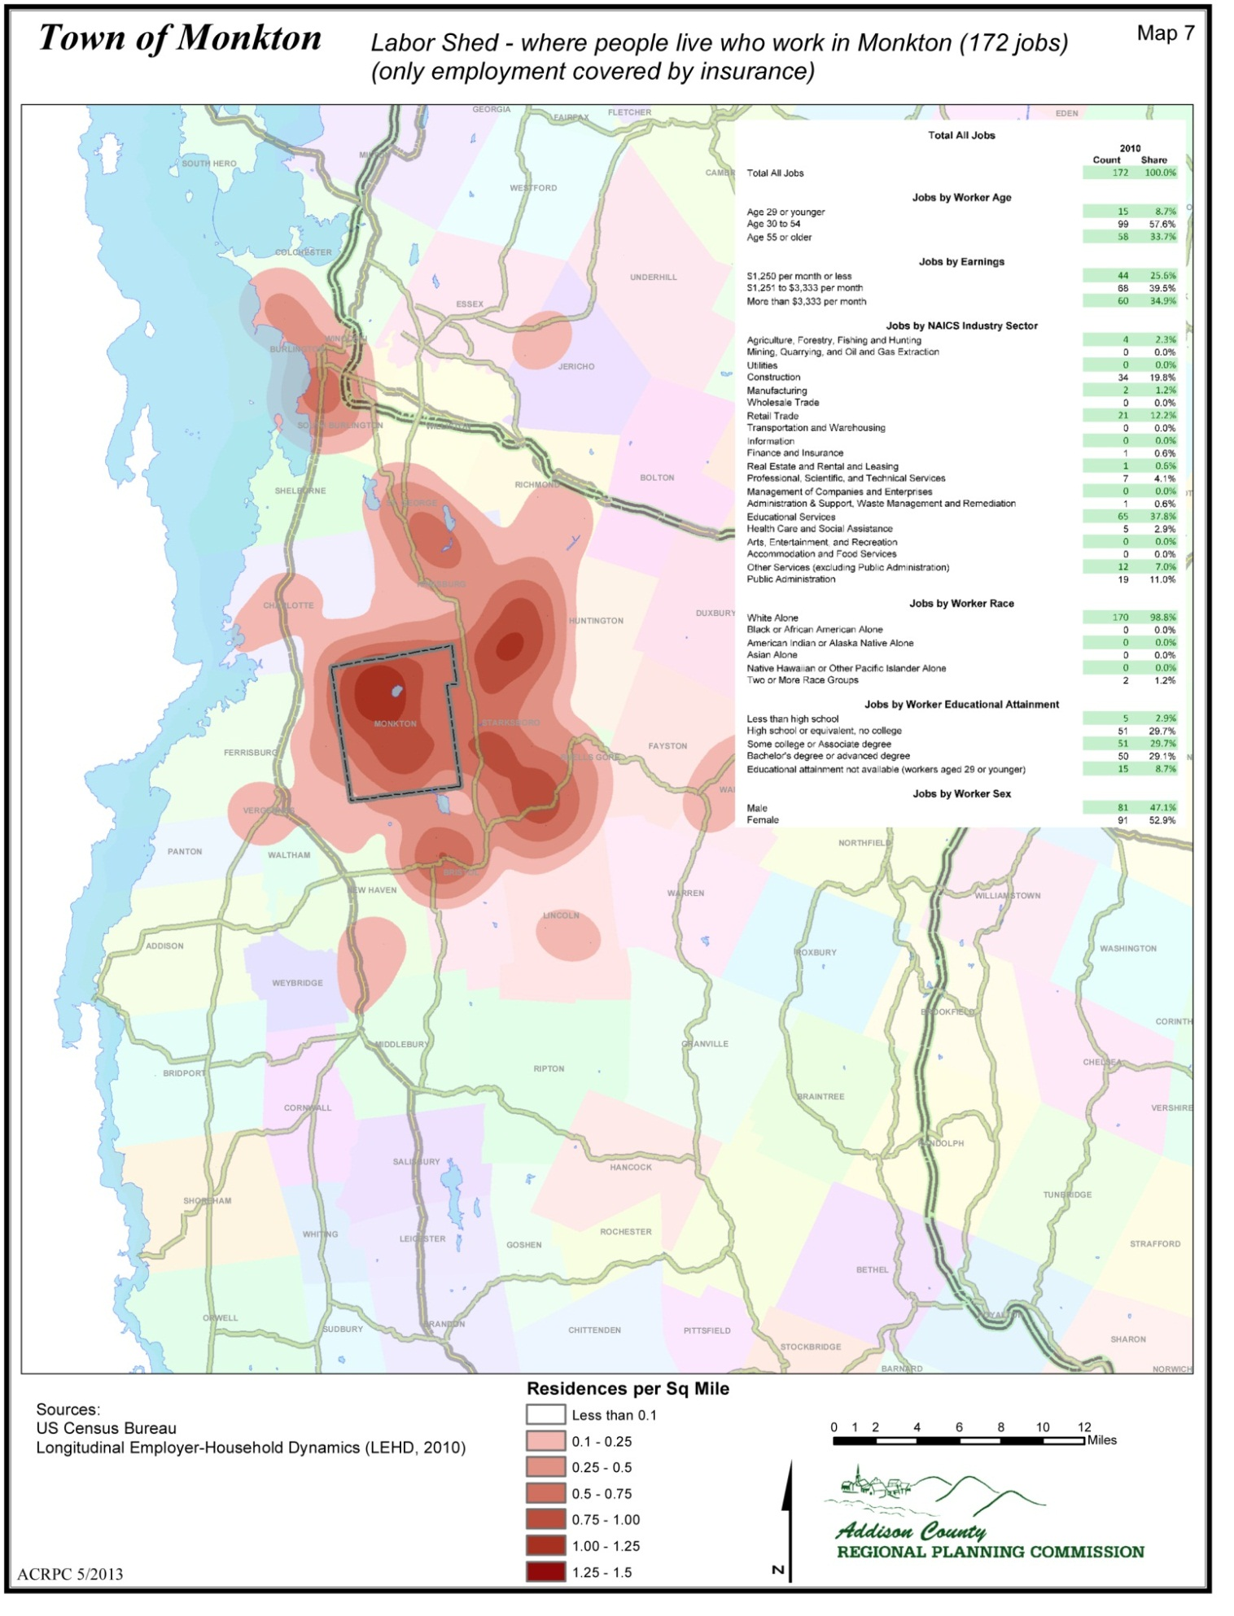
PLACE OF WORK
According to the 2010 Census Bureau, out of 1,196 working residents, 49 percent work in Chittenden County and 41.2 percent work in Addison County. Ninety-eight percent work within Vermont. Approximately 2-3 percent of the working population both lives and work within Monkton. The latter may or may not include all those working from home, having a home-based business, or e-commuting as this is harder to track through U.S. Census data. Places of employment in Monkton include the Monkton Elementary School, Monkton Town Offices, Monkton Library, Monkton General Store, Post Office, and Town Garage. Types of home based businesses include commercial agricultural operations, professional services, e-commuters such as college instructors and professors, construction and woodworking, childcare, artist studios to name a few.

AGRICULTURE
Agriculture and forestry are an important component of Monkton’s historic and current economy. In 2011, there were twenty commercial agriculture operations in Monkton. Much of our land and rural character is dependent on the success of the working landscape. A total of 5651 acres, which is 24.3% of the land, are in commercial agriculture operations, providing an important source of employment within the town. See the Agricultural section for more information.

COST OF HOUSING
Living in Monkton has become much more expensive. The cost of home ownership and housing rentals, heating and maintaining a home, food costs, costs of commuting to work and driving to goods and services are common factors in determining the affordability of living anywhere. Having a diversity of housing options, access to public transportation, and being able to afford to heat and maintain your home are all topics addressed throughout this plan.

See the housing, energy and transportation sections for more information.

TOWN OPERATING BUDGET
The town operating budget including administration, road improvement and maintenance has increased over time at a normal rate of inflation. This cost trend is likely to continue, as well as follow the changes in the cost of energy.

Maintenance and improvement in our highway system is vital to maintaining safe roads and maintaining property values for the citizens of Monkton. The goal of our town plan regarding highways is to improve the efficiency of our highway system via redirecting traffic and optimizing our road system as suggested in the Transportation section of this plan.

TOURISM AND OTHER TOWN ATTRACTIONS
According to a study done for the Vermont Department of Tourism and Marketing in 2009, visitor spending in Vermont supported an estimated 33,530 jobs for Vermonters (approximately 11.5% of all VT jobs). The agricultural, forestry and art sectors can attract tourists as a way to increase business in town. Vermont branded arts and food sell well directly from local farm-stands and studios and also on-line to those dedicated to supporting Vermont’s local economy. Recreational attractions in Monkton include walking, hiking, cross country skiing/snow shoeing and cycling. Raven Ridge Natural Area, owned by the Nature Conservancy, has trails for walking and bird watching (see the Facilities section for more on recreation in Monkton). Monkton can take advantage of being centrally located between larger commuter and visitor destinations.

Monkton’s monthly Community Coffee House, Front Porch Forum, and the proposed new library and town office building create community and encourage our residents and neighbors to invest time and money in Monkton. These kinds of activities contribute to the unique character of Monkton and is crucial in creating a culture supportive of local businesses.

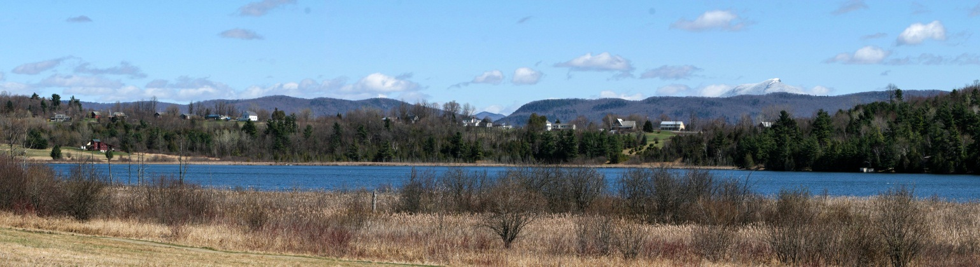
Monkton Pond in the Winter

NATURAL RESOURCES

The Natural Resources section is the heart of our town plan, because it under lies Monkton’s economy and quality of life. This section has many sub-sections, including: wildlife, water, and soil and mineral resources, as well as agricultural, forest resources, and scenic resources, and air quality. To facilitate a better understanding of this section guiding principles are listed below. The goals and recommendations described in each sub-section have their foundation in these guiding principles:

- To promote land use development, practices and techniques which protect Monkton’s natural and scenic resources.
- To support public education, knowledge and involvement regarding the town's natural resources, and their maintenance and enjoyment.
- To encourage measures that protect, maintain or regain the health of the water, air, land, plants and wildlife and their habitats; these resource systems underpin our economy and quality of life through the ecological services they provide, use as the working lands, and scenic and recreational value.
- To foster the growth of Monkton’s agricultural and forest economies to support the working landscape.
- To support, develop and maintain techniques to encourage natural and scenic resource conservation, including the work of Monkton’s Agricultural and Natural Areas Committee, and the use of conservation easements, proper zoning, tax incentives and voluntary measures such as enrollment in the State's Use Value Appraisal Program.

WILDLIFE GOALS AND RECOMMENDATIONS
Our plan to protect wildlife will:

- Promote land use development, practices and techniques which protect threatened/endangered species, significant natural communities, natural/fragile areas, wildlife habitat and surface water and wetland systems.

- Encourage measures which maintain or regain the health of wildlife habitat and water resource systems (including streams, open waters, wetlands, and groundwater) for the recreational, working lands, and ecological (for both flora and fauna) roles that they play.

- Support the town's agricultural community and forests while promoting conservation.

- Increase public knowledge and involvement regarding the town's wildlife resources and their maintenance.

- Identify and encourage the acquisition or long-term protection of lands with conservation value.

We will do this by:
- Developing data for wildlife travel corridors in town.
- Supporting conservation of land containing rare threatened and endangered species and their habitat.
- Supporting conservation of land that has unique natural communities.
- Supporting an east-west corridor for animal movement.
- Supporting stream crossing to protect animals from vehicular traffic.
- Prohibiting development in Monkton’s forestland, wetlands and ridgelines (in areas identified by the state as State Natural Heritage Sites and shown on Map 17 of this plan).
- Requiring development in any overlay district meet the associated standards of that district, as stated in the Land Use section.

WILDLIFE DISCUSSION
Monkton encourages the protection of significant wildlife habitat and the maintenance of the full array of native species, while considering community development, agricultural and forestry needs. Responding to a congressional mandate, the State of Vermont in conjunction with many partners has generated a Vermont list of Species of Greatest Conservation Need (SGCN-see appendix), and has suggested strategies for their maintenance. Many species mentioned in this Town plan are SGCN and, when appropriate, Monkton should act in concert with the State and conservation groups to conserve its wildlife heritage.

AQUATIC HABITAT
Aquatic habitats (ponds, streams, wetlands) crucial for both wildlife and recreational use, suffer from loss of floodplain functions, encroachment, stream alterations, poor water flow, removal of in-stream woody material and shady stream-side vegetation, silt build-up and invasive species. Measures should be taken to minimize these effects particularly through the use of Agency of Natural Resources (ANR) and Natural Resource Conservation Services funding programs, the Better Back Roads program and proper Accepted Management Practices (AMPs) and Best Management Practices (BMPs).

FOREST HABITAT AND TRAVEL CORRIDORS
Upland deer wintering areas, bear, bobcat, bat, and (song) bird habitat are the most prominent concerns in this category, but a diversity of plants and animals are also part of an upland forest system. South facing coniferous wintering areas are a crucial element in defining the health of the deer population.

Deer wintering areas need to be available every year in the event that stressful winter conditions require their use for health and survival. Wintering areas not only affect the deer population, but also the quality of recreational activities such as hunting. It should be a priority to encourage private landowners to evaluate their land, recognize wintering areas, and protect them. In the future, incentives may be provided to landowners for incorporating protection of deer wintering areas and other important wildlife habitat into their Current Use Plan or other landowner conservation programs.

Black bear and bobcat are two species that require large territory for habitat and their seasonal and foraging movements. These species are sometimes referred to as “umbrella” species, indicating the belief that if sufficient habitat is maintained for them, many smaller species will also benefit. Maintaining large tracts of connected forest land can be accomplished through regulatory and non-regulatory means. Cluster development (PUDs), which use conservation development criteria, and use of the town conservation fund are tools to help protect large blocks of habitat and avoid fragmentation and perforation of significant habitat areas.

Bear habitat in Monkton is primarily seasonal. The eastern-most portion of Monkton, especially the Hogback Range area adjacent to Starksboro and the Western Green Mountains, serves as a travel corridor from the Green Mountains to early spring food sources located in the Pond Brook wetlands. A few bears are now denning for the winter in Monkton.

Bobcat habitat and travel corridors exist throughout a large portion of the town, ranging from the Vergennes Watershed region in Bristol, on the high elevations of Boro Hill, Mt. Florona and Mt. Fuller, and north to the Charlotte and Hinesburg town lines. Higher elevation rocky outcrops are significant features of bobcat habitat. Bobcat travel corridors include numerous road crossings. These intersecting roads need to be maintained such that they minimize interference to wildlife corridors. Landowners are also encouraged to take wildlife habitat and travel corridors into consideration in their land management practices.

RIPARIAN HABITAT BUFFERS
Providing natural land cover adjacent to water bodies is crucial to wildlife as they access water and food. The suggested width recommended by the Department of Fish and Wildlife is 300 feet of land cover from the edge of surface waters.

Stream flow, hydrology and equilibrium channel shape conditions can be maintained through adherence to Department of Environmental Conservation guidance that suggests planning to accommodate aquatic species and riparian areas by protecting, at a minimum, the predicted fluvial erosion hazard area of a river corridor. Monkton streams have been field assessed by Lewis Creek Association and the Department of Environmental Conservation. Data results are held in a data management system and resulting river corridor plans prioritize stream corridor management options for towns, road managers and landowners (http://www.lewiscreek.org/lewis-creek-corridor-plan-2010). In general, small seasonal streams require 50 ft. setbacks while larger streams and floodplains require 50 to 100 feet to move through over time.

Wetlands support great numbers of plant and animal species, particularly marsh birds, waterfowl and amphibians. For this reason, these areas are of significance and should be protected with buffers between 50 and 100 feet.

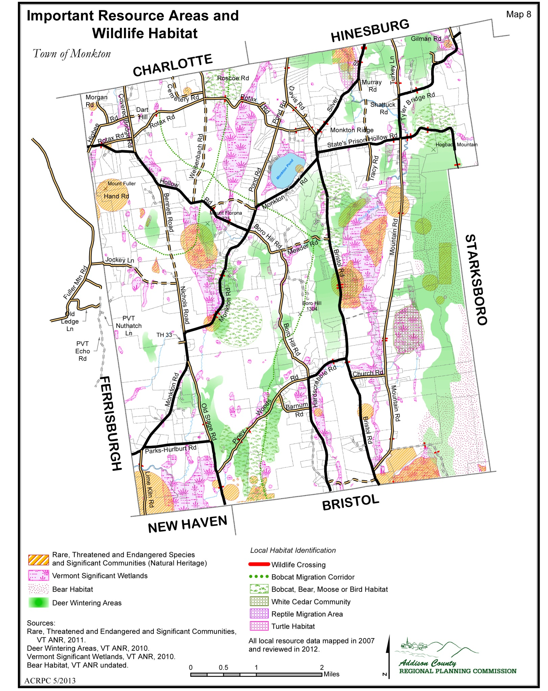

LAND PROTECTION AND MAINTENANCE
The state and various land trusts use easements to acquire or protect lands determined to have high ecological value as natural or fragile areas, as well as those with recreational use potential. Management plans are encouraged for areas of high public value. On the local level, habitats or areas that are important to the town should be identified and protected for future generations. The Monkton Agricultural and Natural Areas Committee (ANAC), which is the committee that works to conserve land in town, has identified important land values to help with acquisition of easements. Community planners at the Department of Fish and Wildlife can assist with habitat planning for Monkton wildlife.

RARE, THREATENED, AND ENDANGERED SPECIES AND FRAGILE NATURAL AREAS
The town supports the protection of rare species, significant natural communities, important habitat areas, and other natural/fragile area, based on, but not limited to, state and regionally determined definitions. Additionally, conservation efforts such as maintaining wildlife corridors, connectivity and buffer zones as later described in the wildlife habitat section are also encouraged. Some Monkton landowners participate in the Landowner Incentive Program (LIP). This US Fish and Wildlife program provides federal grant funds to protect and restore habitats on private lands, to benefit Federally listed, proposed or candidate species or other species determined to be at-risk.

In Monkton, several of these species and areas are currently known and mapped. Three areas of rare/endangered plant species are known, as well as three areas of rare/threatened/endangered animal species. Additionally, a portion of the marsh/bog vegetation surrounding Bristol Pond, (Lake Winona) defined by the Region as an area of special value, extends into the southeast corner of Monkton. Clayplain forest communities, particularly in the Pond Brook valley, have state significance.

The Eastern rat snake, a large but harmless black snake, was state-listed as threatened in April 2005. This snake is a constrictor that specializes in hunting small rodents such as mice and rats, and is also a good climber. The northern most population in Vermont inhabits woods and edges in the Monkton-Bristol area in the vicinity of the Waterworks property. This species is compatible with humans and will sometimes share barns and outbuildings with people. Mowing fields so not to encircle snakes, but rather mowing furthest from the wood’s edge first and concentrically outward from there is encouraged. For more information please contact the Monkton Conservation Committee.

The federally endangered Indiana bat has been located in Monkton roosting under the loose bark still attached to a standing dead tree. Forest management guidelines for bats and other species are available (for more information contact the Monkton Conservation Commission or the Vermont Department of Fish and Wildlife at: http://www.vtfishandwildlife.com/Conservation_Assistance.cfm.

Grassland birds, as a group, are of conservation concern. Since grassland habitat in Vermont is largely dependent upon the management of agricultural fields, landowner awareness and cooperation is encouraged. When possible, fields with nesting birds should be left uncut until August. Even on land actively managed for agriculture, some fields may be less valuable as forage and could be cut later in the year. Raising the mowing bar is a technique that could protect some nests and animals (e.g., wood turtles; baby Eastern cottontail rabbits). Upland Sandpipers, a state-endangered bird that is found in large grasslands, are known to have nested in Monkton. If known, nest locations should be left undisturbed. Maintaining pasture and fields within a large open habitat matrix will benefit all grassland birds.

Note: Goldfinch nest in old field habitat with shrubs through September. Although not rare, landowners may want to consider late nesting goldfinch when cutting old fields and brush hogging.

The uncommon wood turtle is a moderate-sized stream turtle of regional conservation concern and possibly worthy of federal listing consideration. This long-lived species is believed to be under threat throughout its range, and Vermont is core to that. This species travels well away from its home stream during summer (max. 1400’ recorded in Monkton, and elsewhere reported up to 2000’, but 1000’ likely to contain most individuals). Discouraging road construction and other development within 1000’ of wood turtle streams would assist their long-term persistence. In general, maintaining 300’ of riparian habitat along each side of a stream would benefit many species of wildlife.

Some species of frogs and salamanders make seasonal movements between uplands and spring breeding pools. When a road is located between these areas road kill can be quite dramatic. Over 1000 deaths of four species during two consecutive nights have been estimated at one crossing in Monkton (wood frog, spring peeper, spotted salamander, and blue-spotted salamander). When roads are undergoing upgrades, crossing structures in conjunction with habitat protection should be considered. A similar situation can occur with snakes crossing roads when returning to den sites in the fall.

The Town encourages the compilation of a comprehensive wildlife and significant habitat inventory by the Monkton Conservation Committee and other interested citizens, placing emphasis on threatened/endangered/rare species and significant natural communities, such as Meader White Cedar Swamp, the Clay Plain forests of the Pond Brook valley and the Pond Brook Wetlands conservation area that protects rare species, a portion of an expansive emergent marsh, and a wildlife travel corridor.

A planning map for wildlife habitat within the Town shows patterns of winter wildlife travel corridors for wide ranging species (L CA, VT FWD 2004). Species in the study included bobcat, bear, moose, white-tailed deer, mink and otter. The planning map of significant habitat and travel corridors follows and is included as a point of reference. (Note: this is not an inventory map, MI.)

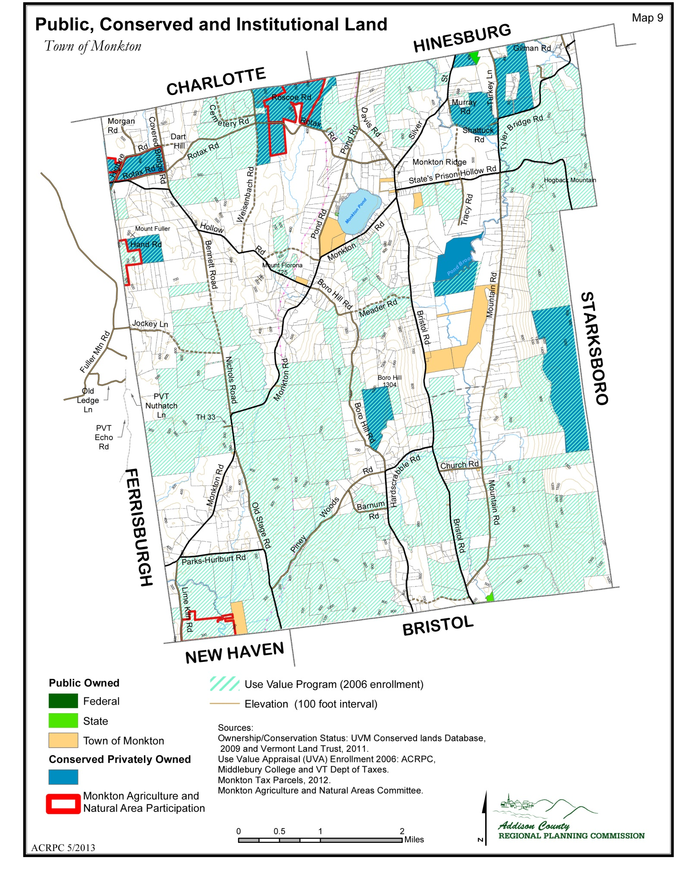

WATER RESOURCES
WATER RESOURCES GOALS AND RECOMMENDATIONS:

Our plan to protect our water resources will:
- Identify, protect and manage the quality of surface water.
- Identify, protect and manage the quality and quantity of groundwater, including groundwater recharge areas.
- Identify and protect significant wetlands

We will achieve this by:
- Working with local groups like Addison County River Watch Collaborative, the Lewis Creek Association, the State and Federal government to develop a monitoring program for Monkton’s surface water.
- Supporting Monkton Conservation Committee or other town committee seeking grant monies to identify and remove invasive species in wetlands, riparian habitat, and ponds.
- Supporting the use of Low Impact Development (LID) techniques, including limiting construction on steep slopes, to minimize impacts to water quality as a result of new development, redevelopment, and modifications to existing development.
- Develop stream/river corridor protection areas with appropriate buffers and setbacks to protect surface water quality.
- Conduct a study to determine where Monkton’s groundwater recharge areas occur and develop a protocol to protect groundwater quality and recharge areas, particularly from incremental degradation and depletion.
- Require the use of “best practice” water conservation measures in all new construction to minimize its impact on groundwater.
- Study the feasibility of developing community well water systems in areas where groundwater has been polluted.
- Work with the Vermont Health Department to educate Monkton residents on the value of testing well water; create incentives where possible.
- Developing river corridor protection areas with appropriate buffers and setbacks to protect surface water quality.
- Prohibiting development in Monkton’s forestland, wetlands and ridgelines (in areas identified by the state as State Natural Heritage Sites and shown on Map 17 of this plan).
- Requiring development in any overlay district meet the associated standards of that district, as stated in the Land Use section.

WATER RESOURCES DISCUSSION
The quality of Monkton’s ground and surface waters are essential to town people’s lives, our economy and environment. All Monkton residences use groundwater in their homes and businesses. The scenic beauty of our town center is focused on Monkton Pond. Wildlife enjoyed by residents use wetlands such as the Pond Book Wildlife Management Area.

Water resources are generally divided into four levels: surface water, wetlands, groundwater, and aquifers. Maintenance or improvements must be made as needed in order to assure water health, safety, and quality. The effects of development via construction and septic effluent, can be minimized through technologies, which help protect the quality of groundwater, lakes and ponds. Locally, invasive species such as Eurasian Water Milfoil, Purple Loosestrife and Japanese Knotweed are a concern to the community and must be addressed.

Regulations and guidance should be developed to minimize the effects of run-off, stormwater pipes, road ditching, erosion and leaching. Land use activities can directly and inadvertently affect the health of surface water systems. Surface water health can be impacted by activities that lead to increased run-off and erosion into surface water and leaching through soil to shallow groundwater or the water table. Shallow groundwater feeds surface waters. Landfills, septic systems, roadways and storage tanks can leach pollutants through soil into water. Pesticide, fertilizer and manure use, if improperly managed, can result in leaching to the water table and runoff into surface waters polluting them. Pollutants can kill or injure aquatic plants and animals, impact the quality of drinking water, and diminish recreational opportunities.

The Lewis Creek Association (LCA), formed in 1990, which protects, maintains and restores the ecological health of Lewis Creek, is monitoring the waters of Lewis Creek and Pond Brook in Monkton. Pond Brook flows into Lewis Creek. LCA is also conducting a study, funded by the Agency of Natural Resource, to identify water quality improvement opportunities with interested landowners in the Pond Book watershed. LCA works on river corridor conservation agrees with interested riparian landowners on Lewis Creek and Pond Book.

Eurasian Water Milfoil, purple loosestrife, and Japanese Knotweed continue to pose a threat to the recreational use of streams ponds and lakes -- including Monkton Pond (Cedar Lake). The key to stopping this problem is early detection and treatment before large spreading occurs. Therefore, support for local efforts to slow or stop invasive spread is crucial, as state funds are generally very limited.

Shorelines and stream banks affect the health of bodies of water. Land use activities adjacent to lakes, rivers, and streams have a direct impact on surface water quality. Vegetated buffers adjacent to surface waters provide benefits that include, but are not limited to: reduced soil loss, reduced stream bank and shore erosion, reduced sedimentation of aquatic habitat, filtration of sediment, nutrients and pollutants in runoff, provision of cover habitat for aquatic biota and other wildlife, and shading of surface water to maintain cooler summer temperatures. Proper design, placement, and maintenance of septic systems, erosion control, limitations of development, and prudent management of vegetated buffers along shore lines and stream banks can all help to protect surface water quality. Thus, the Town of Monkton regulates the development of shoreline areas through sewage disposal ordinances, definition of buffer strips and implementation of erosion controls.

WETLANDS
Wetlands are defined in the Vermont Wetland Rules as those areas of the state that are inundated by surface or ground water with a frequency sufficient to support significant vegetation or aquatic life that depend on saturated to seasonally saturated soil conditions for growth and reproductions. The federal wetland definition under Section 404 of the Clean Water Act similarly emphasizes hydrology, soil, and vegetation as the criteria for determining the presence of a wetland.

Wetlands include such areas as marshes, swamps, bogs, fens, and shallow water ponds. Wetlands are known to provide many important functions that maintain ecological integrity and values that provide human benefits including temporary storage of flood waters, surface and ground water quality protection by trapping sediment and adsorbing nutrients and metals, ground water recharge, wildlife and migratory bird habitat, fisheries habitat, threatened and endangered species habitat. They are open space that provides recreation, education and aesthetics cultural values.

The Vermont Wetland Rules, implemented by the Water Quality Division of the Department of Environmental Conservation, protect Class One and Class Two wetlands. The State rules describe certain activities that are allowed uses and may occur within these wetlands and identify other uses that are conditional uses and which may only be approved if it can be shown that the use will not adversely affect the function and values of the wetland.

The general locations of Class Two wetlands in Monkton are shown in the National Wetlands Inventory maps, copies of which are kept in the town offices. It should be noted that not all Class Two wetlands are mapped due to limitations of aerial photography, and smaller wetlands connected to Class Two wetlands may not be mapped.

Class Three wetlands are generally small wetlands and are not identified on the National Wetlands Inventory maps. Class Three wetlands are not initially protected under the Vermont Wetland Rules, although they may provide significant function and value and may be protected under Act 250.

There are currently no Class One wetlands in Monkton.

The USDA Wetland Reserve Program provides funds to protect and restore wetland values and functions. The ANR Ecosystem Restoration Program provides funds to protect wetlands adjacent to streams, especially if the wetland can help to attenuate water flow and reduce phosphorus flows to Lake Champlain.

GROUND WATER
Groundwater resources provide water for personal, agricultural, commercial and industrial needs. Virtually all Monkton residents have private or community wells, and thus, use ground water; it is essential.

Groundwater consists of surface water that has percolated through the soil to the water table. It can percolates through fractured bedrock and gravel deposits to recharge subterranean or deep groundwater aquifers. The type of soil and bedrock determines this process. Presently in Monkton, groundwater appears to be plentiful, but as growth continues more consumers will share water resources. The point at which the degree of development affects water quality and quantity is undetermined. The Town should determine where the important ground water recharge areas exist in order to protect them. If water resources are impacted by growth measures must be taken to preserve its quality and quantity. Regulations should require the use of best water conservation practices in all new construction to minimize its impact on groundwater.

AQUIFER/ WELLHEAD PROTECTION
Generally, aquifers serve as geologic storage tanks for large volumes of water, which originated as surface water. These sources and their recharge areas must be protected, especially gravel deposits on hillsides, which must be reviewed as much for their water recharge and purification qualities as for their septic carrying capacity. As defined by the Region, no aquifers serving public water systems presently exist in Monkton. All drinking water sources are private or community wells. This plan encourages the use of Accepted Management Practices (AMP’s) for any farms near wellhead areas.
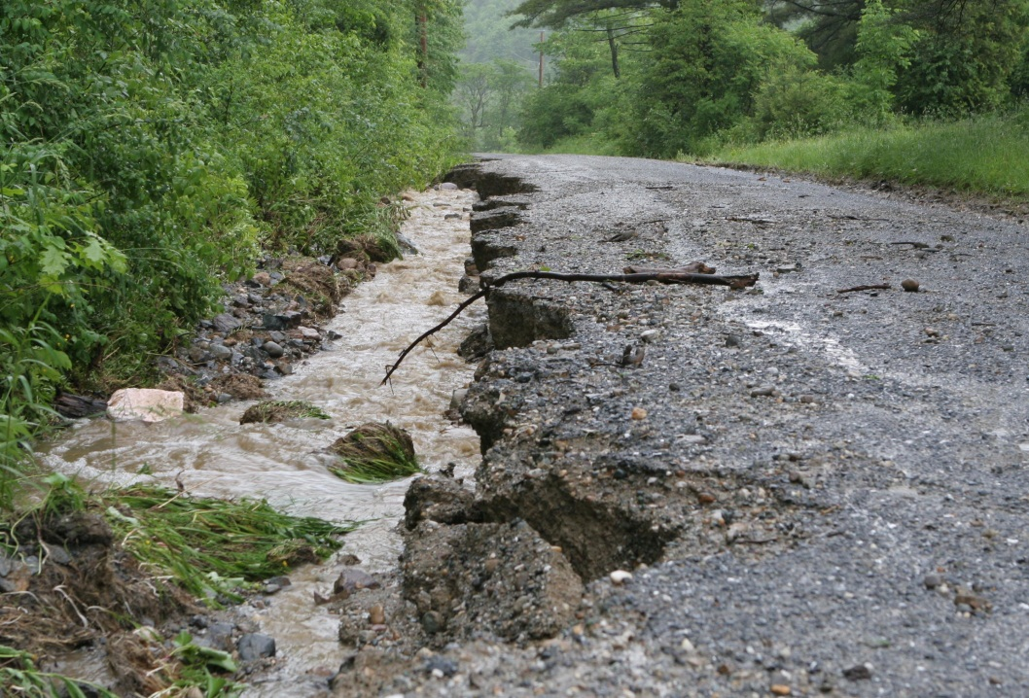
Stormwater degrades a Monkton road

DRINKING WATER QUALITY
The quality of Monkton's groundwater is dependent upon bedrock geology, proper land use practices, and waste disposal. That is why the Vermont Department of Health (VDH) recommends three tests to determine drinking water quality. The VDH recommends yearly testing for Ecoli and coliform bacteria; a positive test indicates that water has been polluted by animal or human waste. The inorganic chemicals test and gross alpha test are recommended every five years by the VDH. The inorganic chemicals tested include nutrient pollutants such as nitrate, and naturally occurring pollutants such as arsenic, lead, and uranium. The gross alpha test measures radioactivity from radionuclides in the water.

Bedrock geology can affect the chemistry and quality of drinking water. The Champlain Valley contains several rock layers or strata that can negatively affect groundwater quality with naturally occurring pollutants. Some contain inorganic chemicals and/or radionuclides. Aerial reconnaissance and well testing for radis nuclicles of the northeast part of Monkton showed promise for uranium extraction in 1976; bedrock testing determined that not enough radioactivity occurred for profitable mining. Some bedrock strata in the Champlain Valley, like the Clarendon Springs formation, are known to contain radionuclides. Several others are suspected. Although the Clarendon Springs formation does not exist in Monkton; it occurs in Hinesburg, Charlotte, Ferrisburgh, New Haven and Bristol. Underground cracks of many miles in length allow water to move from one rock formation to another. Radionuclides can be removed from well water by different filtering systems. Children, the elderly, and infirm people are especially vulnerable to these pollutants. From the benefit of public health the Town of Monkton highly recommends that residence test their drinking water following the guidelines set by the VDH. Many of these pollutants are easily treated if you know your water contains them.

Known sources of contamination from human activities include storage tanks, municipal landfills, illegal dumps and dumping, septic tanks, road salting and runoff for leaching of materials from some home landscaping, and runoff, farmyards and manure pits and some other agricultural activities. Prevention of contamination by human activities is critical, as treatment of groundwater is extremely difficult. The State has a grant program for the removal of underground storage tanks (UST) with 1000 gallon capacity or less (e.g. home heating fuel tanks). The Agency of Agriculture has programs to help with managing the water quality of agriculture operations.

On Monkton Ridge leaking underground fuel storage tanks has impacted groundwater quality; these tanks have been removed, but ground water is still polluted. The State currently provides water to these homes, business and the Town Hall. In the future the town might consider the feasibility of providing drinking water to affected homes through community water system: some grants are available for these activities.

SOIL AND MINERAL RESOURCES
SOIL AND MINERAL GOALS AND RECOMMENDATIONS:
Our plan to preserve soil and mineral resources will:
- Identify and protect primary agricultural soils.
- Identify and protect wetland soils.
- Identify and develop sand and gravel resources for the town.

We will do this by:
- Working with NRCS and the Development Review Board to develop electronic tools and maps that identify primary agricultural soils and wetland soils to support their deliberations.
- Conducting a feasibility study of sand and gravel resources in town and the suitability for extraction; Monkton needs a source of material to maintain gravel roads and for sanding winter roads.
- Continuing to support conservation of natural areas and farmland in town.
- Prohibiting development in Monkton’s forestland, wetlands and ridgelines (in areas identified by the state as State Natural Heritage Sites and shown on Map 17 of this plan).
- Requiring development in any overlay district meet the associated standards of that district, as stated in the Land Use section.

SOIL AND MINERAL DISCUSSION
Monkton sits at the interface between soils formed in the Green Mountains to the east and those formed in the Champlain Valley to the west. The Town’s soil resources include significant areas of silty and clayey valley soils that have primary agricultural classification, and forested ridge-lines with shallow-to-bedrock soils and soils formed on deep sandy deposits, which are important for groundwater recharge. Wetland soils provide surface water renovation, minimize flood damage, and plant communities growing there provide food and habitat for wildlife. Monkton also has some deep well-drained soils suitable for septic systems and development.

Large tracts of primary agricultural soil influence Monkton's rural character. (All soils that have an important farmland rating by the Natural Resource Conservation Service (NRCS) as either prime or state-wide.) Criterion 9B of Act 250 outlines the State’s desire to keep primary agricultural land undeveloped unless specific guidelines are met or a special case exists. For this reason and residents' desire to preserve working farms and open land, developers and planners should work with specialists in the region to minimize the reduction of agriculture potential in subdivisions or developments through
community planning. Some developments fall under the State’s Act 250 criterion for primary agricultural soil, which is specified in 9B.

Monkton's rural character is also influenced by its forested ridgelines and working landscape. The forested foothills of the Green Mountains in Monkton have soil that is shallow to fractured bedrock. There are also sandy deposits in these areas and at lower elevations in Town. All are important groundwater recharge areas as it is here that rainwater can percolate through over-lying materials into the bedrock for groundwater storage. These forested areas of groundwater recharge are crucial for a town, like Monkton, whose water supply is only from wells. For this reason, developers and planners should work with specialists in the region to protect groundwater and groundwater recharge areas.

Monkton's rural character is influenced by its large tracts of wetland or hydric soils. Wetlands are defined as those having hydric soil, hydrology and plants (Vermont’s Wetland Law SS 905). Most Vermont wetlands are defined as Class 2, and thus, require a 50 foot protective buffer from any development. Wetlands are protected because they are areas of groundwater discharge that retain water to slow flood events and stabilize banks. They renovate water quality by adsorbing nutrients and sediment. They provide fish and wildlife habitat and are areas for rare plant species. They also provide for traditional recreational opportunities. For these reasons, developers and planners should work with specialists in the region to protect wetland resources in the town as specified in Vermont’s Wetland Law.

Monkton has limited large tracts of soil suitable for conventional in-ground or mound septic systems. However, within unsuitable soil tracts are suitable soil inclusions that allow for septic systems and development. State regulations determine soil properties that make a soil acceptable for the treatment of septic system wastewater. Vermont's Environment Protection Rules that govern septic system placement are designed to prevent health hazards and pollution, and contamination of drinking water supplies to ensure adequate supplies of potable water.

Monkton’s mineral resources include the past production of crushed stone at the Wolford Red Marble Quarry, kaolin clay at the Vermont Kaolin Corporation, aluminum at Monkton Kaolin, iron, at the Monkton Ore Bed and Boston Iron Company Mine. These are all historical operations; no commercial mines exist in town.

No large commercial gravel or sand pits currently exist in town. The town would like to develop a gravel/sand pit to supply it with materials to maintain roads and provide sand in winter. A feasibility study will help Monkton properly site such a sand /gravel pit to minimize the impact on town residents.

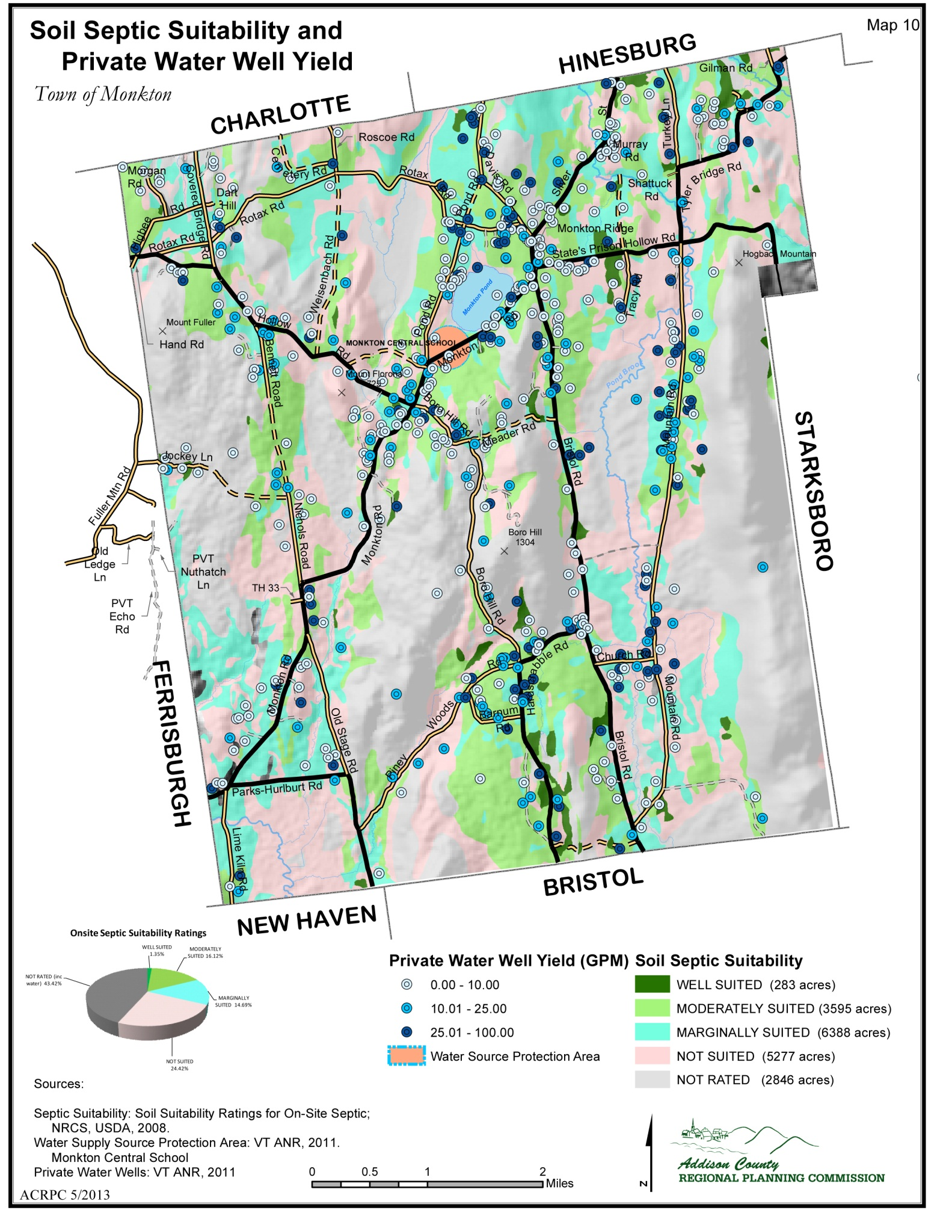

AGRICULTURAL RESOURCES
AGRICULTURAL GOALS AND RECOMMENDATIONS:
Our plan to maintain our agricultural resources will:

- Support the agricultural economy and land base in town.
- Encourage the stewardship and protections of agricultural land through agricultural easements and land conservation.
- Encourage the use of Best Management Practices to protect water quality and maintain soil quality.

We will do this by:
- Fostering the development of new farmers and diverse agricultural enterprises and uses of farmland.
- Fostering the growth of agricultural support services, food processor and value-added production on local farms.
- Working with ACORN to fostering the growth of markets for agricultural products in Town and the region.
- Encouraging development patterns that are compatible with farming.
- Protecting primary farmland in the development process.
- Encouraging the use of local products in our schools.
- Protect the farmer’s right to farm.
- Encouraging participation in NRCS/USDA and State programs to promote soil conservation and water quality protection.
- Encourage active participation in a five town regional farmer’s market.

AGRICULTURAL DISCUSSION
Agriculture has been a significant part of Monkton’s landscape, rural character, economy, and land use. Currently, there are 20 commercial agriculture operations in Monkton. A total of 5651 acres, which is 24.3% of the land, are in commercial agriculture operations. Based on the 2005 town survey, preservation of working farms and open land is a priority for Monkton residents. The continued consolidation of dairy farms will dramatically change the Town’s character. For this reason, the Town of Monkton recognizes the farmer’s right to farm. Agricultural policies are very important to protect land and water resources. The use of Acceptable Agricultural Practices (AAP’s), Best Management Practices (BMP’s), and Acceptable Management Practices (AMP’s) by the farmer are strongly encouraged.
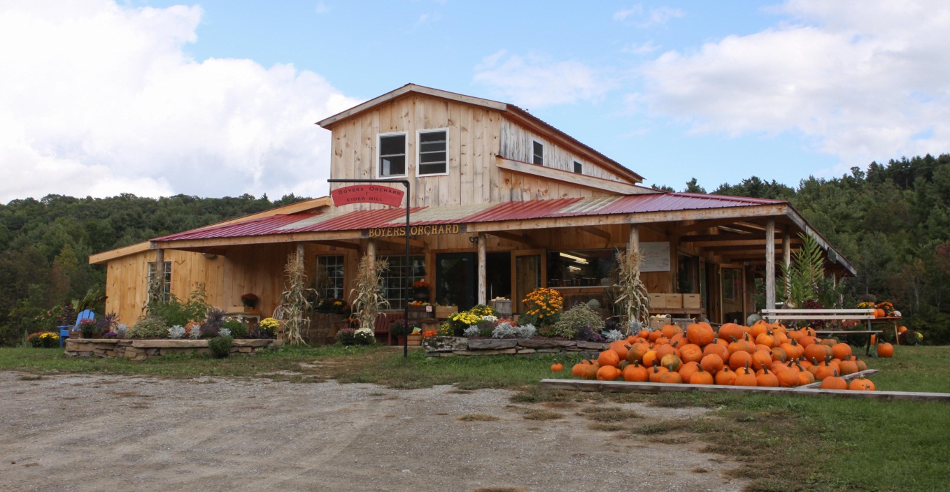
Boyers Farm Market
Dairying has been the primary form of agriculture in Monkton, however, the number of dairy farms that exist in Monkton has declined in recent years. Many are leasing their land to dairies in other towns. Others have diversified and become direct marketing operations such as market vegetable gardens, Community Support Agriculture (CSA) farms, berry and tree fruit farms, and specialty cheese-making operations have been successful as well as wholesale landscape nursery operations and forestry operations for lumber and firewood. Dairy farm operations are eminently suitable for other pasture-based livestock operations (e.g. beef cattle, small ruminants, horses), because of their barn facilities and acreage. The Town of Monkton encourages diverse farming operations, pasture or grass-based animal production systems, and specialty farms.

There are several measures that can be taken to encourage economic viability for farmers together with the preservation of the valuable resource of good quality agricultural land. These include taxing agricultural land at a lower tax rate based on their actual use, the purchase of development rights or the outright purchase of agricultural lands by the State or Town, and zoning and subdivision regulations that minimize the impact of development on agricultural land.

Providing tax relief for farmers is a priority. The State’s Use Value Appraisal Program (Current Use) provides tax relief by taxing land based on its actual current use. The Use Value Appraisal Program is an example of how the State allows farms lands to be taxed at use value rather than development value. In 2012, 5089 acres of Monkton’s agricultural lands were enrolled in this program. The State Use Value Appraisal Program should be supported through Statewide funding sources.

The 2005 town-wide survey showed a high level of support at 60.5 % for the concept of the Town of Monkton allocating town funds to purchase the development rights as well as the outright purchase of agricultural and open lands in order to preserve and maintain the rural character of the Town, and to protect open land and view sheds. At the 2006 Town Meeting, the Town voted 2 cents on the grand list to purchase land or the development rights of land to protect open land and agricultural lands. The Agricultural and Natural Areas Committee (ANAC) in Monkton is working with the Vermont Land Trust to conserve agricultural and forestland through protective easements.
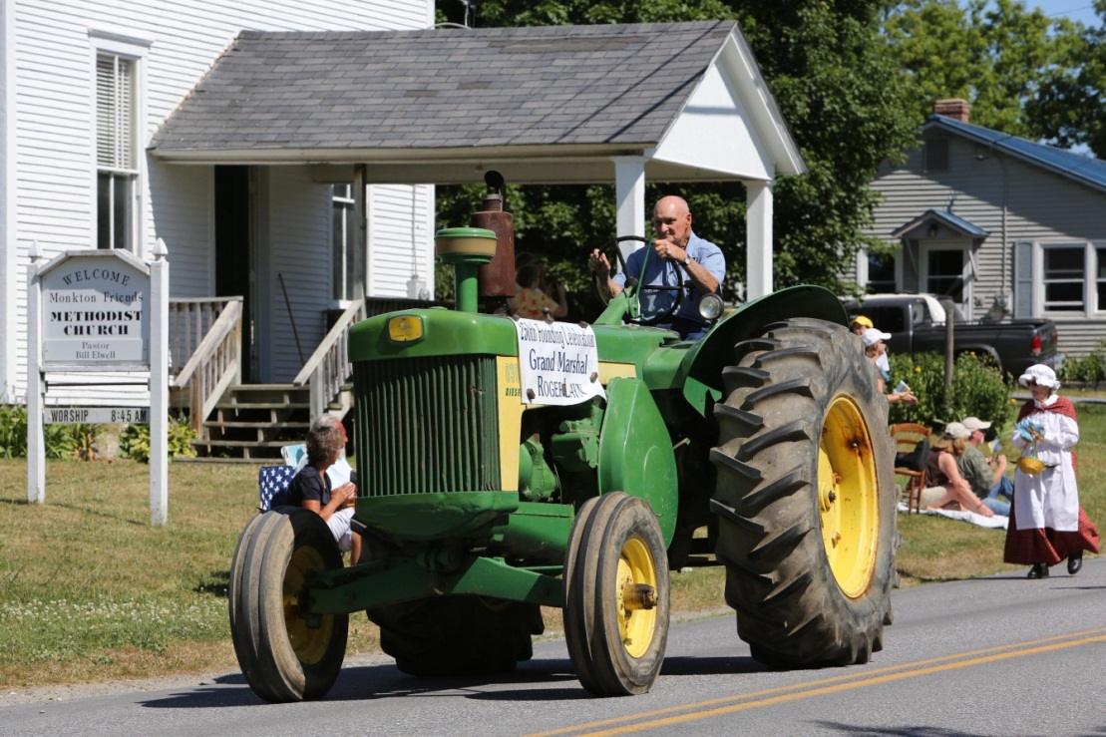
The Vermont Land Trust will buy farmers’ development rights, thus providing farmers with a monitory benefit while using conservation easements to preserve the land for agricultural uses. In 2012, 391 acres or 7% of agricultural farmland in Monkton was held in trust with conservation easements in place.
Monkton Celebrates

Zoning and subdivision regulations by the Town should encourage development that minimizes its impact on agricultural land to support agricultural operations and their infrastructure. In development, encouraging the use of "cluster housing" methods or Planned Unit Developments (PUD’s) will help keep good quality agricultural land free for agricultural and forestry uses while still allowing development and economic resources to exist. On farm parcels or land contiguous to farm parcels, housing should
minimize its impact on the farmland and farming operations. Town residents that choose to build or buy houses near farm or forestry operations or farmland must respect the farmer’s right to farm. The town should consider developing and agricultural zone to protect farmer’s rights to farm.

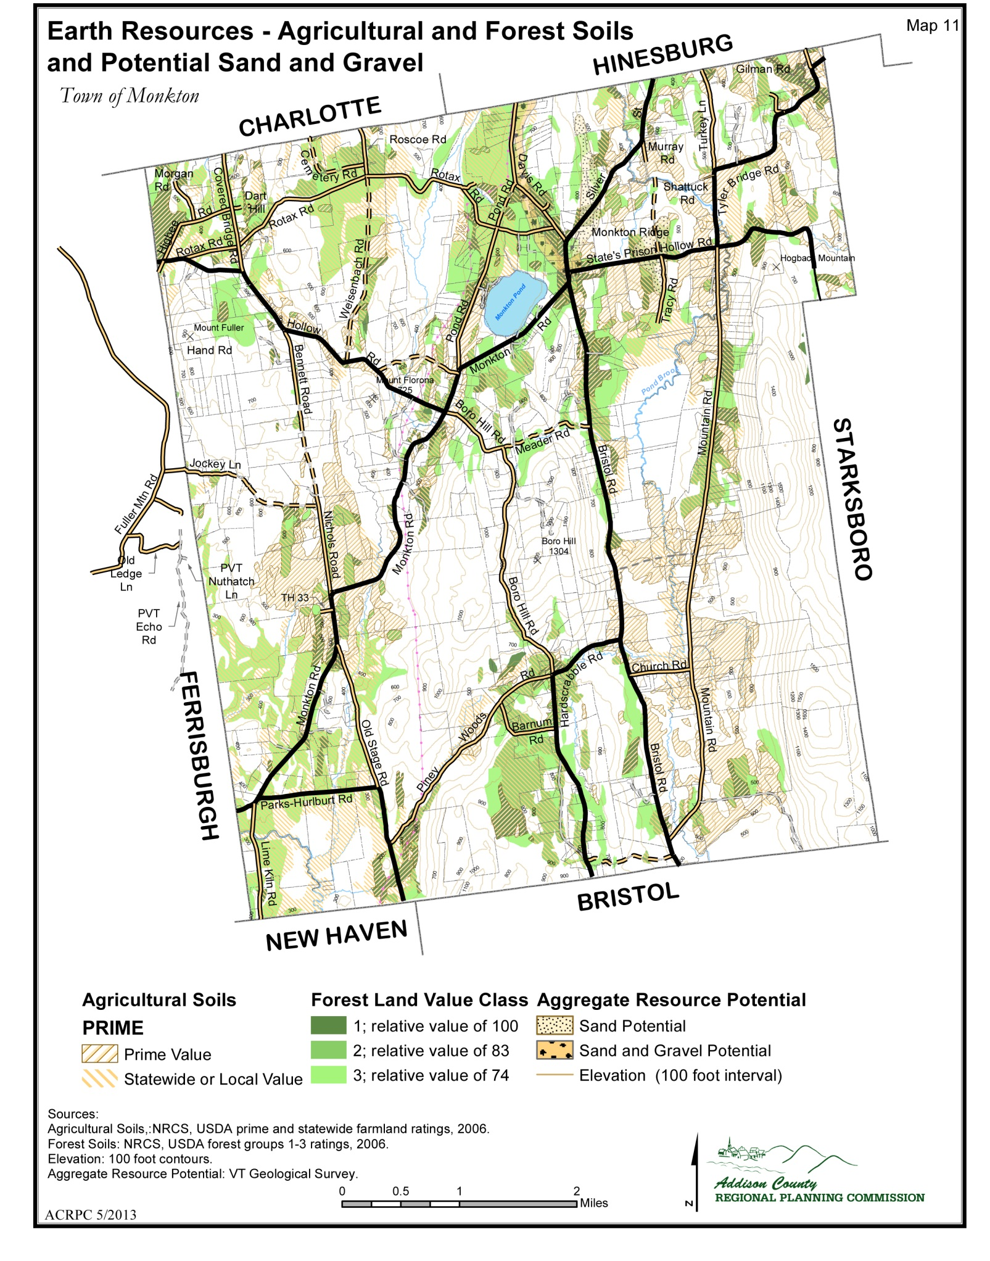

FOREST RESOURCES
FOREST RESOURCES GOALS AND RECOMMENDATIONS:
Our forestry plan will:

- Plan for an east-to-west forest corridor for wildlife travel.
- Foster the growth of the forestry sector and markets for forest products. Encourage forest stewardship and use of best practices.
- Encourage the conservation of primary forestlands.
- Identify and protect threatened or endangered species forested habitat.
- Support contiguous forests within our landuse and development plans.

We will do this by:

- Creating planning strategies that promote ecological health and sustainability.
- Supporting landowners’ efforts to develop and manage their forests sustainably.
- Encouraging best management practices and promoting Vermont Family Forest’s community forest model of forest stewardship and ownership.
- Encouraging the sustainable use of forests for local energy and heat production.
5. Encouraging local processing and marketing a diversity of forestry products.
6. Encourage further development of a trail system in town for recreation and enhanced quality of life.
7 Encouraging management of invasive species.
8. Creating a town forest that can serve education and recreation needs of residents.
9. Prohibiting development in Monkton’s forestland, wetlands and ridgelines (in areas identified by the state as State Natural Heritage Sites and shown on Map 17 of this plan).
10. Requiring development in any overlay district meet the associated standards of that district, as stated in the Land Use section.
FOREST RESOURCE DISCUSSION
Forestland has made a remarkable comeback from the 1800's when much of the state was clear cut and
converted to other uses. With that comeback came the return of forestry as a major industry within Monkton and the State of Vermont. Wise use and management of forested lands can enhance its long-term economic and ecological value. In 2012, it was estimated that 6589 acres in Monkton, which is 28.3% of the land, are in commercial forestry operations.

Forests provide many essential services to town’s people. Ecological services forests provide include, soil and hillside stabilization, erosion and flood control, wildlife habitat, groundwater purification and recharge, surface water recharge, and air pollution remediation as they remove pollutants from the air and act as carbon storage. Economically they are a source of raw materials for hardwood veneer, lumber, pulpwood, fuel wood, chipwood and maple syrup. They provide for a scenic working landscape. Forests provide educational opportunities and offer recreational opportunities like hiking, horseback riding, cross country skiing, hunting and snowmobiling.
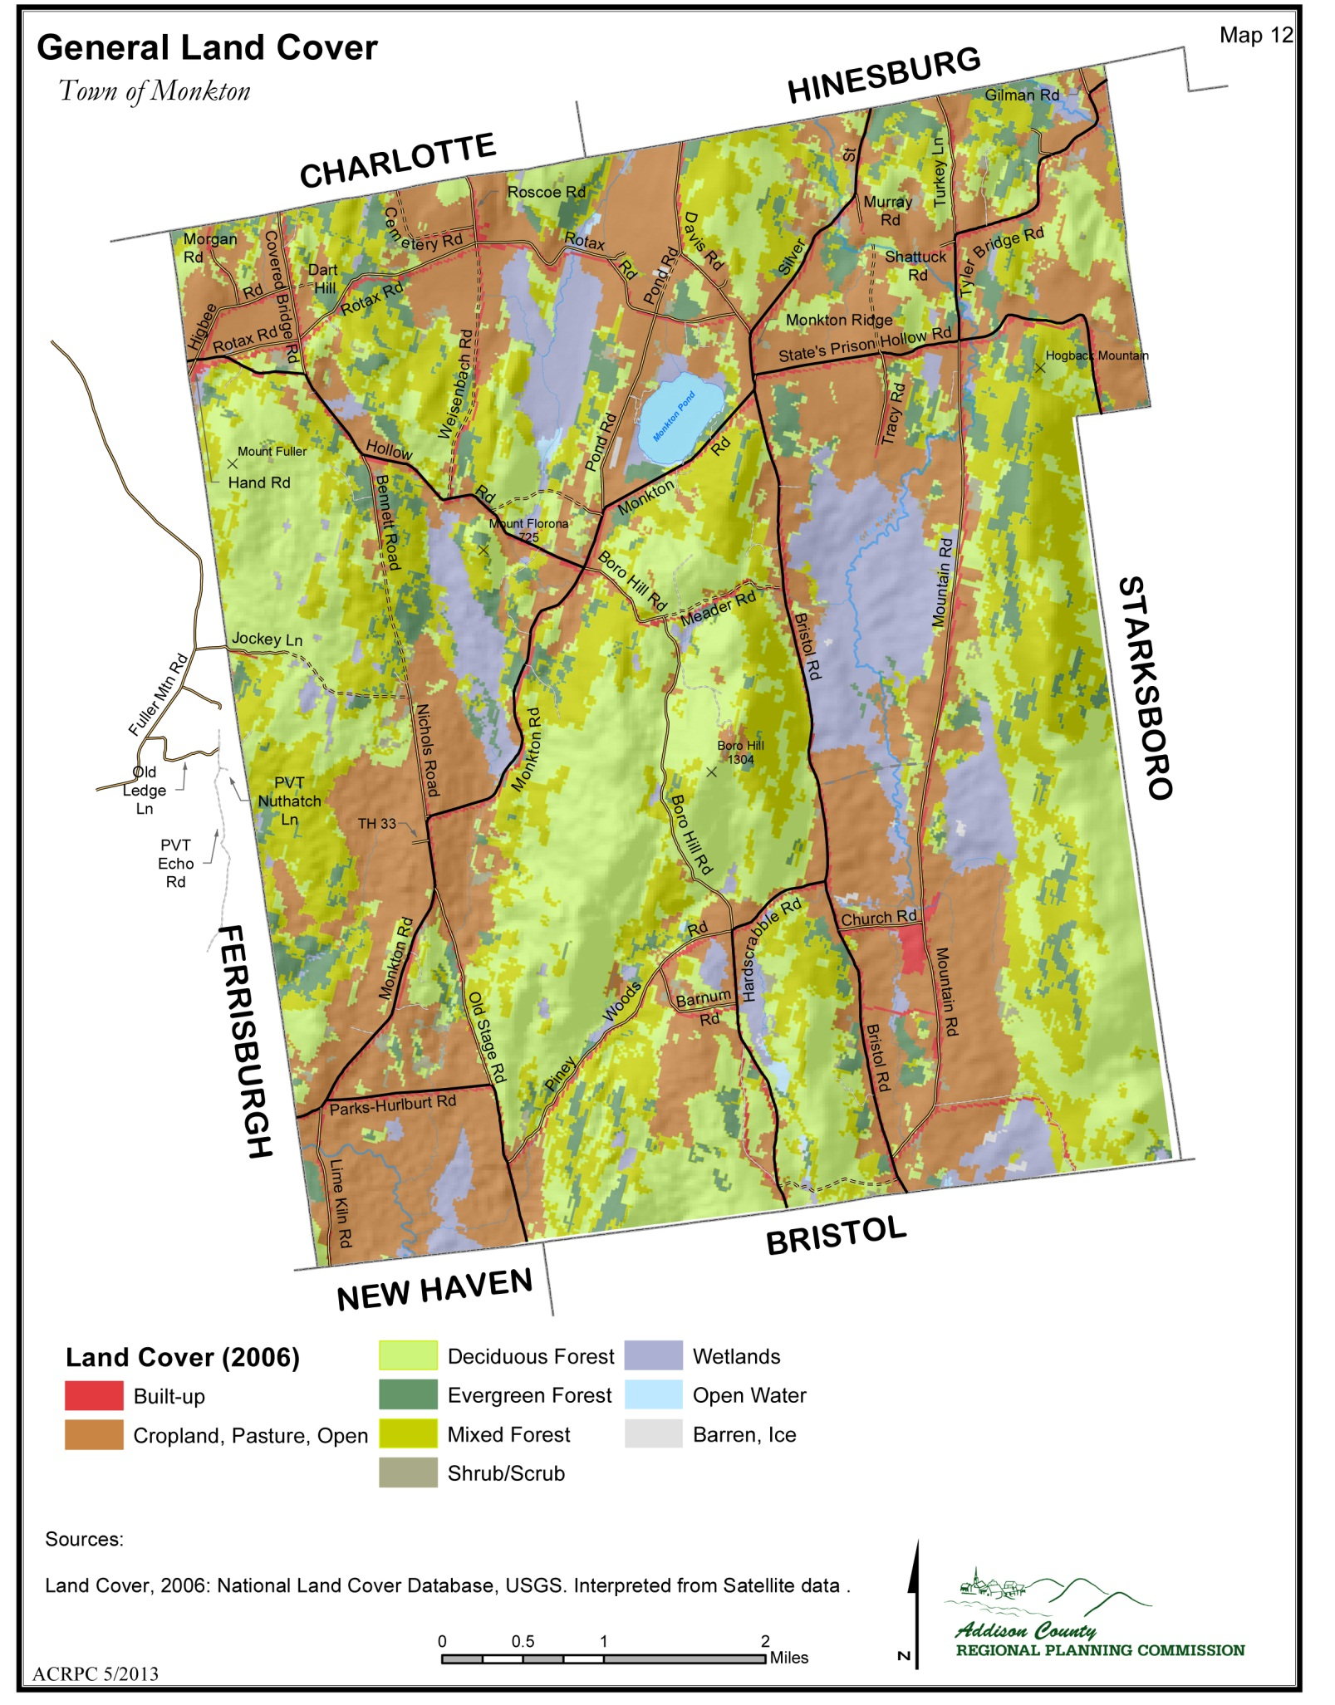

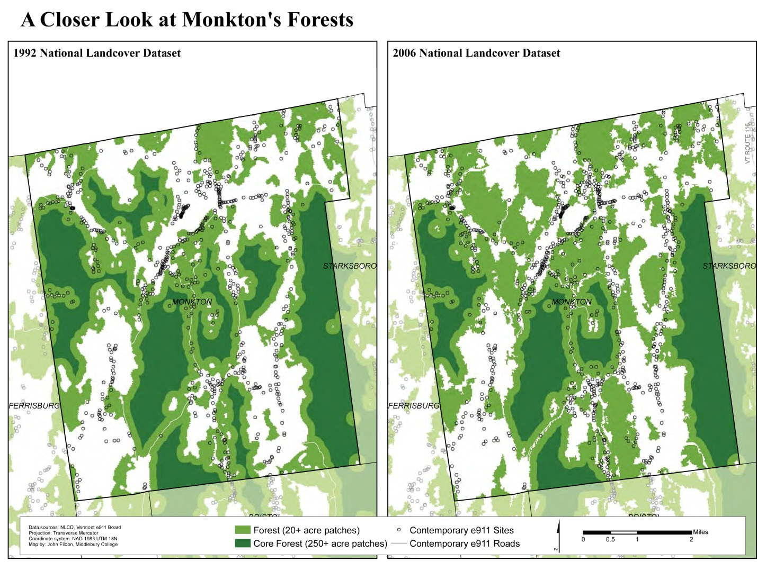
Middlebury College Forest Change Study
There are several measures that can be taken to encourage economic viability of forest operations together with the preservation of the valuable resource of good quality forestland. These include taxing forestland at a lower tax rate based on their actual use, the purchase of development rights or the outright purchase by the State or Town, and zoning and subdivision regulations that minimize the impact of development on forest land.

The Vermont Land Trust will buy development rights to forest lands, thus providing land owners with a monitory benefit while using conservation easements to preserve the land for agricultural uses. The Agricultural and Natural Areas Committee (ANAC) in Monkton is working with the Vermont Land Trust to conserve agricultural and forest land through protective easements. As of 2012, 1236 acres of Monkton forest and wetlands were held with conservation easements in place or 17%, including Raven Ridge Natural Area, Pond Brook Wildlife Management Area, Hogback Heaven, and Hogback Community Forest.

Providing tax relief for forestland owners is a priority. The State’s Use Value Appraisal Program (Current Use) provides tax relief by taxing land based on its actual current use. The Use Value Appraisal Program is an example of how the State allows farms and forestlands to be taxed at use value rather than development value. At the current time 7,341 acres of Monkton’s forestlands are enrolled in this program. The State Use Value Appraisal Program should be supported through Statewide funding sources.

The 115 acres Hogback Community Forest is Monkton’s only community forest. Vermont Family Forest’s innovative model of forest ownership conserves forestland and gives residents affordable access to firewood, timber and forest recreational opportunities and a return on their investment over time through community ownership. The Town should support innovative models of forest ownership and conservation.

In 2011, 6,589 acres were enrolled in the forestry section of the Use Value Appraisal Program. As with our agricultural resources, the use of AMPs, and Forest Management Plans are strongly encouraged. Forest management plans support the economy by contributing to forest related industries in the Town and region, providing recreational activities, as well as the importance conservation and maintenance of habitat, ridgelines, riparian areas, shorelines, vernal pools, and seeps.

Parcelization, the breaking of contiguous forestland blocks into smaller and smaller units, causes the loss of habitat through fragmentation, negatively impacts wildlife diversity, disrupts the movement, migration and behavior of wildlife, introduces exotic invasive species, and can degrade water quality. Monkton is one of the last towns in Addison County with significant forestland cover that provides an east west corridor for wildlife from the Green Mountains in the east toward Lake Champlain in the west. Conservation of forestland should be supported whether it is through the Vermont Land Trust or federal forestland aggregation opportunities. These efforts will support wildlife conservation.

Monkton has one forest community that has state significance: the clay plain forest communities, which can be found in the Pond Brook valley. The clay plain forest has been fragmented in many places, but this forest is a unique community and hosts diverse species because of its high calcium clay soil. This community should be protected and conserved where possible.

Monkton should start the process of creating a town forest. A town forest would provide educational opportunities for the school and recreational opportunities for residents. The town could manage timber on the land to offset a lost in property taxes. The town forest could be connected to a town wide trail system that would allow for recreational opportunities and improved quality of life.

The large majority of Addison County forests are well stocked, and therefore the continued proper management of these areas should prove economically, environmental and recreationally beneficial.

Town residents that choose to build or buy houses near farm or forestry operations or forestland must respect the landowner’s right to manage their forestlands. The town should consider developing and a forest zone to protect forester’s rights to log and manage their forests.

SCENIC RESOURCES
SCENIC RESOURCES GOALS AND RECOMMENDATIONS:
Our plan will:
- Protect and improve Monkton’s scenic resources.
- Maintain Monkton’s existing character by encouraging agriculture and forestry activities as a part of the working landscape.
- Encouraging commercial activities to locate within the existing town center.
- Minimize the impact of development in areas of high scenic or historical value.
- Support the development of alternative and conventional energy sources in such a way that they do not have an adversely impact scenic town resources.
- Preserve the nighttime ambiance and aesthetic qualities of the village and rural landscape minimizing the undesirable impacts of nighttime lighting.

We will do this by:

  - Using a public process to identify views of high scenic and community value.
  - Adopting planning and zoning policies that minimizes strip development.
  - Encouraging the siting of new buildings in ways that preserve the scenic qualities of Monkton’s ridges and pond shores and scenic resources.
  - Encouraging and incentivizing the creation of conservation subdivisions.
  - Minimizing the impact of alternative and conventional energy system infrastructure.
  - Requiring developers to address light pollution to night skies and energy efficiency in lighting plans.
  - Requiring location of communication equipment only on existing poles and towers.
  - Locate utility poles and lines in areas lower than the principle view or lines be buried, and require plantings to shield properties from visual impact of any new utility lines.
  - Using the lighting guidelines set forth in “Outdoor Lighting Manual for Vermont Municipalities” to guide new zoning.
  - Expanding the scenic overlay district.
  - Prohibiting development in Monkton’s forestland, wetlands and ridgelines (in areas identified by the state as State Natural Heritage Sites and shown on Map 17 of this plan).
  - Requiring development in any overlay district meet the associated standards of that district, as stated in the Land Use section.

SCENIC RESOURCES DISCUSSION
For over 250 years, family farms have shaped Monkton’s landscape. Layered on top of the ridges and valleys, agricultural and forestry have patterned the landscape with a patchwork of fields, meadows, forests and farms. Monkton has the panoramic views of the Green Mountains and their foothills, Monkton Pond, and its north-to-south valleys. Monkton has retained its small village settlement surrounded by a rural landscape; development has occurred on a small scale. However, development pressure is significant; Monkton is the fastest growing town in Addison County. It has become a bedroom community housing commuters who work in larger towns in Chittenden County and Middlebury.

It is time for Monkton to begin the public process of determining its viewscapes of scenic value. The Vermont Agency of Natural Resources publication “Vermont’s Scenic Landscapes: A Guide for Growth and Protection” recommends following these steps: 1) Describe the resource, 2) Identify the sensitivities, and 3) Prescribe the protections as a clear community standard. Scenic landscapes can include a village center, working landscape, public corridors or distant views.

A landscape’s scenic value is dependent on characteristics. Some characteristics which make some landscapes more scenic than others include:
- Landscape diversity and spatial contrast such as topographical variations, mixtures of open meadows and woodlands, water, distant views, and a mixture of vegetative types, which together enhance visual scenic qualities.
- Order and harmony in the human-made or cultural landscape. Building scale, pattern and architectural similarities in form and size can contribute to pleasing visual order.
- Focal dominance such as a natural distant ridge or human-made church steeple in a village can be a focal point.
- Intact or unique traditional landscape patterns or those that adsorb more modern development with minimal disruption contribute to scenic qualities.

Scenic areas that should be considered by the town include:

Unique or prominent landscapes areas that are generally accepted as having scenic significance and thus, should be address in a public process include:
- Shore lands immediate to public ponds, rivers or streams;
- Areas immediately adjacent to scenic corridors;
- Prominent ridgelines, mountain tops, or excessively steep slopes that can be readily seen from
public corridors;
- Exceptional agricultural and historic areas, recognized as outstanding resource values;
- Areas within or immediately adjacent to significant natural areas; and
- Areas of high scenic quality, which are publicly recognized as exceptional.

Development and new construction can be done in such a way to minimize its impact on scenic resources by following traditional size, scale and form, siting to minimize obtrusiveness on the landscape, materials used in construction that fit the location on the landscape and screening with vegetation.

AIR QUALITY
AIR QUALITY GOALS AND RECOMMENDATIONS:
This plan will:
- Identify, protect and improve the quality of air in Monkton.

We will do this by:
- Working with other towns in Addison County to encourage the development of an air quality-monitoring program for the county.
- Working with surrounding towns to develop park-and-ride areas in the north-south corridors of travel.
- Developing bicycle, horse, and walking paths in and through town to allow for alternative transportation.
- Encouraging forestland conservation and tree planting to improve air quality.

AIR QUALITY DISCUSSION
Given the rural nature of our town, issues regarding air quality are seldom expected. However, increases in traffic over the last 10 years and expected continued increases in vehicular traffic the future will impact air quality. The State of Vermont has 2 air quality-monitoring stations in Chittenden County, 1 station in Rutland County and 1 in Bennington County. Addison County has no air quality monitoring station. So there is no baseline data available to determine how increases in vehicular traffic has impacted air quality.
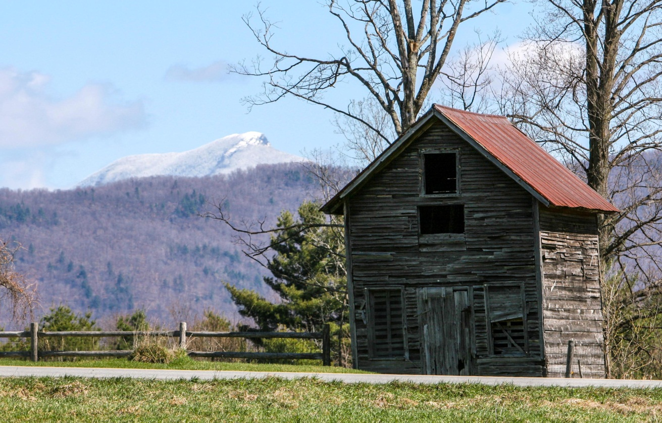
Views to Camel's Hump Mountain
Criteria air pollutants were selected by the EPA based on extensive scientific research showing the direct relationship between exposure to pollutants and their short and long term effects on human health and the environment. These pollutants include carbon monoxide, lead, nitrogen dioxide, ozone, particulate matter, and sulfur dioxide.

Zoning regulations in place have use restrictions that support maintaining clean air. Quality of air issues will continue to be among those factors considered during any subdivision or Conditional Use Application.

Challenges to air quality in Monkton include, illegal burning of trash and motor vehicle emissions as traffic on Monkton roads continues to increase. Monkton can encourage bicycle, horse and foot traffic in town by developing infrastructure for these alternative forms of transportation. Forested areas play a key role in the maintenance of air quality in the Town and region.

LAND USE
GOALS AND RECOMMENDED ACTIONS
Our Land Use plan will:
- Restore historic land use patterns of denser village centers and hamlets surrounded by agricultural lands and open space.
- Protect our natural and scenic resources and our agricultural, ecological and recreational lands.
- Respect the right to farm.
- Support the development of more affordable housing.
- Support appropriate commercial and/or light industrial growth.
- Support a transportation network which includes vehicles, cyclists, pedestrians and public transportation opportunities.
- Encourage a sense of place and civic identity.

We will achieve this by:

- Identifying the village district areas of our Town as a way to maintain and increase our integrity as a unique and identifiable place on the map and which provides residents with local services.
- Identifying and mapping our scenic and natural resources, including conserved lands, wildlife habitat and significant views.
- Discouraging commercial strip development and large, big box and/or franchise development as a way to preserve the integrity of Monkton’s unique identity.
- Better understanding opportunities and restrictions for transportation linkages, including cycling and pedestrian opportunities, between the ‘Boro’ and the ‘Village District’.
- Supporting the preservation of agricultural land and programs that encourage agricultural lands be kept for future generations.
- Supporting the use of Agricultural Best Management Practices.
- Performing a visual impact assessment in order to identify and protect prominent views and ridgelines unique to Monkton.
- Clearly defining our conservation areas, including wetlands, forested lands and ridge lines.
- Identifying growth areas appropriate for emerging commercial and light industrial uses.
- Identifying and managing forest land for both wildlife habitat and as a local economic/forestry resource.
- Preserving remaining hilltop locations from further development.
- Encourage the use of PUD’s.
- Encourage buildings consistent with the surrounding neighborhood.
- Prohibiting development in Monkton’s forestland, wetlands and ridgelines (in areas identified by the state as State Natural Heritage Sites and shown on Map 17 of this plan).
- Requiring development in any overlay district meet the associated standards of that district, as stated in this Land Use section.

DISCUSSION
This part of the Plan describes Monkton's current land types, land use patterns, and a vision for the future growth of our Town. The land use plan provides the information necessary to create distinguished zoning districts within our land use regulations.

This land use plan recognizes the importance of maintaining the environmental stability of the town’s resources, while meeting our planning goals and the needs of our residents. Strategies within this plan create the structure to protect wildlife areas, environmentally sensitive areas including wetlands, and looks to maintain Monkton as a unique, rural town rather than an extension of the strip and suburban development that is moving south from Chittenden County.

FARMS, FORESTS AND OPEN SPACE
Over 50 percent of land in Monkton is either forested or in Agriculture. The farms in Monkton provide a large economic base for our Town. When a farm ceases to operate significant economic and land use impact may result if another farmer does not retain it in agriculture. The people of Monkton have demonstrated through a town wide survey that they prefer that as much of this land as possible remain open and available for new forms of farming and to preserve the rural character of the town. Farms not only provide an economic base with a minimal demand for town services, but also provide a large amount of open land. Open land is used primarily for growing crops or as pasture for livestock. Additional benefits of open land are freedom of movement for wildlife, recreation for hunters and other outdoor enthusiasts, protection of ground water recharge areas and protection for watersheds.
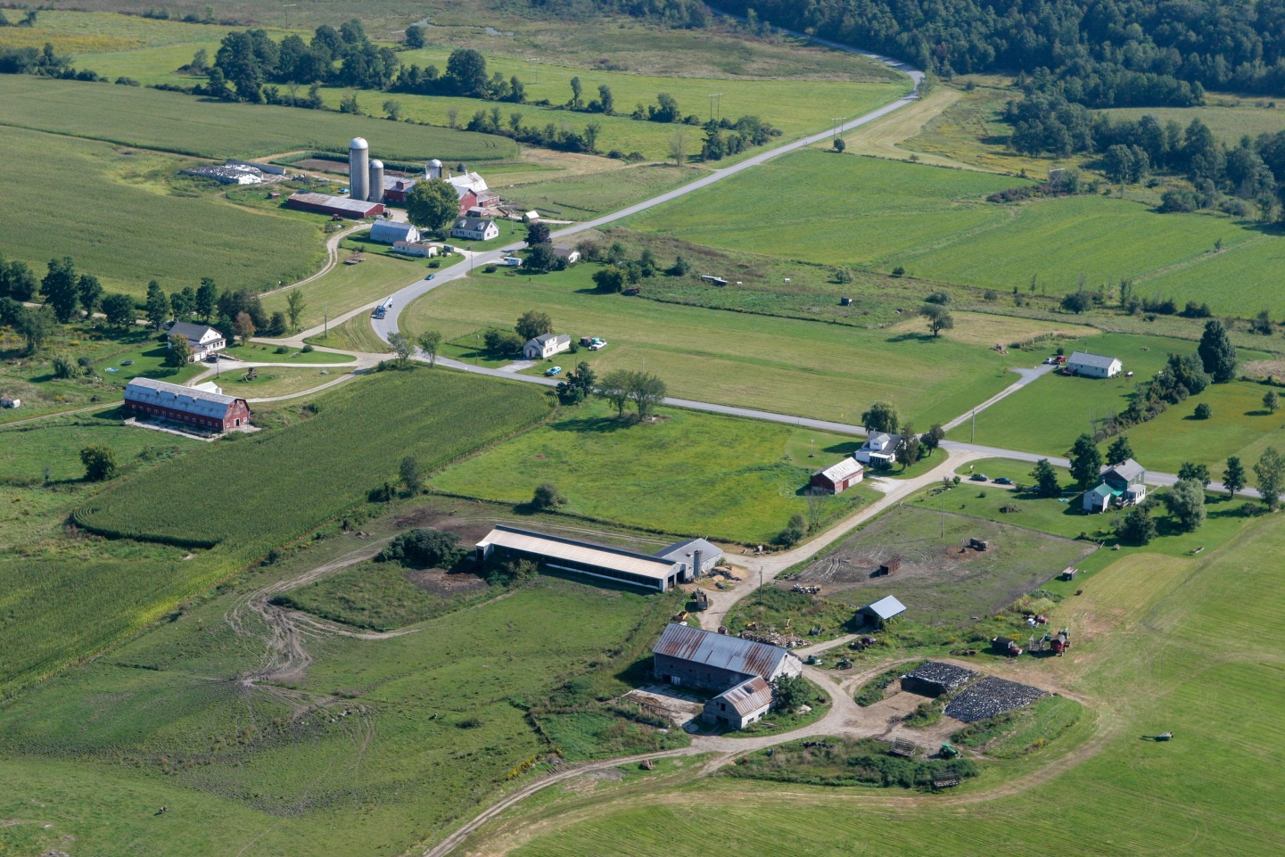

Monkton’s forestry industry depends on the maintenance of wooded lands. The forests are economically and ecologically important. They provide lumber and other by-products of the forest industry. The forest also provides wildlife habitat and recreational opportunities for hunting, hiking, snowmobiling and other recreational activities.

In the everyday activities of farming and forestry, there are inevitable side effects which may include: dust, noise, odors, outside storage of equipment, an occasional stray animal, and large equipment on roads, including delivery and product transport trucks. This plan recognizes the farmer/foresters right to operate and manage their land in an economically and environmentally sound manner. Becoming the neighbor of a farm includes the recognition that these side effects are all necessary aspects of rural life. The use of Best Management Practices is strongly encouraged.

ENVIRONMENTALLY SENSITIVE AREAS
Increased understanding of the nature of our environmentally sensitive areas, including ridgelines and steep slopes, wetlands, flood prone areas, and forest habitats, requires a re-evaluation of our present conservation and overlay districts ² in our land use regulations. While these districts preserve areas where development is inappropriate due to topographic, soil, geologic and ground water recharge conditions, they may need to be expanded and/or consolidated to include more sensitive plant and wildlife communities. A wildlife corridor overlay district is an example of a possible addition. The latter could include areas designated as significant by the Vermont Department of Fish and Wildlife and other areas based on local knowledge and expertise.

It is recommended that the Town engage experts to revisit our planning and zoning maps, taking note of all conservation and overlay districts to determine any needed additions and clarifications. These maps are instrumental when making land use and development decisions, including decisions associated with Act 250 applications.

HILLS AND RIDGELINES
A ridgeline is defined as a line marking or following a ridge, top of a hill or ledged area, behind which is open space or horizon. Ridgeline development creates highly visible structures that become prominent features on the landscape, detracting from the natural beauty and nature of Vermont and Monkton.

The hill areas of Monkton are defining characteristic of our town and provide important natural areas.
The eastern portion of Monkton, with its higher elevations, contains the most visible of the Town’s ridgelines. Although topography is not as dramatic on the western side, the hillsides are visually important because of their contrast to the surrounding lowland.

² An overlay district is an area superimposed over an existing zoning district in order to create a more definable land use area with specific regulations associated with it.

Uncontrolled or improperly planned development threatens the environment of hills and ridgelines.
Because of this, Monkton’s land use regulations restrict development on the upper reaches of our hills and ridgelines, and prohibit commercial wind projects on Monkton Ridgelines. Degree of slope and elevation were used to help identify these areas. Please see the Conservation-Prohibited Districts map for these specific areas.

Please refer to the Energy Section within this plan for details on commercial wind projects.

IMPORTANT SCENIC VIEWS
Critical to the unique rural character of Monkton is the protection of our prominent scenic views, including views of our undeveloped ridgelines. This does not refer to any individual’s right to a preferred
view, but view sheds that are landmarks and provide Monkton with a distinct familiarity. This plan recommends that such views be identified through a visual impact study and regulatory standards developed for their protection.

MANAGING GROWTH
A 2005 town-wide survey indicated that the residents of Monkton encourage the development of commercial and light industrial activity in appropriate areas, while retaining as much land as possible in an open or rural state. The identification of growth areas that may require rezoning to support emerging commercial services is critical.

Residential development outside of the village district should be encouraged to follow cluster development and PUD (Planned Unit District) techniques. Zoning regulations should offer incentives to encourage this form of development. Examples of incentives may include density bonuses to encourage maintaining as much open and wooded land as possible and/or to provide affordable housing (see inset below regarding density bonuses). The use of master plans, the identification of wildlife corridors and riparian buffer areas, partnering with land trusts and other sustainable land use strategies are encouraged.

Issues regarding the impact of traffic will continue to be scrutinized during the conditional use application process.

LAND USE PLAN

LAND USE PLANNING REGIONS
The Land Use Planning Regions map, Overlay and Conservation-Prohibited Districts maps should be used in conjunction with this text.

Monkton’s Land Use Plan divides Monkton into two broad regions: the village-residential and the rural residential planning regions. The village-residential planning region encompasses the two traditional settlement areas of Monkton Ridge and Monkton Boro and the areas between them on the north, west and south sides of Cedar Lake (Monkton Pond). The rural residential planning region encompasses all other areas of Monkton.

Village-Residential Planning Region
One of the central aspects of the traditional Vermont landscape is an identifiable village center – typically this is a designated place for civic and commercial activity and denser residential development patterns. The Town of Monkton recognizes the importance of these centers and accepts the challenge of joining the historic village centers of the Boro and Ridge with the emerging village center of the elementary school and Morse Park. The following characteristics are integral to the creation of an improved village center:

- Transportation networks which include sidewalks, pedestrian and cycling paths, traffic calming and the possible redesign of some roads and intersections;

- Diversity of activities that includes commercial, recreational, municipal and educational as well as residential uses.

- A gradual increase in the housing density and affordability with the inclusion of multifamily units, PUD’s (clustered housing with associated pathways and natural areas, together with density bonuses) and assisted living facilities; and

- As a centrally located, unique place within the proposed village region, Monkton Pond serves as a focal point for the community. In order to preserve this area for the future an overlay district
has been created to preserve the existing scenic and ecological characteristics of the Pond and surrounding residences.

Rural Residential Planning Region
As mentioned previously, the rural-residential planning area encompasses all land outside of the village-residential region. This region houses medium and low-density residential areas, and all of Monkton’s agricultural, forest and other open space land. How we manage this land is critical to ensuring our rural character and the integrity of our working landscape.

Planning efforts should include understanding advances in septic technology and alternative septic systems in relation to existing soil conditions and current zoning. New technology allows for less restriction on where development can occur. It is in Monkton’s best interest to understand how this fits with our current zoning and land use goals and whether regulations should be adjusted to reflect this technology.

A note on residential density and density bonuses
This plan supports that maximum average residential density be based on overall dwellings per number of acres, not on minimum lot sizes. This encourages Planned Unit Development (PUD's) and other forms of development which enhance the goals of the rural-residential planning region.

An average density of one dwelling per 5 acres is proposed. If, however, as part of a subdivision master plan, a landowner is willing to create smaller lots, while simultaneously placing deed restrictions on the remaining acreage for residential, conservation, agricultural or commercial use, than the overall density on the proposed development may be increased. Monkton zoning regulations varies the density bonus based on the percentage of land that is left open, the provision of affordable housing or housing for the elderly. The higher the percentage of land conserved, the greater the potential density. The primary tool to achieve this goal is the use of PUD’s which encourage clustered development.

ZONING DISTRICTS
Within the above-mentioned planning regions, five underlining zoning districts have been identified (please also refer to Monkton’s Unified Planning Document):

- High Density Village District
- Traditional Village District
- Medium Density Rural Agricultural District
- Low Density Rural Agricultural District
- Conservation, Prohibited (Forest, Wetland and Ridgelines)

The five zoning districts in Monkton regulate the degree of density and the type of growth allowed based on the characteristics of these identified areas. Zoning districts are identified based on natural features of the land (topography, elevation, slope etc.), distance and proximity to the historically denser center(s), important natural features, open space, existing road network etc.

Monkton’s conservation-prohibited districts, as outlined in the zoning regulations, prohibits growth due to the importance of these areas for wildlife habitat, natural flood and erosion mitigation and/or scenic qualities. Conservation districts should not be developed for residential or commercial use. Potential uses for land in these areas are limited to agriculture, forestry, outdoor recreation such as walking or hiking trails, or wildlife refuge. Conservation-prohibited districts in Monkton include forest lands, wetland areas and ridgelines. See map for specific areas.

OVERLAY DISTRICTS
Overlay districts are used as additional regulatory measures, superimposed on existing zoning in order to protect specific characteristics of that land. Monkton’s land use regulations include three overlay districts:

- Monkton Pond Overlay District
- Natural Heritage Protection Overlay District
- Flood Hazard Overlay District

Development in any of these overlay district areas must comply with the following standards:

1. Monkton Pond Overlay District
All development is conditional in this overlay district in order to ensure no new development blocks views to the pond for existing residential properties.

2. Natural Heritage Protection Overlay District
This overlay protects critical wildlife transit corridors and fragile or endangered plants or wildlife and must adhere to setback and vegetated buffer requirements, siting specifications, and/or maximizing contiguous open space in any development project.

3. Flood Hazard Overlay District
Land within this overlay district has been recognized by the Federal Emergency Management Agency (FEMA) as being prone to flooding and must adhere to State regulations, as referred to in our regulations.

Please refer to other specific zoning regulation for all zoning and overlay districts in Monkton’s Unified Planning Document.

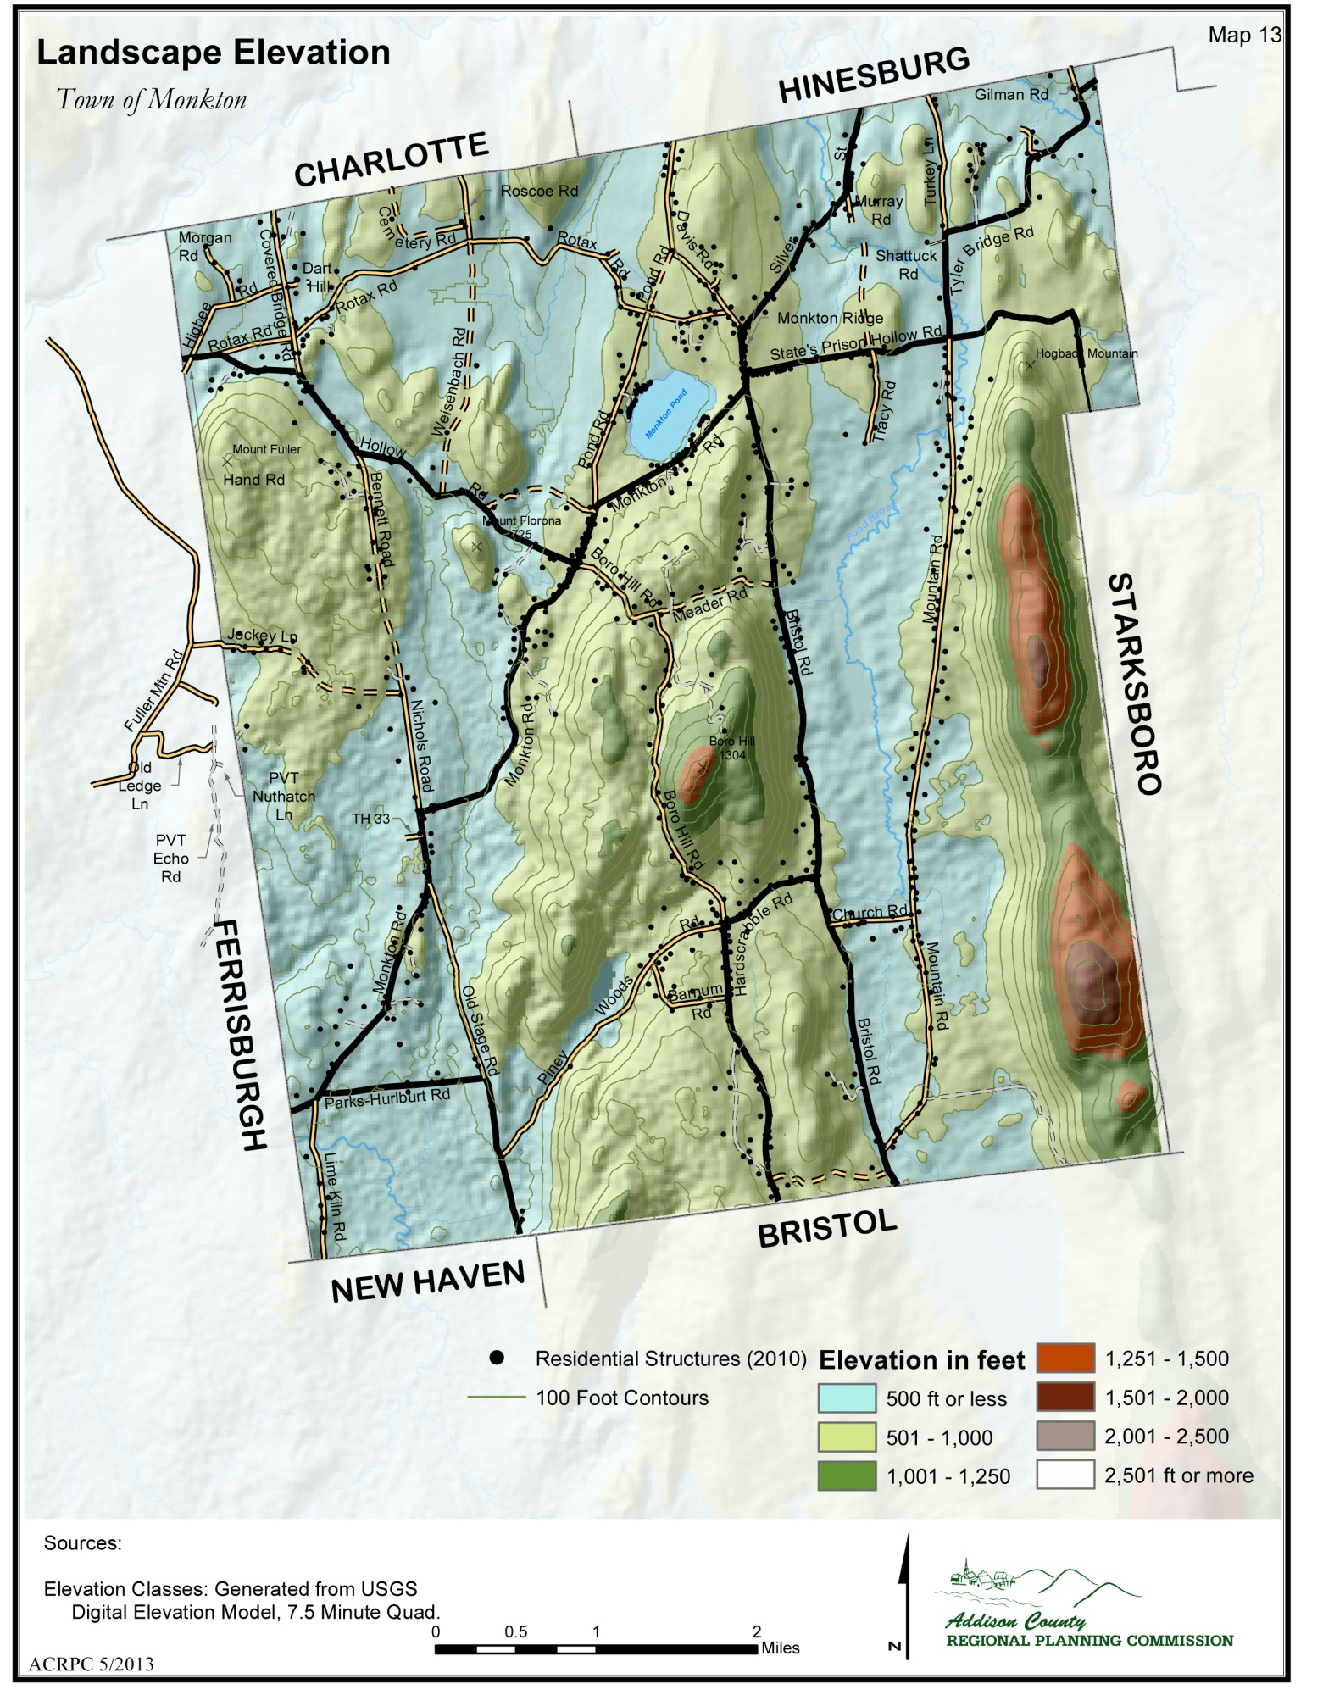
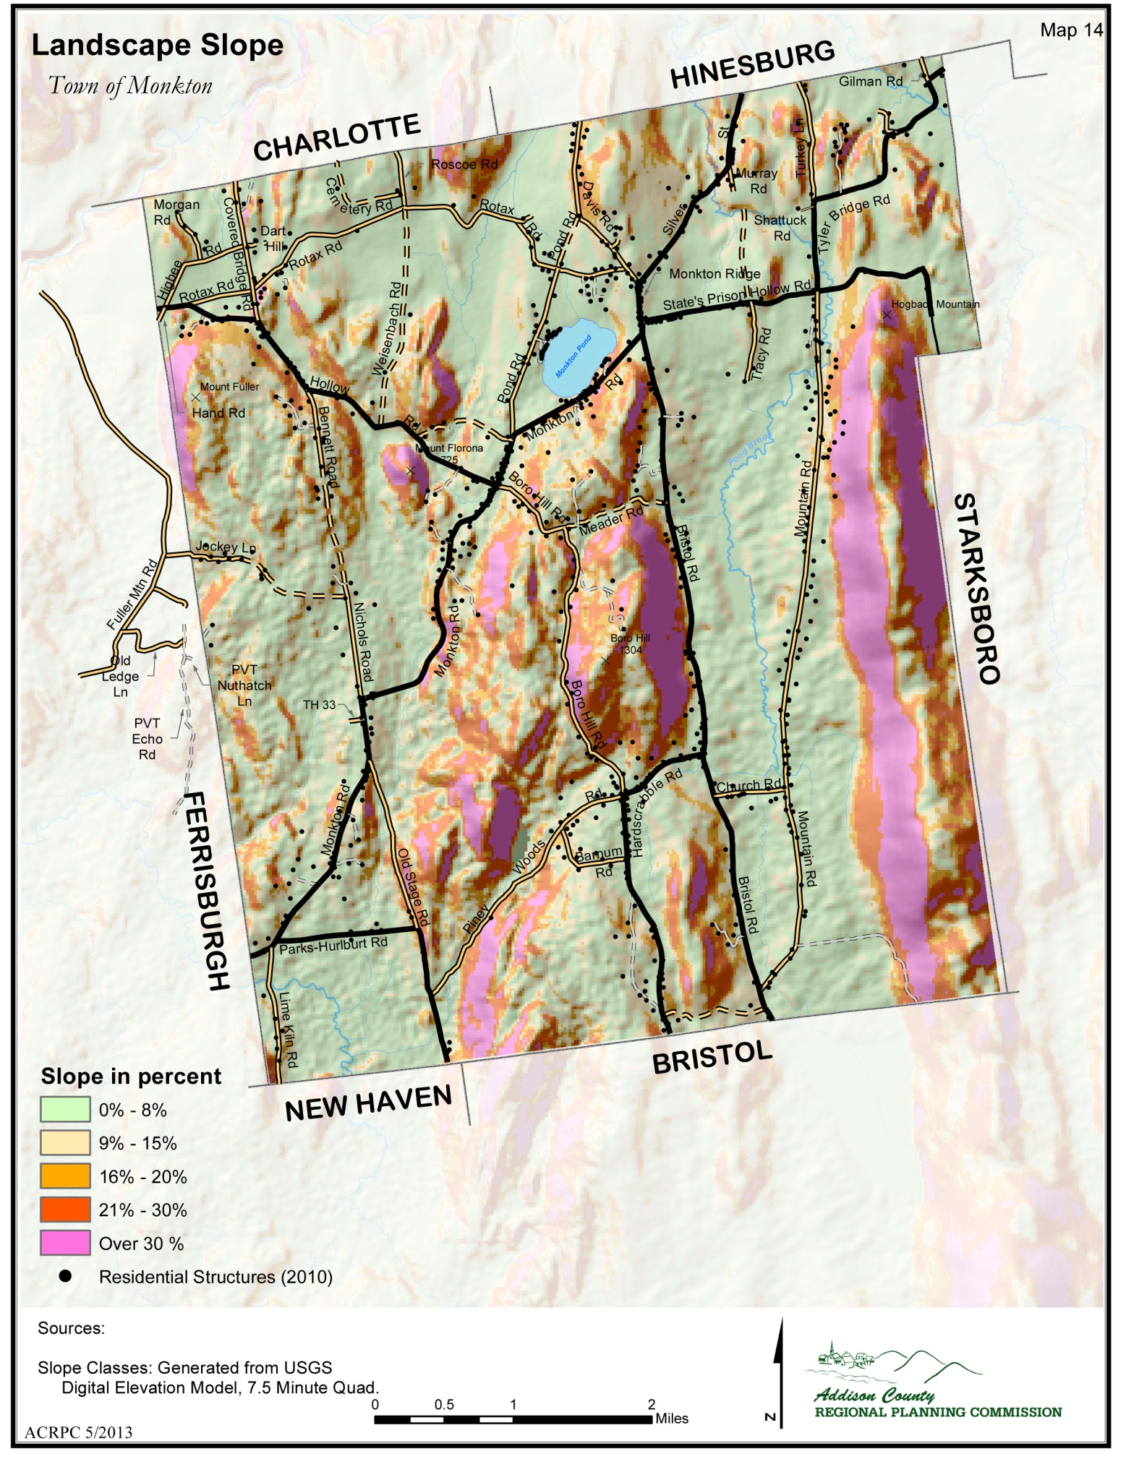
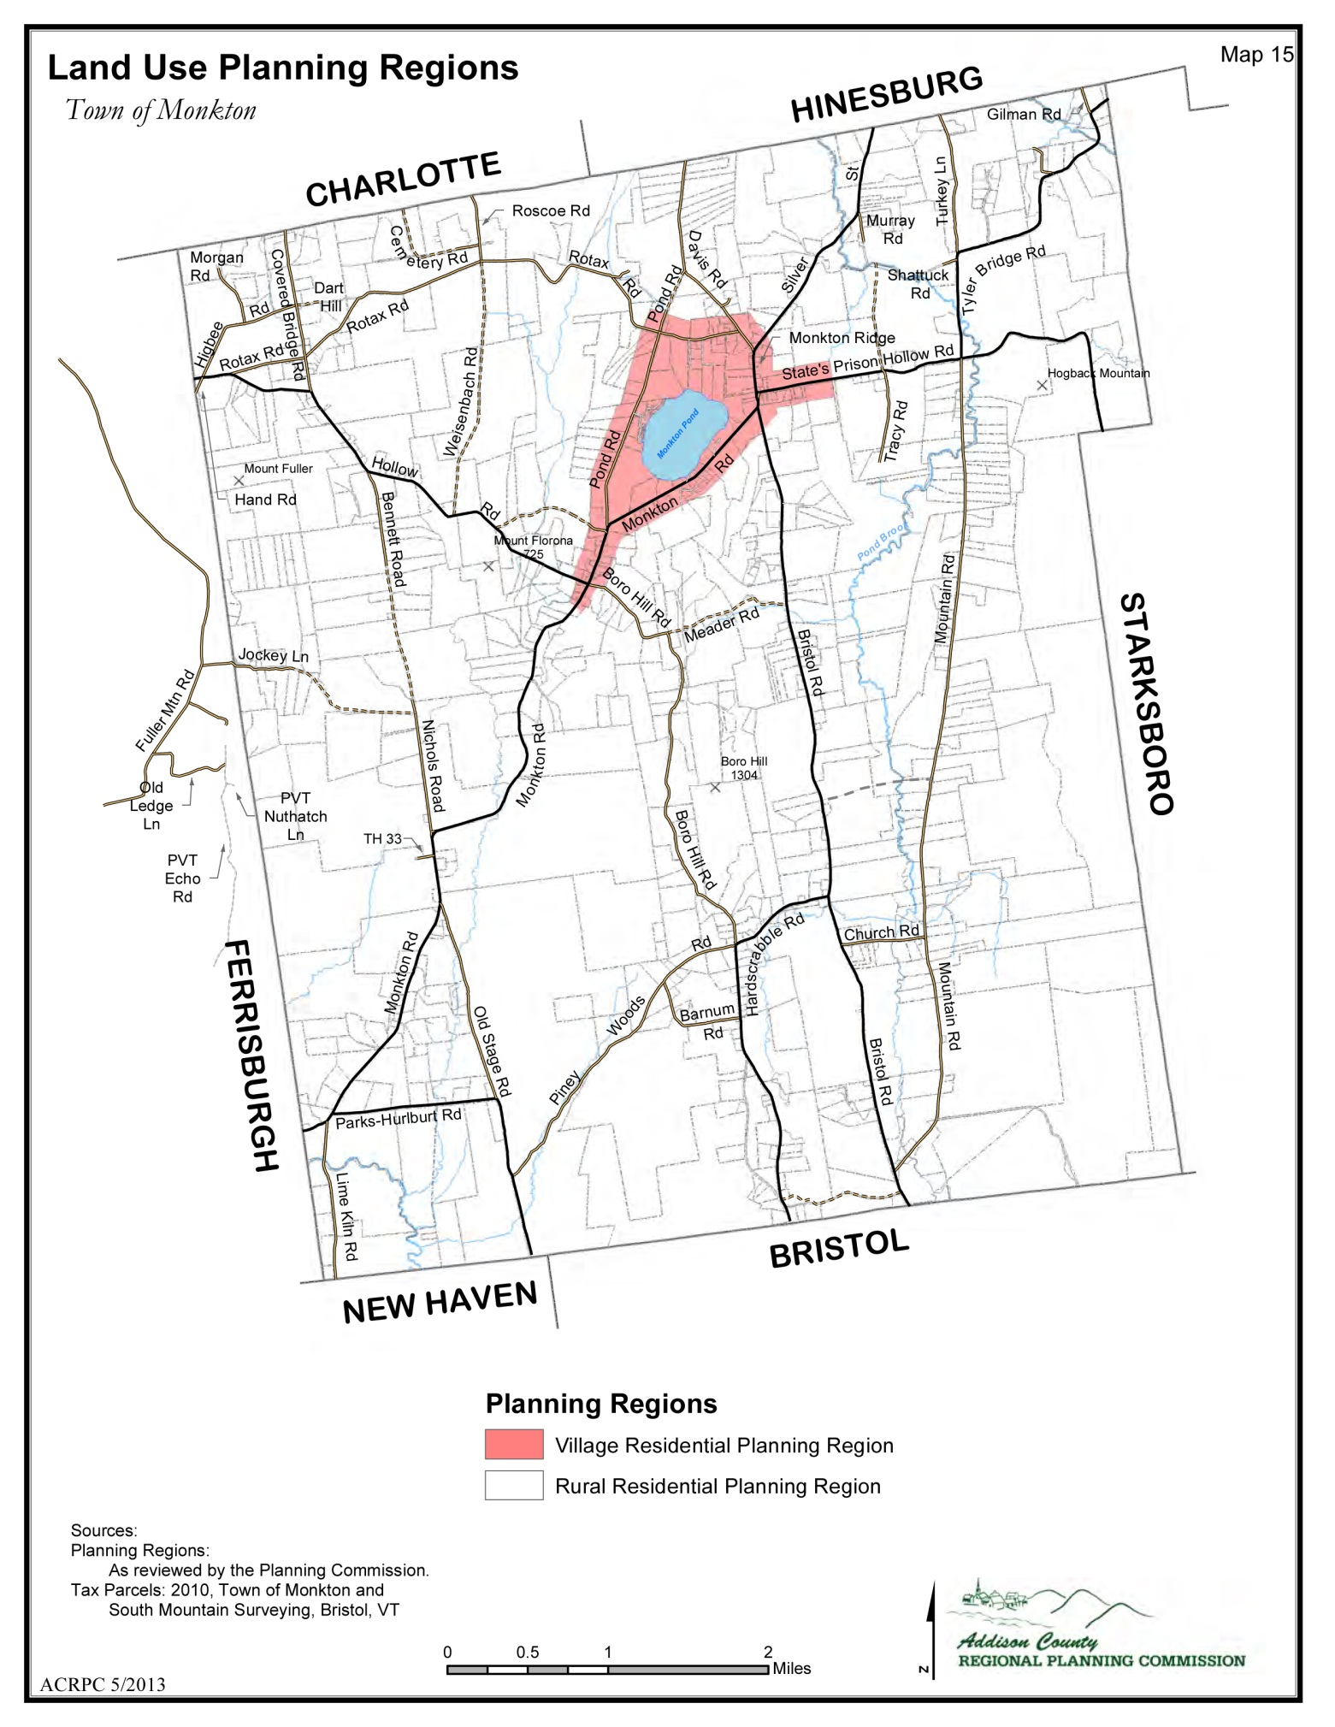
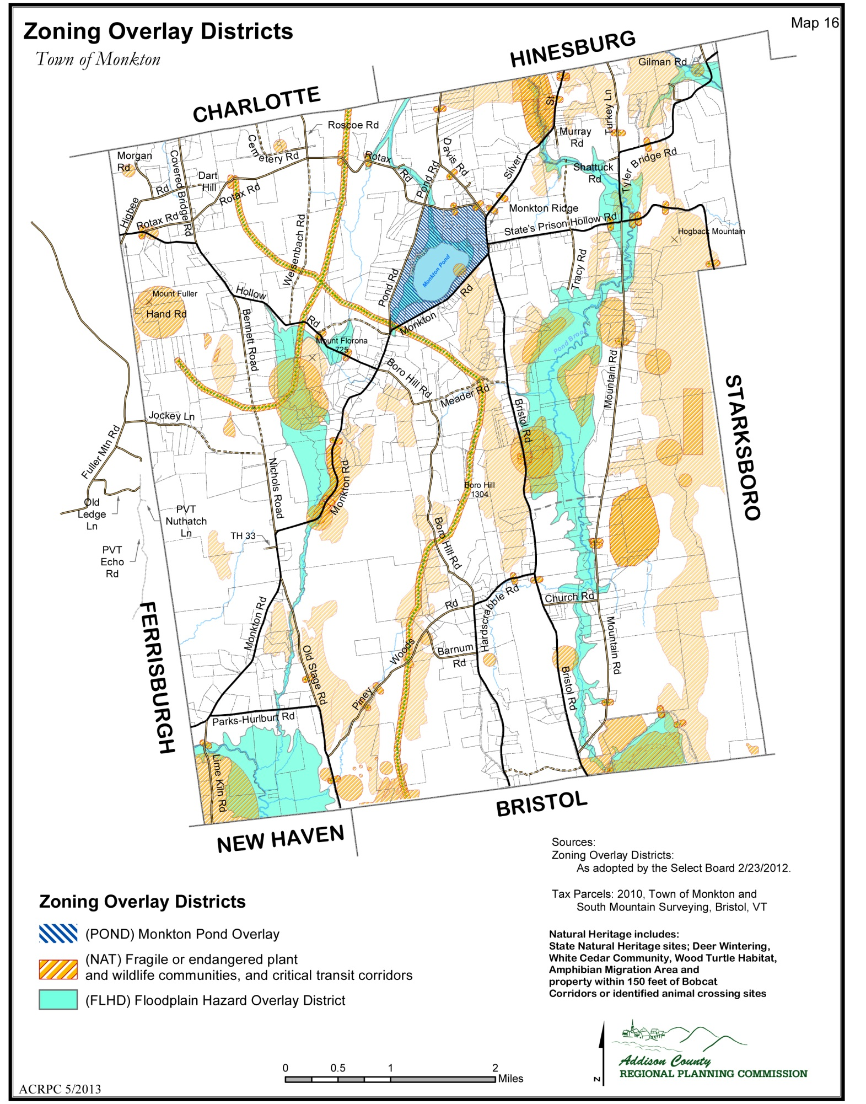
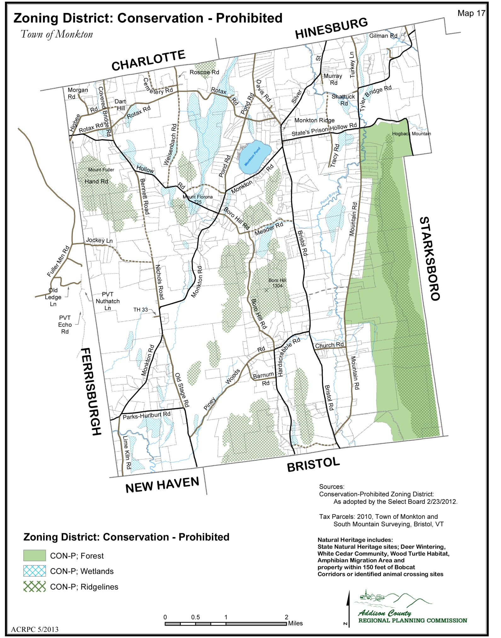

PLAN IMPLEMENTATION

This section provides a road map for the Monkton Planning Commission, prioritizing planning tasks based on goals and recommendations within the plan. The order of priority considers timing of projects with con-current and relevant activities occurring in Town, and concerns that have been raised by Town staff and residents of Monkton.
YEAR 1 TASK LIST (2013-2014)
Action 1: Complete a feasibility study to identify the sand and gravel resources in the town and determine the suitability for extraction.
Who: Consultant
How: T/B/D
Why: Monkton needs to understand the available resources in order to write zoning regulations that will meet the vision of the town regarding extraction.

Action 2: Identify and inventory the scenic roads and features within Monkton.
Who: Addison County Regional Planning Commission
How: T/B/D
Why: In order to create meaningful zoning and subdivision regulations, we must determine what scenic means, the value of the scenic location to the town, and establish the balance between maintaining the rural character of the town and the rights of the individual landowner(s).

Action 3: Work with Addison County Transportation Resources (ACTR) to create bus service to Monkton.
Who: Planning Commission
How: Dialogue with ACTR
Why: Traffic abatement (reduce number of single rider trips), support affordable transportation including small mass transit and reduce dependence on fossil fuels.

Action 4: Develop a monitoring program for Monkton’s surface waters.
Who: Planning Commission by partnering with the Monkton Conservation Commission, other local groups and working with appropriate State and Federal government.
How: T/B/D
Why: Water is one of, if not the single most, valuable natural resource within the town. All possible steps should be taken to maintain the health and safety of the Towns water supply and ensure that no development is allowed that will degrade it.

Action 5(a): Engage Monkton business owners in a dialogue to understand impacts of local regulations and how to create a climate which welcomes new businesses.
Who: Planning Commission
How: T/B/D possible ways include a survey and round table meetings.
Why: To gain a better understanding of the economic forces at work within the town.

Action 5(b): Survey the needs of the senior population of Monkton.
Who: Planning Commission
How: Survey and other outreach
Why: To identify the needs of the senior population and whether or not they are being met.

Action 6: Participate to the fullest extent possible in hearings before the Vermont Public Service Board on projects located in Monkton, our neighboring towns and our region.
Who: The Town of Monkton through the Select Board or other appropriate town board or commission.
How: Through written or personal testimony as required, or the assistance of legal counsel when necessary.
Why: To ensure that the town is always a participant in discussions which have a significant local or regional impact.

YEARS 2-5 TASK LIST (2015-2018)
Population
See task 5b in year 1 tasks, above.

Housing
Offer educational seminars/workshops for homeowners regarding grants and programs supporting energy efficiency/weatherization, and best practices related to residential development and the protection of natural resources.

Education and Childcare
Inventory existing home daycare operations in Monkton to better understand our local needs and offerings.

Utilities and facilities
1. Survey the needs of telecommuters and other business owners in Monkton.
2. Implement a capital budget and strategic planning for town facilities.

Energy
1. Seek funding to create park and ride areas to promote car and van pooling (see transportation task 2, below).
2. Research funding sources and support programs that would enable the town to retrofit/ install renewable energy systems for town buildings and the school.
3. Develop a municipal energy plan and encourage energy conservation.

Transportation
1. Survey public transportation needs and perceptions of Monkton residents.
2. Seek funding for Park and Ride infrastructure through VTRANS park and ride grant programs.
3. Seek funds to create a Monkton cycling and pedestrian plan focused specifically on creating connections between Monkton Ridge and Monkton Boro for bikes, feet, horse riding, and other non-motorized opportunities.
4. Partner with the Addison County Transportation Committee (the TAC) and neighboring towns to develop ways to redirect traffic back to route 116 and US Route 7.

Economy and Development
Work with ACTR to improve transportation options and ride sharing opportunities to employment centers such as Burlington and Middlebury.

Natural Resources
Also See Tasks 1, 2 and 4 in Year 1 Tasks above.

Wildlife
Develop data for wildlife corridors in town.

Water Resources
Conduct a study to determine where Monkton’s recharge areas occur and develop a protocol to protect groundwater quality and recharge areas, particularly from incremental degradation and depletion.

Soil and Mineral Resources
Work with NRCS and the Development Review Board to develop electronic tools and maps that identify primary agricultural soils and wetland soils to support their deliberations.

Agricultural Resources
Communicate with local agriculturally-related committees to understand needs and concerns.

Forestry Resources
Create a town forest that can serve education and recreation needs of town’s people.

Scenic Resources
Also See Tasks 2 and 6 in Year 1 Tasks above.

Air Quality
Develop bicycle, horse, and walking paths in and throughout town to allow for alternative transportation.

Land Use
1. Identify and map our scenic and natural resources, including conserved lands and ridgelines, wildlife habitat and significant views.
2. Clearly identify our conservation areas, including wetlands, forested and ridgeline areas

COMPATABILITY
GOALS AND RECOMMENDED ACTIONS
Our plan will:
Look to our surrounding towns as planning collaborators and stewards of our shared natural resources.

We will do this by:
- Working with adjoining towns to develop transportation strategies that minimize traffic, air, water and noise pollution, which are energy efficient, appealing and serviceable for the region’s people.
- Improving communication and coordination with adjoining municipalities regarding land use and planning for future growth.
- Working with adjoining towns to develop wildlife corridors that maintain and enhance wildlife habitat and which preserve wildlife migration routes.
- Working with adjoining towns to develop recreational corridors for enjoyment of the regions agricultural and forested landscape.
- Collaborate with the neighboring towns to expand recreational opportunities for Monkton’s residents.
- Work with neighboring towns, organizations and state agencies to develop sustainable energy resources in the region and coordinate energy planning initiatives.

The following describes adjacent land uses of Monkton’s neighboring towns. To the best of our knowledge, there are no major land use conflicts between Monkton and a neighboring town. There are many shared natural resources and roads.

Charlotte shares Covered Bridge Road, Raven Ridge Road and Raven Ridge. Bordering land is rural, agricultural and/or conservation land.

Hinesburg shares Turkey Lane, Silver Street, Baldwin Road, the Velco Easement and Raven Ridge. Bordering land is zoned Agricultural.

Starksboro shares Hogback Mountain and the Northern reaches of Lewis Creek. Land is zoned agricultural, rural, scenic-residential.

Bristol shares Pond Brook, a tributary of Bristol Pond (Winona Lake). It also shares Monkton Road, Hardscrabble Road and Hogback Mountain. Land is zoned low-density rural, agricultural and/or conservation district.

New Haven shares Lime kiln Road and North Street and also a section of the Orb Weaver Farm property. It is zoned rural agricultural, and partly a flood hazard district.

Ferrisburgh shares Rotax Road, Fuller Mountain Road, Jockey Lane and Vergennes Road. It is predominately a rural-agricultural and conservation area.

Vermont Division for Historic Preservation - The Historic Architecture of Addison County

